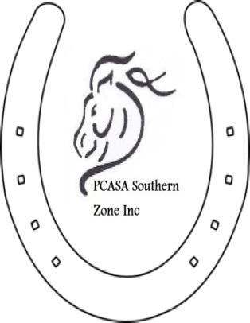

MONARTO EQUESTRIAN CENTRE BOOKING FORM
for PCASA & EA Financial members
P.C.A.S.A. SOUTHERN ZONE INC.

C/- BOOKING OFFICER, Beth Cook
beth@equestsportsphotography.com.au
PH: 0427 979 588

CONDITIONS OF USE:

- A responsible adult must be present with riders at all times.
- Access to a telephone.
- In case of emergency the road number for Monarto is 214 Peach Rd
- The cost to repair any damage to equipment or property (including jumps) is to be borne by the hirer.
- All equipment is to be returned to the correct storage area.
- Stables and yards are to be left in a clean and tidy state.
- Manure is to be removed from, yards & stables & around building and house paddock.
- All buildings, including house, dormitories, toilet block etc are to be left clean and tidy.
- All gates must be shut at all times.
- As there are sheep on the property NO Dogs
- Road doubles are out of bounds.
- Park on water jump side & access house side jumps from gate by road crossing
- Water jump water is not available without prior request

PLEASE NOTE: dates will not be booked unless booking form, for each riding member, financial status (membership card) or text of them & dates have been approved by.

Beth Cook 0427 979 588 or Deb Cook 0457 699 049
EA Riders need to supply financial status & a receipt of hire payment- $35/ combination

PCASA Southern Zone INC
BSB: 085 921 Acct: 794913855

Bookings are required

MONARTO EQUESTRIAN CENTRE REQUEST FOR BOOKING FORM.

NAME OF HIRER:.....................................................................................

POSTAL ADDRESS:.........................
.............................................................................................
............................P/C.........................
PIC #.............................................................

PCASA #....................................
Club................................................... Southern Zone members no charge except for training days

EA #..............................................................

PHONE NUMBER:..............................................

MOBILE:.................................................

EMAIL:..............................................................................

DATE/S REQUESTED:............................................TIME: ………………………..

Cross Country:............

The hirer acknowledges that the Pony Club Association of South Australia Southern Zone Inc. will not accept any liability or be responsible for any accident, damage, injury or illness to any horse, rider, spectator, instructor, organizer, hirer or any other persons present during the hire period.
The hirer accepts responsibility for informing all participants of the aforementioned requirements.
Has read the above conditions of use and agrees to abide by these conditions.

SIGNED:...............................................
PRINT NAME:..............................................................
ON BEHALF OF:.........................................................
DATE:.............................

After receiving this form you will be sent a confirmation.

