Herniated Disc = Back Pain

Natural Treatment:
- External Inflammation
  - Ice
  - Joint Health Complex DAILY
  - Joint & Muscle Pain Cream

- Internal Inflammation
  - Alfalfa (2 to 3 per 10 pounds of body weight) … a smorgasbord of minerals for healing
  - GLA (gamma-linolenic acid) – natural’s steroids for anti-inflammation
  - Vitamin C Complex – 3000 mg per day
  - Pain Relief Complex – 3 per day (available in the US only)
  - Vivix – 1 or 2 teaspoons per day
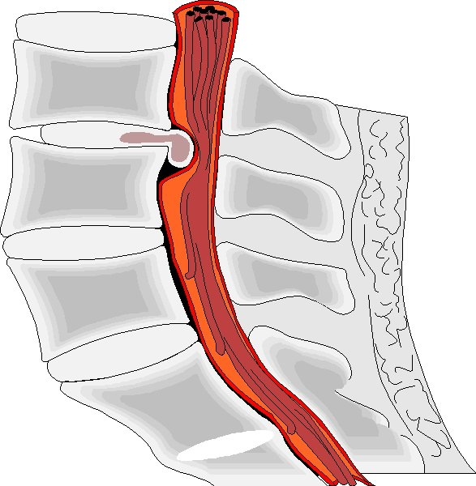
- Tissue Repair
  - Physique – 1 serving per day
  - Shaklee 180 Smoothees – 1 serving per day
  - Multiple Vitamin/Mineral – Vita Lea
  - Additional Zinc

- Therapeutic Treatment
  - Adjustments by chiropractor
  - Electrical stimulation

- Diet
  - No caffeine
  - Reduce or avoid red meat, sugar
  - Eat LOTS of fruits & vegetables (lots of raw ones)
  - Consume RAW nuts & seeds … Avoid roasted nuts

