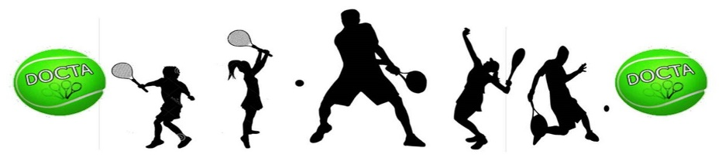
DURHAM-ORANGE COMMUNITY TENNIS ASSOCIATION (DOCTA)
USTA JUNIOR TEAM TENNIS LEAGUE – 2019 CHAMPIONSHIP YEAR
Eno River Area Local League Regulations

PARENTS AND PLAYERS

Local League Coordinator (Ages 5-18) – LeeAnn Rose – Email: leerus@icloud.com; Telephone: 919-358-1179
This is a co-ed league that plays doubles and singles matches and is for youth between the ages of 5 to 18. The teams are comprised of players of similar age and skill in beginner, intermediate and advanced levels. League winners will advance to the junior state tournament.
Registration Begins – February 1, 2019
Team Registration Deadline: March 3, 2019 (need a minimum of 5 players to make up a team)
Season Start Date: April 6 – May 18, 2019
League Fee - $25 per player (additional fee will be added to teams advancing to the state tournament)
(Tennis Link Fee - $3 (nonrefundable) + $22 DOCTA JTT Fee (refundable before 1st match) = $25.00
Practice – once a week (time will be set by your coach)—minimum 30 minutes (10U) and 1 hour (12U-18U);
Includes – Match Play – once a week on weekends.
League Fees do not include additional charges by coaches for practice clinics, if applicable.

TENNIS LINK (Register an individual junior player)
- A USTA membership is required. The annual junior membership fee is $20 (new 10 and Under members can use the promo code to play free in 2019 (FYFE for English and FYFS for Spanish). For more information or to join USTA visit USTA Membership at

https://www.usta.com/en/home/membership/individual-memberships.html.

- The following are the procedures to sign up on the official USTA Junior Team Tennis registration site:

- Go to www.usta.com website.
- Click on Tennis link option on menu at top of page.
- Click on the Junior Team Tennis box option
- Click on “Find a Program” (unless you have been given a team number to enter)
- Use the drop-down box to indicate Junior Program and enter your zip code
- Locate the 2019 Spring DOCTA JTT Program and click register on the right side.
- Enter your USTA number and select the appropriate division, based on age and skill level.
- Proceed to checkout.
PARENT SUPPORT AND INVOLVEMENT
Parent support and involvement is a key component to a successful USTA Junior Team Tennis Program at all levels of play. Parents are needed to assist as “Team Managers”, and in some cases parents may serve as “Coaches”. The role of the parent volunteer will be more clearly defined by each participating site. Parents may organize a snack schedule for weekly matches, as well as an end-of-season team party.
Parents are encouraged to be good role models and to talk with their youth about good sportsmanship and respecting opponents, other players and their coaches/captains on and off the court.
Important reminders for parents are as follows:
Parents assisting with coaching duties must have on file a USTA approved background check form with DOCTA and JTT Community Tennis Coordinator (LeeAnn Rose). Coaching duties include, but are not limited to the following:
- Running team practices
- Coaching during match play
- Assigning kids to courts during match play or doing lineups for matches
- Any duty that puts coaches in direct contact with the youth participants.
- Parents on or off court may not give instructions to players during matches (except parent coaches).
- Parents should applaud good shots made by both players; and encourage good sportsmanship.
USTA JUNIOR TEAM TENNIS SPECTATOR GUIDELINES
There is to be absolutely no coaching between a player and a spectator. Team coaches/representatives, teammates, or spectators may not volunteer advice on line calls or scoring. Excessive cheering or clapping is not permitted. It is the responsibility of both teams’ coaches and representatives to work together to control the conduct of the spectators during the match.
The following specific rules have been created to help spectators know what is allowed.
- Allow players to coach themselves
- Allow players to make ALL line calls.
- Allow players to keep their own score.
- Allow players to handle their own disputes.
- Watch from a comfortable distance from the players (not on the court).
- If a player is using profanity or throwing his/her equipment, contact the team coach/representatives.
HELPFUL WEBSITES
https://www.usta.com – United States Tennis Association (USTA)
https://nctennis.com – United States Tennis Association/North Carolina
https://southern.usta.com – United States Tennis Association/Southern Section
https://netgeneration.usta.com – USTA Net Generation
https://docta.org – Durham-Orange Community Tennis Association (DOCTA) (Manage DOCTA JTT Leagues)
https://enocta.tennis – Eno Community Tennis Association (ENOCTA)
https://www.dprplaymore.org – Durham Parks and Recreation, Durham, NC (Manage Adult Leagues)
https://www.townofchapelhill.org/town-hall/departments-services/parks-and-recreation - Chapel Hill Parks &
Recreation, Chapel Hill, NC
http://carrbororec.org/275/Recreation-Parks - Carrboro Recreation and Parks, Carrboro, NC
http://orangecountync.gov/1631/Recreation-Services - Orange County Recreation and Parks, Hillsborough, NC

PARENT/PLAYER AGREEMENT
We understand and agree to abide by the USTA and DOCTA JTT national, state and local rules and regulations for Junior Team Tennis League participation and play. I hereby release USTA, USTA/NC, USTA/Southern and DOCTA, coaches/captains and owners of tennis court facilities from any all liability due to illness, injury or accident while participating in the JTT League.

______ I give permission for my/my child’s photo from JTT League participation to be used on the DOCTA, USTA or local private club website. (Please initial).
Printed Parent Name______________________________Printed Youth Name__________________________
Parent Signature__________________________________________________Date______________________
Player Signature ________________________________________ (if 18 years) Date______________________
Questions – Please let us know. Durham-Orange Community Tennis Association – 919-547-4354. Community Tennis Coordinator – LeeAnn Rose can be reached by phone or email (see page 1). Thank you for your support and participation in the 2019 DOCTA – JTT Spring League. 1/11/19

