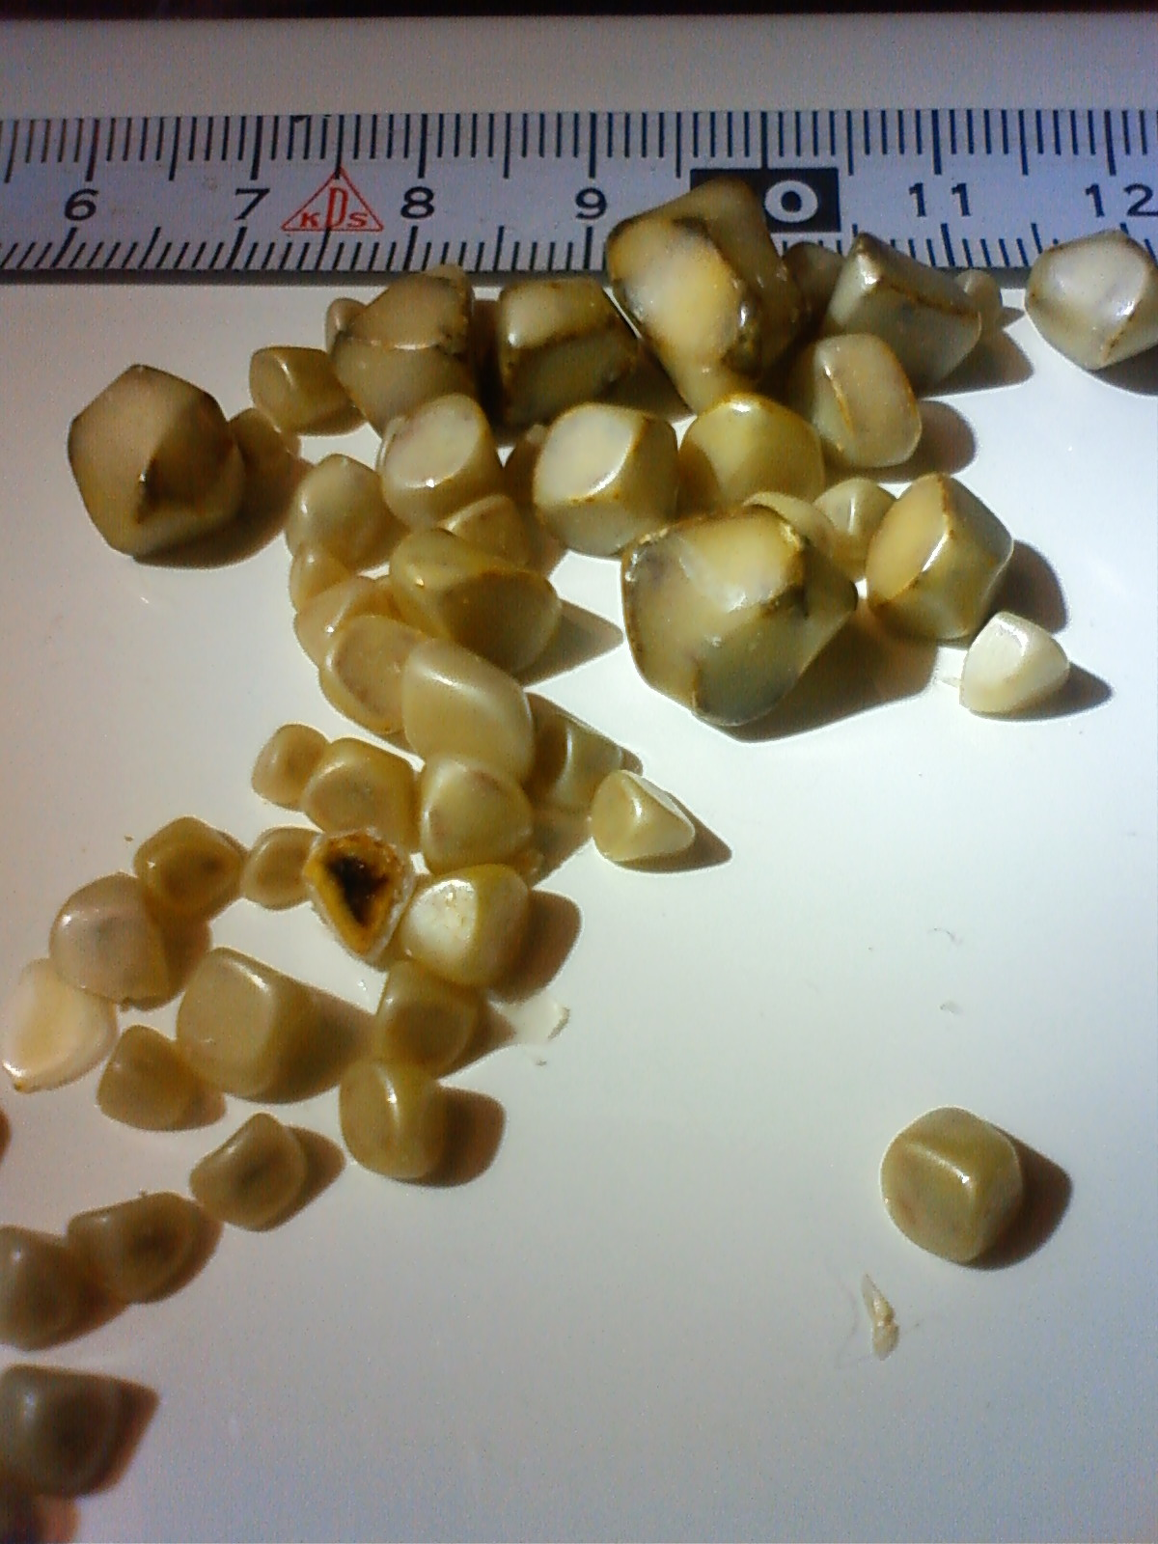
TWO TYPES OF GALLSTONES:

- Cholesterol Gallstones
√ Represents 80% of gallbladder disease
√ Made up mostly of cholesterol similar to what is found in hardened arteries

- Pigment Gallstones
√ Made up of calcium bilirubinate & other calcium salts
√ Main cause is excess bilirubin which causes liver abnormalities (such as cirrhosis)

THREE MOST COMMON CAUSES OF
CHOLESTROL GALLSTONES
1. High-Fat diet:
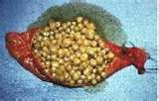
Because the most important function of bile is to break down fat, a high-fat diet
causes the liver to manufacture too much cholesterol.

2. Refined sugar:
Refined sugar reduces the liver’s production of bile salts. Therefore, this lowers the
solubility of cholesterol, and causes it to come out of solution to form stones.

3. Low-fiber diet:
Low fiber causes a deficiency in the production of a bile salt called chenodeoxycholate.
A low level of chenodeoxycholate causes the cholesterol to come out of solution to
form stones.

SEVERAL OTHER CAUSES OF GALLBLADDER DISORDERS

1. Deficiency of Vitamins:
According to Melvyn Werbach, M.D., a deficiency of vitamin E&C increases your risk of developing gallstones.

2. Deficiency in Hydrochloric Acid:
According to Melvyn Werbach, M.D., approximately ½ of all people with gallstones are deficient in hydrochloric acid, the stomach acid necessary for the body to properly utilize nutrients
Note: A natural way to help the stomach to produce more acid is to take peppermint & ginger in either a tablet or a drink

3. Deficiency in Taurine (an amino acid):
Taurine helps remove residual cholesterol and reduce gallstone formation

4. Stress & Emotional Upheavals:
These upset the chemistry of the body and can be a cause of gallstones

5. Food sensitivities or allergies:
These also upset the body chemistry and can be a cause of gallstones

6. Side effects of some Drugs:
- Many drugs (especially cholesterol reducing drugs) affect the balance of bile, & contribute to the formation of gallstones
- The use of the birth control pill for four years or more causes gallstones to form at twice the normal rate.

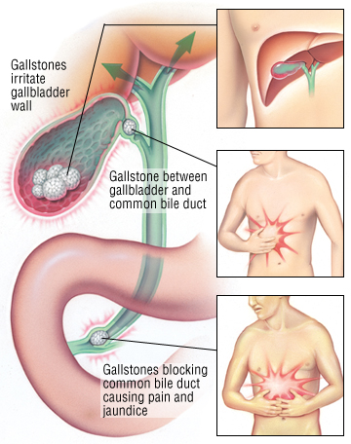

NON-INTRUSIVE METHODS TO TREAT GALLSTONES

1. Litholripsy
- A technique for breaking up large gallstones (larger than a dime) into small pieces by sound waves (litholripsy), in order for them to be passed by doing a gallbladder flush.
- Involves directing ultrasonic waves at the gallbladder
- However, the problems will reoccur unless the person makes necessary diet changes

2. Fresh extracted juices: (See instructions below)*
- Large quantities of fresh fruit & vegetable juices from a juice extractor
- Especially green juices, apple, pear, lemon, beet, etc. have been known to bring much relief

3. Gallbladder flush
- Extremely effective (see document under cleanses … liver/gallbladder cleanse)
- Not recommended for people who have large gallstones bigger than a dime
- Involves a specific one-week program including apple cider, cold pressed olive oil, lemon juices & Epson salts.

*Fresh Extracted Juices can dissolve Gallstones
Lemon juice, in the proportion of the juice of one lemon to a cup of hot water, taken many times a day, supplemented with a cup of carrot, beet and cucumber juice 3 or 4 times a day has helped a great many sufferers to experience with satisfaction the disappearance of both gravel and stones within a matter of a few days or a few weeks.

The larger the stones, the longer a person would need to do this.
N.W.Walker, D.Sc
from his book “Fresh Vegetable and Fruit Juices”

Long-term Results/Risks of Removing the Gallbladder
- Malabsorption: … because when the gallbladder is removed, the “holding tank” for bile is removed, and the bile that is produced by the liver while the food is being churned in the stomach (for 2 to 4 hours) has nowhere to be stored, and therefore, is released into the intestinal tract prematurely before the food is released by the sphincter valve at the bottom of the stomach. Since the bile goes into the intestinal tract before the food, rather than with the food, this creates a malabsorption which can be up to 50% or more.

- 50% higher Risk of Bowel Cancer: When concentrated bile enters the intestines prematurely and it has not been diluted by the food coming from the stomach, then the concentrated bile causes irritation to the intestinal wall, which can lead to inflammation, and cellular damage. This increases the risk of bowel cancer significantly.

