Nutrition Plus, Inc.

121 Mays Rd., Winfield, KS. 67156
www.nutritionplusinc.com

Executive Director: Emily Roark (620) 221-2777 roark2@cox.net
Administrative Supervisor: Patti Brenn (620) 218-1811 pattibrenn@cox.net
Topeka Area Coordinator: Susan Morrell
(785) 230-7441 smorrell12@gmail.com
Menu Advisor: Jacque Zimmerman (620) 660-0236 jacque.nutritionplus@gmail.com

August is:

2nd – National Coloring Book Day
5th – National Underwear Day 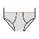
(I’m not sure if we are to celebrate or curse the day these were invented, so you do you on this one!)
9th – National Melon Day
11th – National Play in the Sand Day
12th – National Elephant Day
16th – National Rum Day (YUMMY!)
22nd – National Eat a Peach Day
23rd – National Cuban Sandwich Day
26th – National Women’s Equality Day!
27th – National Banana Lover’s Day
29th – National More Herbs, Less Salt Day

Important Dates:

August 2nd – Topeka Training 6:30p-8:30p
August 5th – Claims Due
August 11th – Winfield Training 6:30p-8:30p
August 26th – Checks/Direct Deposits go out
Last trainings of the year will be in August. If you attended the March trainings, you’re ok. If you didn’t, you need to be at one of these!

Kids are sweet enough without sugar!

The American Academy of Pediatrics says children 2 years of age and older should have less than 25 grams (about 6 teaspoons) of added sugar per day. We should avoid serving food and drinks with added sugar to children under 2 years of age.
August 2022
This is especially important this time of year when we are taking them outside for fresh air and it is so hot! Our instinct may be to replenish their fluids with juice or a sports drink like Gatorade® or Powerade®. It is important for you to know that 4 grams of sugar is equal to 1 teaspoon. The following amounts are based on the same serving size of 12 oz. For reference, one packet of sugar—the kind people put in their coffee—is typically 4 grams. Let’s check the math on some of our favorite drinks!
A glass of grape juice has 63 grams or 15.75 teaspoons of sugar. That is like pouring 15 sugar packets in your child’s glass.
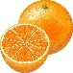A glass of orange juice has 45 grams or 11.25 teaspoons of sugar. That is like pouring 11 sugar packets in your child’s glass.
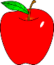 A glass of apple juice has 42 grams or 10.5 teaspoons of sugar. That is like pouring 10 sugar packets in your child’s glass.
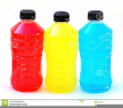 Sports drinks like Gatorade® or Powerade® have 21 grams or 5.25 teaspoons of sugar. That is like pouring 5 sugar packets in your child’s glass. (Remember, this is almost the full sugar serving for the whole day)
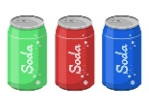 The top 4 sodas have between 38-46 grams or 9.5-11.5 teaspoons of sugar. That is like pouring between 9-11 sugar packets in your child’s glass.

I hope this gives you some perspective. I have nothing against sugar, I love it! But then again, I’m not watching multiple kiddos all day every day!
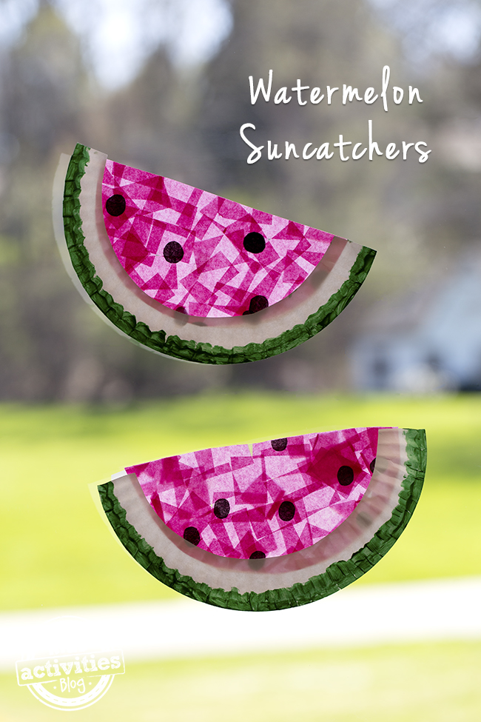

Supplies
pink tissue paper (cut into 1-inch squares)
black tissue paper (cut into small circles)
white paper plates
adhesive clear laminate shelf liner
green paint
a paint brush
tape
scissors

Instructions
Cut the paper plate in half. Next, cut off the center part, leaving only the textured rim. Paint the bottom half of the textured rim green.

Next cut a small rectangle of clear shelf liner (enough to fit inside the space in your paper plate).

Cut small circles from the black tissue paper and place them directly onto the sticky side of the shelf liner. Add the small squares of pink tissue paper onto the sticky side of the shelf liner, overlapping them for a cool effect!

When the shelf liner is covered, cut another small rectangle (about the same size) and place it over the tissue paper to seal it in. Trim any ragged ends.

Place the tissue paper rectangle into the paper plate (seed side out) and secure it with tape. Trim off excess edges to create a watermelon slice.

Hang in the window with tape and enjoy!
Cuban Sandwich
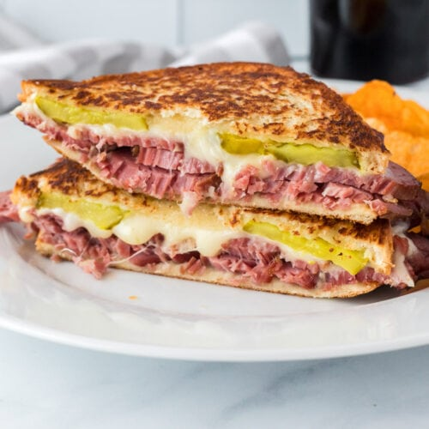

Ingredients

8 slices whole grain bread
4 tablespoons mustard
4 slices ham, deli sliced (thick)
4 slices Swiss cheese
8 slices dill pickles
4 tablespoons butter, unsalted

Instructions

- Preheat a sandwich press or griddle.
- Spread bread with mustard; layer with ham, cheese, and pickles, forming 4 sandwiches.
- Spread the outsides of each sandwich with butter.
- Place into a hot sandwich press or griddle until bread is golden and cheese is melted.
- Cut each sandwich in half. (Allow to cool before serving). Serves 8.
Melon popsicles
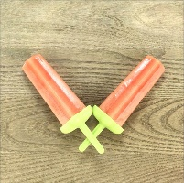

Ingredients
Any size melon (watermelon, cantaloupe, honeydew)

Instructions
-Scoop the melon out of the rind and place in a blender.
-Blend until smooth and pour into ice pop molds.
-Freeze 6 hours to overnight, until frozen through, and serve.

