**Apple Cider Vinegar Tablets (60 Day Supply) with The Mother Organic, Unfiltered ACV Capsules / Pills**

* Apple cider vinegar provides a magnitude of natural health benefits and has garnered superfood status over centuries of use
* Each capsule provides 500mg of Apple Cider Vinegar preparation and 110mg of Acetic Acid per serving – each serving (2 capsules) is equivalent to 6 liquid teaspoons (40ml)!
* Each component of BioPharmX advanced formulation has been highly refined and exceeds the HIGHEST pharmaceutics purity standards.
* Manufactured within an FDA and MHRA approved facility for your highest level of safety

Some of the benefits of apple cider vinegar that are backed by science include:

* **Weight loss:** Drinking diluted vinegar may aid in weight loss and decrease body fat
* **Blood sugar control:** Vinegar has been shown to decrease blood sugar levels
* **Reduction in cholesterol:** Consuming vinegar may reduce cholesterol and triglyceride levels

## Important information

#### Ingredients:

Each tablet contains pure certified and pharmaceutical graded; Apple Cider Vinegar 500mg (Providing 55mg of Acetic Acid).

## Product Description

### Apple Cider Vinegar Extract Tablets (x60) 1 Per Day / 60 Day Supply

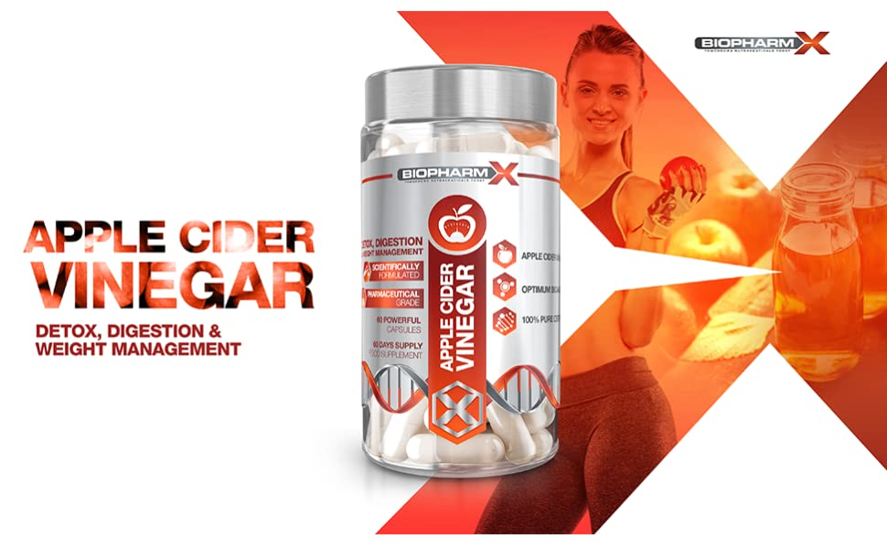

Apple cider vinegar provides a magnitude of natural health benefits and has garnered superfood status over centuries of use. Often referred to as the “father of modern medicine”, acetic acid (the main active component within Apple Cider Vinegar) has been utilized as a potent and multipurpose substance with powerful antimicrobial, anti-inflammatory and antioxidant properties!

|  |  |  |
| --- | --- | --- |
|  |  |  |
| Appetite Control & Weight Management Apple Cider Vinegar has risen to prominence for its exceptional weight loss benefits. It targets multiple pathways to:   * Increase metabolic rate * Suppress appetite * Reduction in fat stores | Heart Health A healthy heart is central to overall good health and longevity. Apple Cider Vinegar is incredibly beneficial for overall heart health.   * Lowers bad cholesterol * Reduce high blood pressure * Lower blood sugar levels | Immune Support Apple cider vinegar has a long history of use in traditional medicine, specifically to improve overall health and boost the immune system.   * Balance Body PH Levels * Treat and preventing bacterial infections * Contains beneficial bacteria and probiotics * Antibacterial properties fight off pathogens |



### Why not just drink Apple Cider Vinegar?

Traditionally taken in liquid form, most people find that incorporating drinking Apple Cider Vinegar into their daily routines difficult. Mainly due to the strong sour taste and smell of the vinegar, but you also have to consider it has an average pH between 2.5 and 3 which can weaken tooth enamel and consequently lead to decay, sensitivity and cavities.

Each maximum strength capsule is made from premium quality, unfiltered vinegar from organically grown apples – providing 110mg of acetic acid per serving!

BioPharmX manufacturing department is within an MHRA licensed, GMP certified and ISO accredited, operating within compliance of relevant laws and regulations.

* Suitable for Vegans
* Suitable for Vegetarians
* GMO Free
* Maximum Strength Formulation
* Premium Grade Ingredients

### BioPharmX: Superior Standards in Nutritional Supplements

|  |  |  |
| --- | --- | --- |
|  |  |  |
| Leaders in Nutritional Supplements BioPharmX has the goal of enhancing the well-being of their customers around the world by delivering premium pharmaceutical grade nutritional supplements.  Each tablet has been formulated to safely provide significantly more then other Apple Cider Vinegar supplements on the market. | Premium Quality Every bottle is manufactured in a fully licensed facility, using only premium graded ingredients.  Rest assured that we would never consider manufacturing an item that did not fully meet these requirements. | Directions for Use Adults: As a supplement begin by taking 1 tablet in the morning on an empty stomach with at least 8fl oz of water.  Do not exceed stated dose in a 24-hour period.  Use only as directed. |