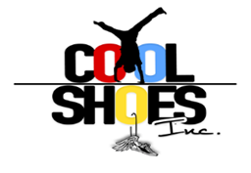
COVID - 19 CONSENT FORM

Childs Name (First & Last) ______________________________________________________

Checking the boxes below indicates that I have read and agree that I do not hold Cool Shoes Inc. Summer Camp liable pertaining to the Coronavirus.

- Thank you for your continued trust in our business. As with the transmission of any communicable disease like a cold or the flu, you may be exposed to COVID-19, also known as "Coronavirus," at any time or in any place. Be assured that we have always followed state and federal regulations and recommended universal personal protection and disinfection protocols to limit the transmission of all diseases in our Summer Camp and continue to do so.
- Despite our careful attention to disinfection, there is still a chance that you could be exposed to an illness in our camp, just as you might be at your gym, grocery store, or favorite restaurant. "Social Distancing" nationwide has reduced the transmission of the Coronavirus.
- Although we have taken measures to provide social distancing in our camp, due to the nature of the service we provide, it is not possible to maintain social distancing between counselor and campers.

Although exposure is unlikely, do you accept the risk and consent to your child attendance at Cool Shoes Inc. Summer Camp?

Circle Yes or NO to following questions
Has your child been around anyone exposed to anyone with COVID-19? YES / NO
Has your child exhibited any symptoms of COVID – 19? YES / NO

Parent Signature: _____________________________________________________________
Date: ________________

