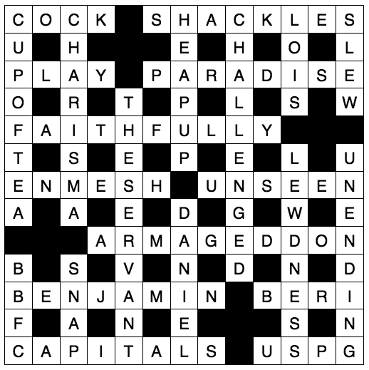

Readers contributions to the magazine are always welcome. Hard copy (hand written if easier) to the Rectory address or by email: to : st.marysstockport@gmail.com
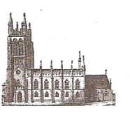
Editorial discretion with regard to content and space available will apply.
St Mary’s in the Marketplace
St Mary’s Rectory, 24 Gorsey Mount Street,
Stockport, SK1 4DU.
0161 429 6564 www.stmarysinthemarketplace.com.
St Mary’s in the Marketplace
50p
Parish Magazine
January 2014

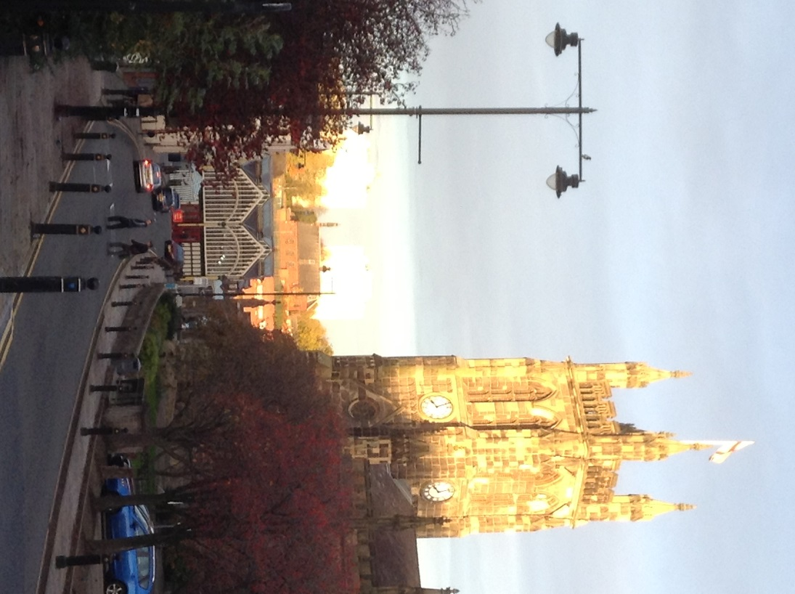

From the Rector’s “ i-pad”
Dear Reader
A Happy New Year to you!
The year ahead at St. Mary's looks as though it is going to be another busy and eventful one. I very much hope that we shall see the completion of the final phase of work on the two vestries, with the help of further substantial funding from the Heritage Lottery Fund, without whose assistance we would be quite unable to undertake such major restorative, and essential work. Once completed, the whole of the ground floor of the church will once again become fully operative, and the much hoped and planned for developments of the use of the church will be able to go forward.
1914 is of course a date which conjures up memories of the Great War which began 100 years ago and will be fittingly commemorated around the country in the coming months. There are some fine memorials (in St Mary’s) to those who fell in the Great Wars, and these will no doubt become a focus of attention and interest for the wider community in the coming months and years. As the Civic Church we will play a full part in the commemorations of the Great War, and I hope that our friends the Stockport Heritage Trust, who have settled back so well with us, exercising great patience and sensitivity, will play an active and creative role in our commemorations.
One of the distinguishing features of St. Mary's as a site of historical and sociological interest is the graveyard, which lies, literally, all around this ancient Parish Church. A couple of years ago Jill Trumble and a colleague spent hundreds of hours recording and collating the details of every grave inscription, providing the church and wider community with a unique record of our heritage. It's available in booklet form in the Heritage Centre.

Thank You

A BIG THANK YOU to anyone and everyone who helped to give a welcome at the many services and concerts which took place in St. Mary's in December leading up to Christmas. Many visitors , who had not seen the reordered interior expressed surprise and delight at seeing the improvements , making many favourable comments. The heating, which worked perfectly throughout our busiest period of the year, provided a suitably warm setting for the beautiful Advent carol services, and the carol services which followed. The comfort of the warm church together with the new seating , made the many and varied concerts a pleasure to attend according to people's responses.
The Nave Cafe continued to be open throughout December. It even remained in action while the services and concerts were going on, providing quite a novel approach to church life. This initiative was obviously appreciated by those who had " only called in for a cuppa" and found themselves entertained by carols and readings, children's brass bands and adults choirs alike.
It has been another memorable, indeed extraordinary Christmas at St. Mary's . One dares to suggest that there isn't a parish church in the land which works harder through Advent, and offers a wider variety of community seasonal activity,
and in doing so , helping to prepare the local community for the great Christian festival of Christmas .
THANK YOU TO YOU FOR YOUR HELP AND CONTRIBUTION TO OUR PARISH CHURCH'S LIFE!
The Rector

A New Beginning

“I know the plans I have for you,” declares the LORD…
“plans to give you hope and a future”
Jeremiah 29:11

What will you do with 2014?
How will you spend 2014? All those hours, days and weeks that lie ahead of you…
The Bible says ‘make the most of the time’ (Ephesians 5:16) That doesn’t mean speed up your life. It doesn’t mean more rush. In fact, rush is a hazard to this process.
It means that as this brand new year of 2014 begins, we are called to take time to plug into God’s plan for us – NOW. It means becoming obedient to his revealed will for our personal life, our work, our marriage, our priorities… – NOW. It means prayerfully discerning the divine and eternal opportunities before each of us – NOW. Yes, now. ‘For Now is the accepted time. Today is the day of Salvation.’ (2 Corinthians 6.2) So, today, let us hear his voice, let us harden not our hearts.

During 2014 I am hopeful that Jill will complete yet another detailed survey of the church's artistic and cultural heritage, namely that of the memorials in church.
This too will be an invaluable resource, and it is most commendable of Jill to have undertaken this work, free of charge.
She is also beginning a major study of the priceless archive material given to us by the daughter of Mr. H. Morton ,who was for many years closely associated with the Parish church. His collection of bound copies of the Parish Magazine dating back as far as 1875 will be of the greatest interest, particularly those editions covering the Great War 1914-1918, although sadly ( at the time of writing) the 1914 edition appears to be missing!
The role of the volunteer has never been of greater importance in the life of St.Mary's, nor indeed of the wider community, than it is today. Following an intensely busy period leading up to Christmas, which was hosted by a very small group of volunteers, one could be forgiven for thinking that life can only get quieter! One would be mistaken! Thanks to the invaluable and delightful involvement of Pure Innovations, who run the Nave Cafe during the week, it seems to me that every week the place gets busier, with the smooth running of the Nave Cafe and the ever increasing popularity of the Heritage Centre, besides the midweek service , of which at present there are only two. The prospect of many more events, day conferences, concerts, Wedding fairs, and dinners, suggests to us that the role of the volunteer at St. Mary's is one that will grow and grow during this year. I hope, dear Reader, that you are sharing fully in this vital work!
I am delighted to announce that in March 2014 the Stockport Youth Orchestra is making a rare but welcome return visit to St. Mary's, which is a clear demonstration that with our new, highly acclaimed and versatile seating arrangements, such events will hopefully become a regular occurrence. They need to be, because they are part of our stated " business plan" which will facilitate not only much wider use of this great building by the wider community, but will also provide a much needed alternative income stream, without which St. Mary's will be in dire financial straights in the months ahead.
In St. John's Gospel we read the words ( John 3:16) FOR GOD SO LOVED THE WORLD THAT HE GAVE HIS ONE AND ONLY SON , THAT WHOEVER BELIEVES IN HIM SHALL NOT PERISH BUT HAVE ETERNAL LIFE.
That, dear Reader ,is God's plan for the world, for you and me. That each of us should know the way to God, the way to Heaven, the way to eternal life. Jesus said I AM THE WAY THE TRUTH AND THE LIFE. NO ONE COMES TO THE FATHER EXCEPT THROUGH ME.
St. Mary's has stood in the Marketplace for over 700 years. Within her walls its people have welcomed in all those New Years, celebrated all those Easters and Christmases, prayed for Peace and prayed through Wars, acknowledged new Monarchs and mourned the passing of old ones; it has witnessed the Christening of babies, and the marriage of couples; she has been filled with music and observed solemn silences; she has rung its bells and chimed its Town clock; she has summoned the faithful to hear the Word of God and to share in the Sacrament of Communion; she has by her presence blessed the good people of Stockport, and provided for over 700 years continuity of Christian worship at the very heart of the community. As someone working, on our Market said to me many years ago,
“ST.MARY'S IS WHERE THE COMMUNITY MEETS!”
In recent years we have seen many and great changes in this Parish Church, and indeed all around Stockport 's historic Market. The year ahead promised to bring more changes still. We need to change, or we die!
To give you a good example of how change comes about, some years ago I instituted a Tuesday lunchtime service. 4 people, three of them

Christmas Fayre

Many thanks to all those who baked, boiled, planted and made so many beautiful crafts and goodies for the Christmas Fayre. Those who provided so many items from the Traidcraft goods (pretty bangles to chocolate bars) to books and bric-a-brac etc.
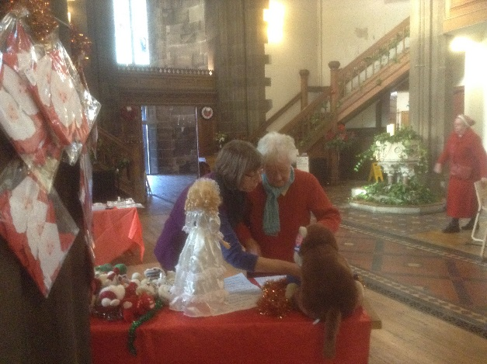

It was lovely to have so many of the “St Mary’s Team” (new and old) together in Church enjoying themselves and making some money at the same time! We banked the sum of £452 from the stalls with items still on sale through the church shop.
A wonderful effort from all involved and a big thank you to all who came to help on the day. It was nice to have with us representatives from CLC, the Norbury Handbell Ringers and our very own “Santa Clause”. Thanks to Gresty’s Florests and Cheshire Weddings for floral displays.
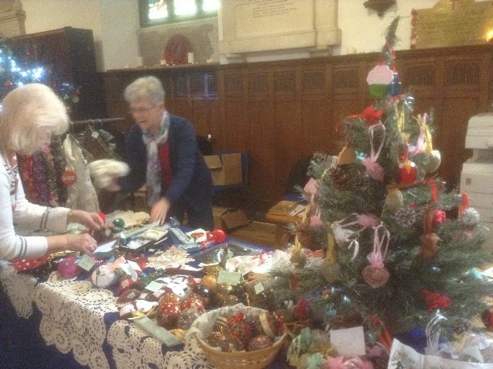

Pat Newsham
Roger Scoones, the Rector writes:
Pat was one of those people whom it is impossible to ignore or forget. Despite her appearance, there was in Pat, a woman of great spirit, independent mindedness, intelligent , imaginative and determined to get on with life despite everything. Life was not easy for Pat, for as long as I have known her; but her sense of right and wrong, strongly supported by her intuitive Christian faith, which had been nurtured in more than one church along life's path, helped her to keep going. Her artistic skills were of the naive kind, vigorous, engaging and perceptive, interpreting the world as she saw it in her own inimitable style. One couldn't help but admire the amount of thought and effort Pat put into her drawings, even if one was left asking oneself how exactly she managed to convey to paper what she had seen. Her portraits were amusing and her drawings of large buildings, like St.George's, of which she was particularly fond, crammed onto one page of her little sketchbook, which she always carried with her, defied imagination.
Although Pat m0oved on in her church membership many years ago, she still retained an affection for St. Mary's , and was often seen coming into the Tuesday lunchtime service, clutching her bag, which I knew contained her sketchbook. I was never allowed to escape before Pat had shown me her latest works of art, which were obviously very precious to her, and gave Pat great satisfaction in undertaking and showing to others , especially those whom she knew would appreciate them. In recent years Pat would also appear from time to time at the Sunday morning service at St. Mary's , when her services were not required in the choir at St. George's .
Sadly Pat's life came to an end suddenly and alone . However, she was not alone in spirit, as she was much loved and appreciated by those of us who were privileged to know her in this life. Her Christian faith carried her through life and she has obtained her reward. God blessed her in many ways in this life and she is now with Him forever.
I will always remember this unique endearing lady ,as someone who sought to give rather than to receive , a gifted lady whose goodness shone out of her and her sketchbook, the pages of which I shall miss seeing week by week, and my saying " yes , very nice Pat, but I must go and take a service now!"
Pat Newsham will be greatly missed at St. Mary's and by all who knew her. May she rest in peace and rise in glory.
members of the Sunday congregation and one from a local Baptist Church, sat in the front row and listened and sang together. How things have changed since those early days!
During the past year that same service has on more than one occasion seen an attendance of more than 40! Never let it be said that the church is dying! The church is changing to meet the needs of the community today! Some 17 years ago I was invited by the then Bishop of Stockport "to put St. Mary's back on the map", which it now is! If you Google Earth you will find us.......” St. Mary's in the Marketplace"!
I shall end as I began, by wishing you a Very Happy New Year, and a prayer that the Holy Spirit will lead you into exciting new ways as together we experience this fast changing world, in which only our Lord, Jesus Christ remains THE SAME YESTERDAY TODAY AND FOREVER!

Rev. Roger Scoones
Rector, St.Mary's Stockport

Advent Candle

On the Sunday before Christmas Emily and Kenneth, members of the St. Mary's family, lit the four Advent candles together and alone, watched by their admiring and respective Grandmothers. This is the first time that children have lit the Advent candle alone without the aid of adults.

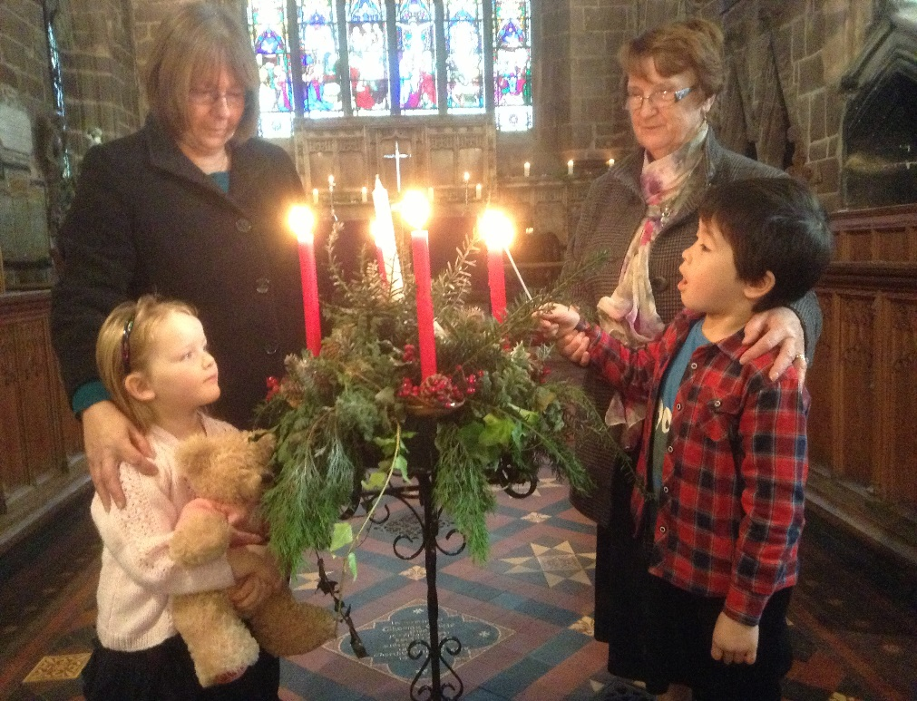

SHOE BOXES FOR OPERATION CHRISTMAS CHILD 2013
A BIG THANK YOU TO ALL THE MEMBERS OF St. MARY'S AND FRIENDS WHO GIFT-FILLED SHOE BOXES, GAVE ITEMS FOR THE BOXES OR GAVE DONATIONS FOR THEIR TRANSPORTATION.
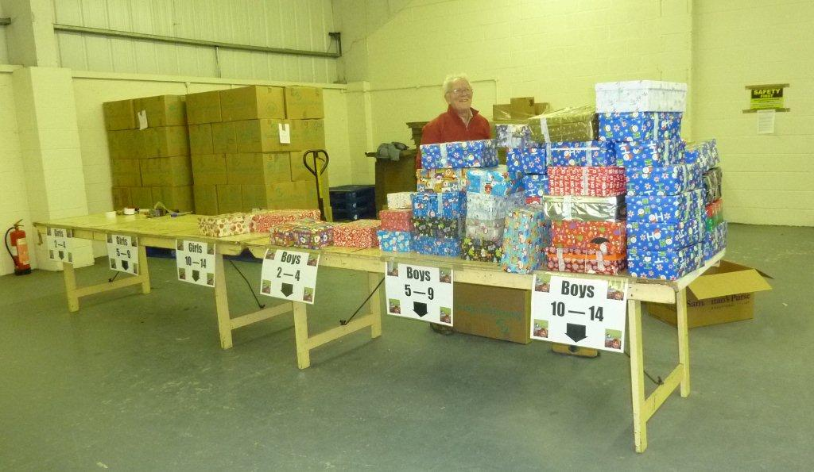
I VOLUNTEERED AGAIN AT THE WAREHOUSE PROCESSING AND PACKING THE SHOE BOXES. CONTAINERS EACH WITH OVER 8,000 BOXES WERE LOADED FOR RWANDA, SWAZILAND AND KYRGYZSTAN SO NOW ARE ON THEIR WAY BY SEA TO AFRICA AND ASIA. ANOTHER LOAD HAS GONE TO UGANDA. THE REMAINING BOXES WERE LOADED ON A LORRY AND BY THE TIME YOU READ THIS WILL HAVE ARRIVED IN BELARUS AND BEEN DISTRIBUTED TO THE CHILDREN AT CHRISTMAS. THE BOXES YOU ALL BROUGHT TO St. MARY'S WERE GOING TO KYRGYZSTAN WHICH THRILLED ME AS THAT IS WHERE I WENT TO DISTRIBUTE THE BOXES BEFORE AND SO MANY OF YOU HAVE SEEN PHOTOS OF THE CHILDREN RECEIVING THEIR BOXES AND SEEN THEIR FACES AND REACTIONS. THE CHILDREN IN ALL THESE COUNTRIES LIVE IN SUCH POVERTY AND YOUR GIFTS WILL BE THE FIRST PRESENT THAT THEY HAVE RECEIVED AND BRING THEM JOY AND SURPRISE THAT SOMEONE CARES FOR THEM.
Crossword

Across
1 ‘Again Peter denied it, and at that moment a — began to crow’ (John 18:27) (4)
3 Fetters (Job 33:11) (8)
8 Perform on a musical instrument (1 Samuel 16:23) (4)
9 Paul describes it as ‘the third heaven’ (2 Corinthians 12:2–4) (8)
11 Loyally (Deuteronomy 11:13) (10)
14 Hens? Me? (anag.) (6)
15 Not visible (Matthew 6:6) (6)
17 Predicted site of the final great battle (Revelation 16:16) (10)
20 Jacob’s youngest son (Genesis 35:18) (8)
21 One of Zophar’s eleven sons (1 Chronicles 7:36) (4)
22 For example, London, Paris, Rome (8)
23 United Society for the Propagation of the Gospel (1,1,1,1)

Down
1 Favourite church activity: Fellowship round a — — — (3,2,3)
2 Divinely bestowed powers or talents (8)
4 Pile together (1 Thessalonians 2:16) (4,2)
5 Commanded to justify (John 8:13) (10)
6 Timothy’s grandmother (2 Timothy 1:5) (4)
7 Killed (Psalm 78:34) (4)
10 One of Graham Kendrick’s best-known songs, — — King (3,7)

WE PROCESSED AND PACKED 36,300 BOXES AT THE MANCHESTER AREA WAREHOUSE WHICH IS WONDERFUL IN THE CURRENT ECONOMIC SITUATION.
A FEW PHOTOS SHOW THE BOXES AFTER BEING SEALED WITH THE SPECIAL CUSTOMS TAPE ARE SORTED INTO THE DIFFERENT AGE GROUPS AND PACKED INTO CARTONS. EACH CARTON IS LABELLED WITH THE NUMBER OF SHOE BOXES AND CHILDRENS AGE AND STORED ON THE PALLETS AWAITING THE LORRY OR CONTAINER TO BE LOADED.
Margaret Forster
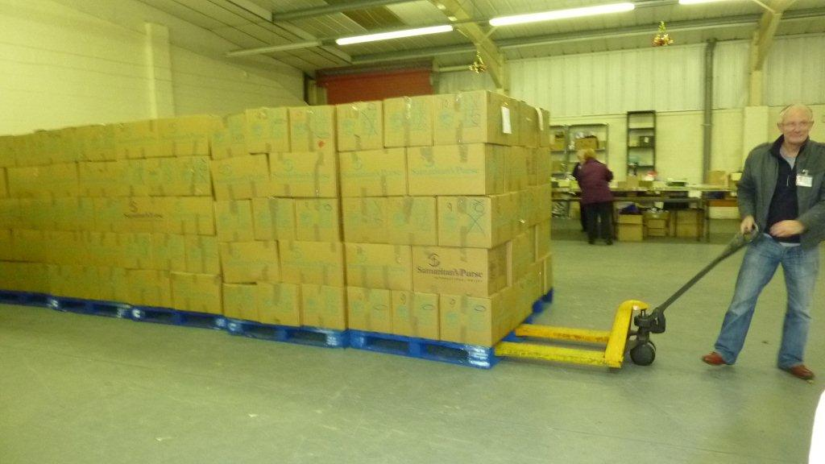

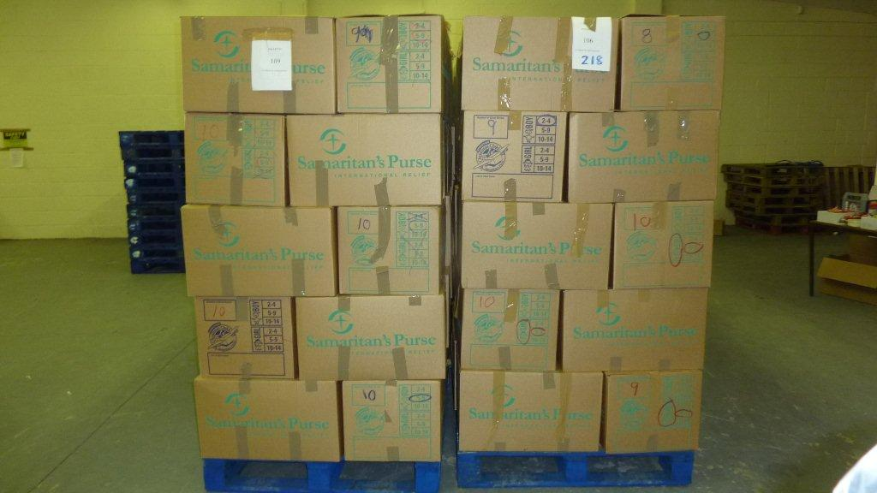

The Nave Café

We are still looking for more volunteers to help us in the café/kitchen, as required during the week (to support Pure Innovations) but especially on a Saturday.

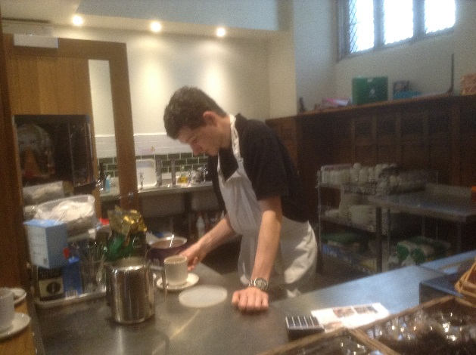
Alec joined us as a church volunteer some weeks ago and has quickly became a valuable part of the team (working on a Friday as well as on a Saturday – and other days as fits his diary and college commitments).

If you wish to volunteer yourself, or know of anyone else who would like give a few hours of their time, or perhaps you know of someone wishing to gain some unpaid work experience (always handy on a CV later on), then please let us know.

We have had a busy Christmas with “specials” including a range of homemade soups with turkey and roast pork Saturday lunch specials. We have provided hundreds of cups of tea / coffee and handed out many boxes of mince pies! And… that was in addition to normal café activities.

Think happy thoughts – and help your immune system
A stressed mind can put your body at risk. If you constantly think about negative things, and dwell on stressful events in your life, you could weaken your immune system and make yourself more susceptible to illness.
A recent study has found that simply thinking about negative events, even if they are only imagined, can increase the levels of inflammation in your body. This inflammation, associated with the body’s response to trauma and infection, can weaken the immune system and has been linked to a number of conditions such as heart disease, cancer and dementia.
St Paul urged a better way of coping with the threats in our lives: “Do not be anxious about anything, but in everything by prayer and supplication with thanksgiving let your requests be made known to God.” (Phill. 4:6)

A DATE FOR YOUR DIARY

STOCKPORT YOUTH ORCHESTRA

the next concert of the Stockport Youth Orchestra
will be held at
St. Mary's in the Marketplace

on

Sunday 23rd March 2014
7.00pm

Coming in February

The Israel Information Centre in association with Stockport Council
MASHAV EXHIBITION
Israel’s Centre for
International Co-operation
At
St Mary’s in the Marketplace
From Tuesday 18th February – Monday 10th March 2014

===========================================================

Advance Notice of the
Women’s World Day of Prayer
Friday, 7th March 2014

Special Service to be held at St Mary’s in the Marketplace at 2pm
Egypt – Streams in the Desert

Saturday, 25th January 2014

Burns Night at the Nave Café
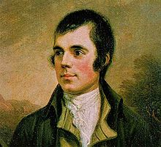
Cock-a-Leekie Soup
Haggis (neeps and tatties)
Cranachan

Tickets available early January.
£12.00

We may not be able to offer the full “Burn’s Night” experience, but if anyone wishes to recite some appropriate verses or just happens to have some bag-pipes hidden away at home (to pipe in the guests/ haggis) – then all offers of entertainment welcome!
Offers to read the “Selkirk Grace” and the “Address to the Haggis” would be appreciated.

And…….. dress code – something in tartan!

Pat Newsham
An appreciation by Frank Hamnett following his attendance at Pat's funeral, on Tuesday 17th December
What does one say about Pat?
She was a person you could not help liking. You spotted her from some distance because she always looked as if she had the world on her shoulders, and at times I'm sure she did!
Pat was born in Bolton in 1938 and moved to Stockport later on in life, at the age of 15 she found herself a job at Garner's farm in Woodford, and worked in the diary for many years, something she loved doing. Being among the cows and delivering the milk was a greater part of her life.
She loved sketching too, and would get great pleasure showing people her latest efforts . I believe she gave Canon Alan Bell one of her works on his retirement from St. George's.
Later on in life when the farming got too hard for her , she went to work at Cheshire Milk Company, where she met her husband-to-be, Roy. Pat and Roy were married in Tiviot Dale Methodist Church. Roy died a few years ago and they leave a son, Richard, who now attends All Saints Church, Heaton Norris, where he sings in the choir. Pat still had a love for the farming world and was a regular visitor to the Young Farmers Show at Romiley. It must have brought all her memories back of days gone by, where her true love for the outdoor life was.
Also something not a lot of people know is that Pat was a member of a dance group. it was nice to see some of her friends from the group at her funeral.
The service to celebrate the life of Pat was held at All Saints Heaton Norris , where Richard attends. It was a lovely service and it was so nice to see so many of St. George's choir join All Saints choir to make a memorable choral service. Pat was a member of St. George's choir and the choirs did her proud.
St. Mary's was represented by present and old members of our church and where made most welcome by All Saints congregation. Richard Garner, Pat's former employer , and his wife, also attended the service.

