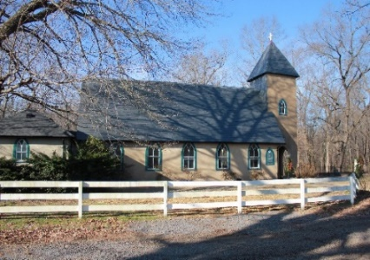
Grace Episcopal Church
Summertime Summertime
Summertime Summertime
Summertime Summertime
Summertime Summertime

Casanova, Virginia 20139

e-mail: gracechurchcasanova@gmail.com website: www.gracechurchcasanova.org

Church
The furnace in the church building was putting out heat on July 11! Not an optimum situation , but it provided yet one more occasion for our flock to experience the true meaning of the Greek word for church “ekklesia” which means “called out.” With the thermostat above 85, I said, “let’s all grab something and head for the Family Life Center” (FLC.) So our congregation, which has over the past year sustained a crash course on the topic “The church is not the building but the people” moved yet again. (A history of our moves in the past year would include moving from outside of the tower to the rectory Oaks for shade, in mid fall moving to the labyrinth for sun, then back to the tower for Christmas, the curb side at church for drive in Lent, church tower for Easter, then to the Parish Hall for inside with restrictions, then back to the church. ) Whew!! So, all right we get it! Under the skylight in the FLC , gathered in a circle, with scripture, bread, wine, and each other, we were church… fully the body of believers on the Lord’s Day doing what we do and being fully “Whose” we are! It was rather glorious, and the Bastille Day breakfast was beyond delicious.
When I was studying my catechism in the Grace Church Hall about 62 years ago before my confirmation, I learned that “the church is the body of which Jesus Christ is the head, and all baptized Christians are the members.” We all had a refresher course together on July 11 and it was rather glorious!
Sunday, 11 July 2021 - Grace Family Ctr
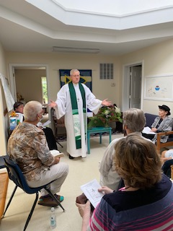
Sunday, 11 July 2021 - Grace Family Ctr 2

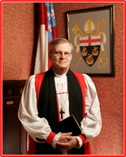 Bishop Ted

FEED MY SHEEP (FMS)
It’s still Summertime and the livin’ Is easy. We are all taking breaks. Picnics, swimming , vacations. Lazy days in the sun. So many things we missed last year. One thing has stayed the same. Families are still struggling to keep their homes, find a job and provide food for their families. Let us not forget how important the Grace family donations are to FMS. Many of our suppliers have “dried up.” Not from lack of food but there are so many organizations that need food. Everyone is stretched thin. May everyone continue to have a blessed and happy summer and not forget our families that may not have the same advantages as we do.
You may send your donations to the Grace Church address - please with this notation on checks: “FMS.” Cash is always welcomed. You may also leave an envelope in the collection plate.
Gods Peace, Carol Grove
SENIOR WARDEN’S REPORT – AUGUST 2021
Dear Grace Family,
In our usual custom, we have suspended Vestry meetings for July and August because many are enjoying a much deserved (after last year’s restrictions) vacation. We pray for safe travels for all! Meanwhile, Grace Church is still in the business of worship and fellowship activities (see “Activities” section of this newsletter.) Please spread the word and bring a friend to Church.
The schedule of servers this month is included in this newsletter as always; however, if I have scheduled you in week that you are unable to serve, please arrange for someone else to cover the duty for you. If you notified me of a time that you would be away and I have forgotten or misunderstood, I ask your forgiveness, please arrange to trade with someone.
As always, volunteers are welcome and the more we have, the less often you will serve.
The Jr. Warden has been at work insuring we don’t again have a heated church in the Summer. The programming that was set for A/C and heat is likely “off” a bit due to our not being in the Church for so long, as well as power outages.
Grace is returning to our occasional serving of Ruritan dinners. If you would be interested in assisting (and eating) please contact Penny DePompa-Davis, (240)893-4049.
The vacationers I mentioned above include yours truly. I will be away during much of August but will still be available by e-mail and text.

Blessings and love on behalf of the Vestry,
Mary
TREASURER’S REPORT – JUNE 2021
Income for the month of June was $7,984.93 (budget $6,267.00); expenditures totaled $6,081.64 (budget $4,543.00) resulting in income for the month of $1,903.29.
The book value of our endowment fund is $60,073.49; market value as of 05/31/21 - $68,989.70.
Please continue to pray for Grace Church that it will grow spiritually, financially and numerically. If you have any questions about this report or any financial matter, please contact me.
Judy Ball, Treasurer

Travis Fields | 3-Aug
Ansel & Melba Hendrix | 3-Aug
Emily Jacobs Johnson | 3-Aug
Art and Sue Payne | 7-Aug
Josh Warren | 7-Aug
Jeannette Cerv | 11-Aug
Marilyn Ottevaere | 14-Aug
Mildred Riddell | 15-Aug
Mary Neal | 16-Aug
Jeff Shipe | 17-Aug
Wesley Moline | 18-Aug
Bob Brewer | 20-Aug
Doris Pearson | 20-Aug
Dale Cirillo | 28-Aug
Nathan Butler | 31-Aug
Ancel Hendrix | 31-Aug

AUGUST BIRTHDAYS AND ANNIVERSARIES

AUGUST SERVING SCHEDULE
Day | Readings | Altar/ Flowers | Reader/ Acolyte | Ushers | Coffee Hosts
1st  Tenth Sunday after Pentecost | 2 Samuel 11:26-12:13a  Psalm 51:1-13  Ephesians 4:1-16  John 6:24-35 | Carol Cordell/  Mignonne Spellmeyer | Bryan Jacobs | Mignonne Spellmeyer/  Carol Cordell | Marilyn Ottevaere/  Sharon Sweeney
8th  Eleventh Sunday after Pentecost | 2 Samuel 18:5-9, 15, 31-33  Psalm 130  Ephesians 4:25-5:2  John 6:35, 41-51 | Sharon Sweeney | Judy Ball | Sharon Sweeney/  Marilyn Ottevaere | Mignonne Spellmeyer/  Dee Garrett
15th  Twelfth Sunday after Pentecost | 1 Kings 2:10-12; 3:3-14  Psalm 111  Ephesians 5:15-20  John 6:51-58 | Pam Ruffner | Barbara Gulick | Sue Ballentine/ Diane Gulick | Sue Ballentine
22nd  Thirteenth Sunday after Pentecost | 1 Kings 8:[1, 6, 10-11], 22-30, 41-43  Psalm 84  Ephesians 6:10-20  John 6:56-69 | Betsy Anderson/  Sharon Sweeney | Betsy Anderson | The Jacobs | Judy Ball/  Barbara Eanes
29th  Fourteenth Sunday after Pentecost | Song of Solomon 2:8-13  Psalm 45:1-2, 7-10  James 1:17-27  Mark 7:1-8, 14-15, 21-23 | Barbara Jacobs /Diane Gulick | Bryan Jacobs | Judy Ball/  Barbara Eanes | Marilyn Ottevaere/  Sharon Sweeney
https://lectionary.library.vanderbilt.edu

ACTIVITIES
Each Sunday: Church service at Grace Church at 9AM with Coffee Hour following at the Family Center
Wednesdays: “The Center” potluck lunch at 12PM at the Parish Hall
Thursdays: Gentle Yoga at 5PM at the Parish Hall
Fridays: Gentle Yoga at 10AM at the Parish Hall
2nd Saturdays: Sewing, quilting, crocheting, knitting, embroidering, cropping, & crafting at 9:30AM, alternating between St. Luke’s and Grace’s Parish Halls
The above activities are open to all. Please come and enjoy the fellowship.

AMAZON SMILE
FOR GRACE CHURCH
Don’t forget to sign up with Amazon Smile to have 0.5% of the purchase price of eligible items given to Grace Church at no cost to you! You can also go to the Grace Church website home page and click on the link there.

*******AmazonSmile Shopping App for Android Users Now Available******
You can now support Grace in the Amazon shopping app on your Android device! Simply follow these instructions to turn on AmazonSmile and start generating donations to Grace from your Android device.
- If you have the latest version of the Amazon Shopping App, open the App on your Android device.
- View Settings and select AmazonSmile.
- Follow the in-App instructions to complete the process.
AmazonSmile is not currently available for IOS users – we’ll let you know when it becomes available.
Flowers by Diane Gulick
Figurines provided by Michael Calhoun
Photos by Diane Gulick

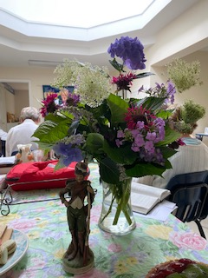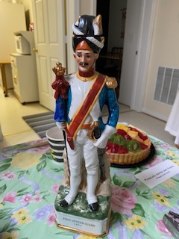
Images above of Sunday worship at the Family Center, remembering Bastille Day (at the request of our talented and highly educated organist, member, and friend, Michael Calhoun.)
~~~~~~~~~~~~~~~~~~~~~~~~~~~~~~~~~~~~~~~~~~
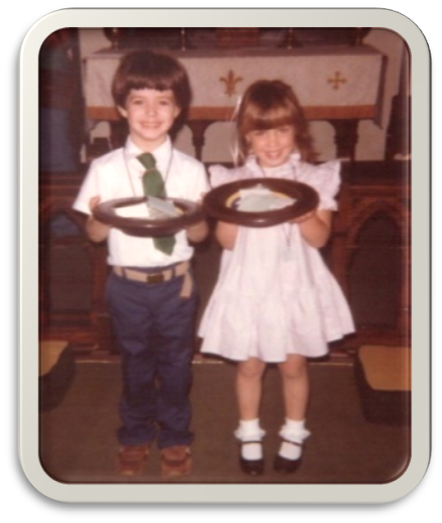
This month’s entry – Do you know these cuties?

From the Grace Archives

Last month

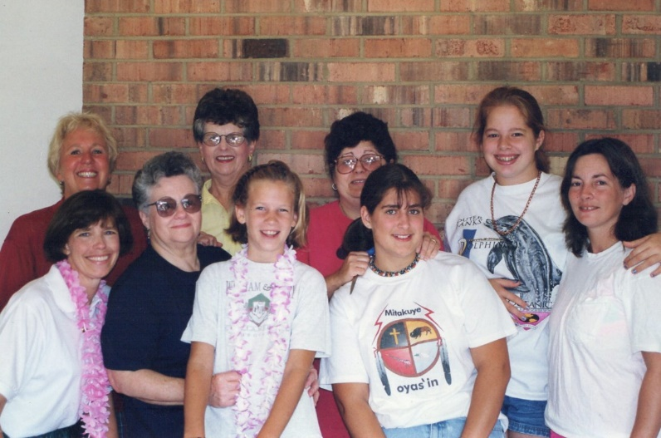
Were you able to identify the individuals in last month’s picture from the archives? They are (from left to right) back row: Charlotte Perry, Drusy Schaeffer, Carol Schaeffer Payne, Shannon Leonard (Perrault); front row: Susan Payne, Judy Shipe, Shannon Schalestock, Katie Payne (Helbock), and Jeannie Leonard. Location: St. Stephens Episcopal Church in Catlett, VA. Occasion: Vacation Bible School. Time period: circa late 1980s/early 1990s, perhaps when Grace & St. Stephens were still yoked.

