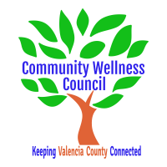
Board Meeting
May 2, 2019
1:00pm-3:00pm Wellness Center

1:00PM-1:10PM

- Call Meeting to Order
- Welcome Guests
- Agenda
- Consent Agenda
  - Minutes of 4/3/19
  - Treasurer Report April
  - Coalition Reports
- Social Media/Website Report
- Consent Exemptions
Business
- Coordinator’s Report (Noelle) 1:10 PM-1:25 PM
- Grant, Grant deliverables/Activities Update (Diana/Noelle) 1:25 PM-1:35PM
- Financial Management Update/Monthly Match (Noelle) 1:35PM-1:45PM
- Anna Age 8 Community Planning Action Lab (Diana/Noelle) 1:50PM-2:00PM
- KAH (Noelle) 2:00pm-2:05PM
- CRUNCH June at Ana Becker Park (All) 2:05-2:20PM
- June 5th Board Planning Retreat (All) 2:20-2:35PM
- OSAP/Community Survey update (Linda) 2:35-2:45PM
- MRGDA Update (Noelle/Diana) 2:45pm-2:50pm
- Review of Activities/Time Line/Action Items 2:50 PM-3:00PM

Additional Items of Discussion
- Adjourn

