CONTINUING EDUCATION

Conference Outcome:

Nurses will apply the knowledge learned about the state of mental health here in Virginia and nature therapy to practice.

CE Opportunity:

The Virginia Association of Community Psychiatric Nurses is approved as a provider of nursing continuing professional development by the Virginia Nurses Association, an accredited approver by the American Nurses Credentialing Center’s Commission on Accreditation.

Up to 6 nursing continuing professional development hours will be awarded.

All professional disciplines are welcome to attend our conferences, however, please note that only members can attend voting sessions during our business meetings.

ABOUT VACPN

VACPN is a group of nurses who are dedicated to the delivery of exemplary mental health services to the state of Virginia. Our purpose is to define and enhance the role of the nurse in the specialties of mental health, intellectual disabilities, and substance abuse; to exchange ideas, models, and experiences; to facilitate networking and mutual support; to promote the improvement of nursing practice; and to promote professional growth.

ABOUT THE LOCATION

Join us for an educational and relaxing conference at Shrine Mont. Re-charge, relax, and become one with nature. Embrace the scenery around you!

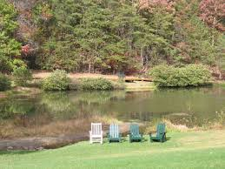

For questions/information, please contact
VACPN Co-Presidents:

Nina Beaman
nina.beaman@aspen.edu

Lisa Babilon
lmbabilon@hanovercounty.gov

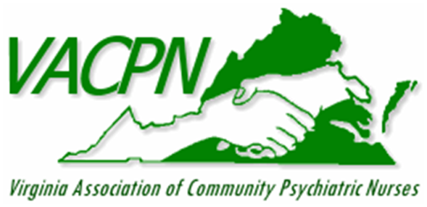

Spring 2022 conference

april 27, 28, & 29, 2022

Post-Pandemic Self-Care: Recovery Through Nature Therapy

An educational conference that focuses on self-care, recovery, and nature therapy.

Shrine Mont
217 Shrine Mont Circle
Orkney Springs, VA 22845

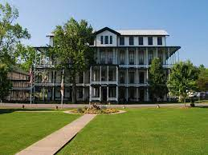

REGISTRATION

Registration & Payment deadline is
April 10th, 2022.
We are unable to offer refunds after this date.

How to register:

1.) Please complete the online registration form on our
website at:
http://www.vacpn.net/Spring-Conference-Event.html

2.) The conference fee is
$365 for VACPN members and non-members.
This includes registration, room, meals, snacks, CE hours, and PayPal fee.

In-Person Vendor Fee: $650.00

This fee can be paid online via our website with registration.

We are unable to accept payment at the door.

PROGRAM AGENDA

Wednesday, April 27th, 2022

3:15 PM: Check-in begins

5:30 – 6:30 PM: Dinner

Thursday, April 28th, 2022

8:00 – 9:00 AM: Breakfast

8:45 – 9:00 AM: Registration

9:00 – 9:15 AM: Welcome and Announcements by VACPN Co-Presidents Nina Beaman and Lisa Babilon.

9:15 – 10:30 AM: Keynote Speaker: Senator Deeds; “The State of the Commonwealth’s Mental Health”.

10:30 – 10:45 AM: Break

10:45 AM – 12:00 PM:
VACPN Business Meeting

12:00 – 1:00 PM: Lunch

1:00 – 2:00 PM: Speaker/Workshop: Michelle Zehr, M.A., M.Ed.: “Experiential EcoHealing: How the Earth Cares for Us” – EcoHealing: Fire

2:00 – 2:15 PM: Break

2:15 – 3:15 PM: Speaker/Workshop: Michelle Zehr, M.A., M.Ed.: “Experiential EcoHealing: How the Earth Cares for Us” – EcoHealing: Water

3:15 – 4:00 PM: Adjournment: VACPN Co-Presidents

4:00 – 5:30 PM: Free Time

4:15PM- ** Guided Hike meet in Lobby

5:30 – 6:30 PM- Dinner

6:30 - 8:30 PM- Socialize and Games in Lobby

Friday, April 29th, 2022

8:00 – 9:00 AM: Breakfast

8:45 – 9:00 AM: Sign-In

9:00 – 9:15 AM: Announcements by VACPN Co-Presidents

9:15 – 10:30 AM: Speaker/Workshop: Michelle Zehr, M.A., M.Ed.: “Experiential EcoHealing: How the Earth Cares for Us” – EcoHealing: Air

10:30 – 10:45 AM: Break

10:45 AM – 12:00 PM: Speaker/Workshop: Michelle Zehr, M.A., M.Ed.: “Experiential EcoHealing: How the Earth Cares for Us” – EcoHealing: Earth

12:00 PM: Evaluations

12:15 PM: Adjournment by VACPN Co-Presidents

12:15 – 1:00 PM: Lunch

