OUTDOOR TRACK
Boys and girls from many of the 95 or so schools in the nine leagues forming Section II compete during the spring season in track & field. Teams from all leagues in Section II compete in varsity track & field even though some schools do not have their own track venues. In a given year there are approximately 79 teams making up the seven leagues comprising local track & field competition. Some leagues conduct only co-ed meets and others with larger teams, conduct single sex meets. Some leagues have scoring junior varsity competition and some have modified team competitions. Varsity league meets, except for their championships, typically do not exceed four schools.
Locally, outdoor venues belong to high schools, none of which have their own indoor track venues. Today’s track is usually 400 meters long; most local tracks have grass infields although some are replacing grass with turf and many have lights so meets can be conducted into the evening hours. Many local venues are used for both league and invitational competitions. Invitational meets are usually held on the weekend and league meets typically occur after school hours during the workweek. Most meets, during outdoor track, are not time constrained and the atmosphere is not nearly as hectic as during indoor meets.
Other outdoor track venues conducting local high school meets and/or invitational are at Union College and Knox Field in Johnstown. Teams might attend an invitational competition from other areas, states and countries. Section II athletes compete at events throughout the United States attending some of the largest invitational and championship meets in the country.
In the Capital District, outdoor track & field has been competed at the scholastic level since the early part of the 20th century. A Section II Officials organization was formed in the early 1970’s and is currently known as the Capital District Track Officials (CDTO). During outdoor track, two certified officials typically oversee league meets; these two officials will be a starter and finish line judge. At league meets, most of the field events are conducted by coaches or volunteers provided by the host school.
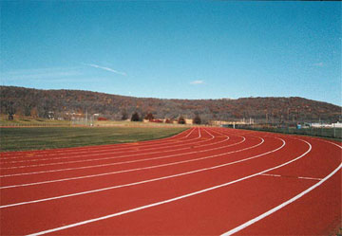
At championship and invitational meets additional officials are usually assigned to cover each of the events being competed and the host school provides helpers and official vouchers. At league meets eleven running events and six field events are competed. An invitational can consist of more and different events than would be held at a league meet. Relay Invitational events including running and field relays of all types are held in the area. Some invitational meets also include races at the mile and two-mile distances; some even include the Javelin.

Normal outdoor league Varsity events for girls/boys in Section II are:
High Jump 3200-meter relay 400-meter intermediate hurdles
Pole Vault 100-meter dash 800-meter run
Long Jump 100/110-meter high hurdles 200-meter dash
Triple Jump 1500/1600-meter run 3000/3200-meter run
Shot Put 400-meter run 1600-meter relay
Discus 400-meter relay

