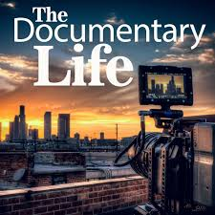 PBL: DOING A DOCUMENTARY!
Within your flexible groupings… 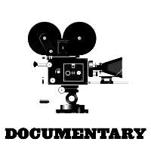

ROLES: Designate who is going to be responsible for various tasks.
RESEARCH: What is the purpose? What does it look like? What information is to be
provided? What questions are to be asked? How is it to be distributed?
RECORD: Itemize a list of specifics for your final product; materials, resources?
RESPOND: Make a plan of action to create your documentary story line(s). Steps,
timeline, duties, etc… Create! Produce, direct your plan!
DELIVER: Present your final product.
Get to it! You are going to be working together to produce a documentary using the Learning Objectives and Essential Questions for the chapter – that would be applicable for the setting (time & place) of your topic. The special focus of your documentary is to provide insights into what social conditions exists/existed and how you could/would respond through educating the public that would identify the main ideas, problems and provide solutions while promoting justice, liberty, prosperity, human rights and security for all members of the viewing audience. First, you must know the problems, their causes and effects. you should provide realistic solutions to the problems. finally, Keep in mind your historical context! What about sports, entertainment, and dditional marketing and business opportunities?

Scoring Rubric Guidelines: Accuracy, Completeness, Neatness, Originality, Presentation

