EQUINE HAVEN Ltd
Jumper Series Horse Shows

Ribbons to 6th place; Prize Money to 5th place.
Champion and Reserve Champion in Each Division
Points Earned for Equine Haven Year End Awards
Entries Limited to 50 Riders/Day
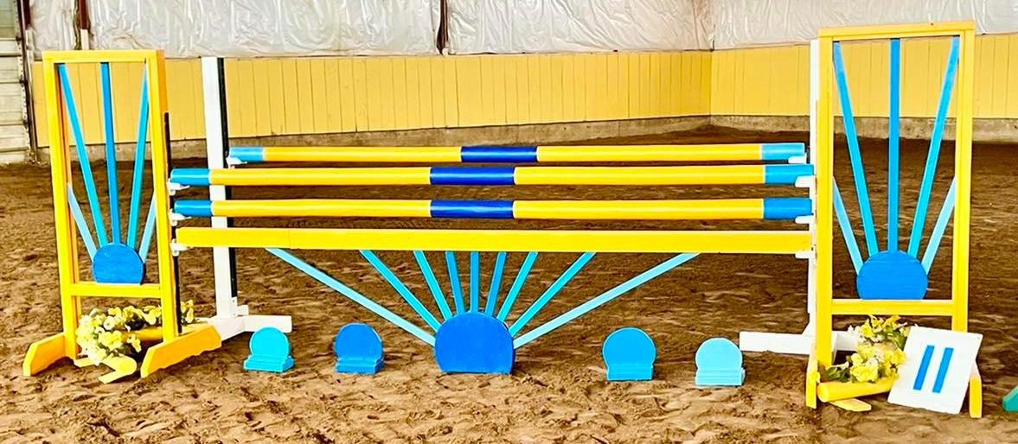
Course Designer: Crystal Turko
Judge: Sadie Turko
General Inquiries and Entry Forms: info@equinehaven.ca
E-transfers for entry fees can be sent to sadie.turko@equinehaven.ca
Equine Haven Jumper Series Horse Shows

Feb 10-12th, Mar 3-5th, Apr 21-23rd, Jul 7-9th, Sep 22-24th, Nov 10-12th, Dec 8-10th
Entries due 1 week before the show

Ribbons to 6th.

Champion and Reserve awarded for each division at every show and Year End awards for each division.

$35 Office Fee.

$15 Paramedic Fee.

$20 Accumulator Speeds.

$20 Scored Jumpers. (Rounds are judged similar to hunters or young horse classes and are looking for jumper suitability. Bonus points are earned on things like form, timely lead changes, and smooth inside turns. Points will be deducted for things like unsteady lines, rails down, or stops.)

$40 Equitation Add Back Stake Classes. (Will be a combined score for the flat portion and the over fences portion.) ($15 added back as prize money.)

$40 Jump Off Add Back Stake Classes. (Everyone can do the Jump Off if they want but will place according to how they actually did in the first round with ties for first broken by the jump off) ($15 from each entry will be added back as prize money)

Prize Money awarded as follows: 1st – 30%, 2nd – 25%, 3rd – 20%, 4th – 15%, 5th – 10%.

Save $10 by entering whole division.

If less than 3 people in a division, consecutive divisions on the same day may be combined.

No one gets Eliminated as long as you keep trying (and get back on if necessary) and finish your course!

New for 2023, introducing the:

Twist Thoroughbred Memorial Award
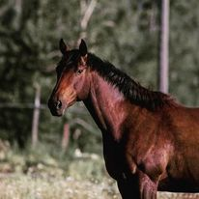

In memory of Twist (JC: Tea Tree 2012-2022), we are happy to announce a High-Point Award for Thoroughbreds for our 2023 Jumper series.

Year End Award is a $250 Greenhawk Gift Card

If there is enough interest a smaller prize will be awarded after our Spring, Summer, and Winter series of shows.

Thank you, Heather Dorosh, for your generous donation. What a beautiful way to memorialize Twist. She is definitely missed around the barn.
For Our Winter Series Shows (Feb, Mar, & April):
Presented by Hub International

Hi-Point Awards!

Categories
Junior - 17 & Under
Adult – 18+
Overall

Prizes: $50 Gift Card to Prairie Rose Equestrian for the Jr & Sr Hi-Point awarded at each of the winter series shows.
https://www.prequestrianboutique.com/

OVERALL Hi-Point awarded to the person with the highest number of points over our 3 winter series show. Beautiful Amigo cooler and $200 gift certificate to Paramount’s show series.

Class List

Saturday

Division 1: Beginner Jumper (Trotting only) (Shorter, simpler courses) $70/division
1. Scored Jumper over poles $20
2. Scored Jumper over 6” X-Rails $20
3a. Equitation flat portion
3b. Equitation Add Back Stake over 6” X-Rails $40

Division 3: 15” X-Rail Jumper $90/division
7a. Equitation flat portion
7b. Equitation Add Back Stake $40
8. Scored Jumper $20
9. Table A 2.2 Jump Off Add Back Stake $40

Division 5: .55m Jumper (No oxers), $90/division
13a. Equitation flat portion
13b. Equitation Add Back Stake $40
14. Scored Jumper $20
15. Table A 2.2 Jump Off Add Back Stake $40

Division 7: .7m Jumpers, $90/division
19a. Equitation flat portion
19b. Equitation Add Back Stake $40
20. Accumulator Speed $20
21. Table A 2.2 Jump Off Add Back Stake $40

Division 9: .85 Jumpers, $90/division
25a. Equitation flat portion
25b. Equitation Add Back Stake $40
26. Accumulator Speed $20
27. Table A 2.2 Jump Off Add Back Stake $40

Division 11: 1.0m Jumpers, $90/division
31a. Equitation flat portion
31b. Equitation Add Back Stake $40
32. Accumulator Speed $20
33. Table A 2.2 Jump Off Add Back Stake $40

Sunday

Division 2: Novice Jumper (trotting only) (Shorter, simpler courses) $70/division
4. Scored Jumper over 9” X-Rails $20
5. Scored Jumper over 12” X-Rails $20
6a. Equitation flat portion
6b. Equitation Add Back Stake over 12” X-Rails $40

Division 4: .45m Jumper (No oxers) $90/division
10a. Equitation flat portion
10b. Equitation Add Back Stake $40
11. Scored Jumper $20
12. Table A 2.2 Jump Off Add Back Stake $40

Division 6: .6m Jumpers $90/division
16a. Equitation flat portion
16b. Equitation Add Back Stake $40
17. Scored Jumper $20
18. Table A 2.2 Jump Off Add Back Stake $40

Division 8: .75m Jumpers, $90/division
22a. Equitation flat portion
22b. Equitation Add Back Stake $40
23. Accumulator Speed $20
24. Table A 2.2 Jump Off Add Back Stake $40

Division 10: .9m Jumpers, $90/division
28a. Equitation flat portion
28b. Equitation Add Back Stake $40
29. Accumulator Speed $20
30. Table A 2.2 Jump Off Add Back Stake $40

Division 12: 1.05/1.10m Jumpers, $90/division
34a. Equitation flat portion
34b. Equitation Add Back Stake $40
35. Accumulator Speed $20
36. Table A 2.2 Jump Off Add Back Stake $40

EQUINE HAVEN 2023 ENTRY FORM

WAIVER
I understand that I enter the Equine Haven Schooling Show and participate in horse activities at my own risk. I or any person related to me will not hold Equine Haven, owners, partners, staff, volunteers, or paid officials, responsible for any injury or damages to myself, horses, or equipment.
SHOW ENTERING _______________________________________________________________________________________________________________________________________
RIDER’S NAME _______________________________________________ SIGNATURE __________________________________________________ DATE ____________________,2022
AGE(IF UNDER 18) ______ GUARDIAN’S SIGNATURE _______________________________________________ EMAIL _____________________________________________________
HORSE _____________________________________________________ TRAINER_________________________________________________PHONE #____________________________
TRAINERS EMAIL ___________________________________________________________STABLE________________________________________________________________________
PLEASE INDICATE DIVISIONS OR INDIVIDUAL CLASSES YOU ARE ENTERING BELOW. (You save $10.00 by entering a full division.)
DIVSIONS ENTERING _______________________________________________________________________________________________________________________________________
INDIVIDUAL CLASSES ENTERING ______________________________________________________________________________________________________________________________
 |  |  |  |  |  |  | _{TOTAL}
Total of classes or divisions entered
FRIDAY SCHOOLING: $25.00
OFFICE FEE: $35.00 |  |  |  |  |  |  | $ 35.00
PARAMEDIC FEE: $15.00 |  |  |  |  |  |  | $ 15.00
DAY STALL: $35.00 (please circle) | Friday | Saturday | Sunday
2 DAY STALL with OVERNIGHT LAYOVER: $90.00 (please circle) | Friday -Saturday | Saturday - Sunday
ALL WEEKEND STALL: $120.00 (Friday - Sunday
TOTAL
G.S. T
TOTAL
PRIZE MONEY
COMMENTS:
PLEASE FILL IN THE TOTAL AMOUNT FOR YOUR ENTRIES AND STALL FEES.
THERE ARE ONLY A LIMITED NUMBER OF STALLS (includes bedding) AVAILABLE.
PLEASE CONTACT SADIE @ 250-520-2018 FOR AVAILABILITY BEFORE ENTERING.
PRIZE MONEY WILL ONLY BE PAID UPON SIGNOUT AT THE SHOW OFFICE
(IF YOU HAVE QUESTIONS, PLEASE CONTACT US at info@equinehaven.ca OR CALL/TEXT 250 520 2018(Sadie)/403-973-9693 (Heidi)). PLEASE E-MAIL ENTRIES AND E-TRANSFERS TO sadie.turko@equinehaven.ca

Show Details
ADMINISTRATION: Equine Haven Ltd reserves the right to cancel or combine any given classes that do not fill to their satisfaction. All exhibitors in cancelled classes will be notified by either email or telephone (if number is provided on entry form) and any entry fees refunded. No advanced notification will be given for combined classes.
ADMINISTRATION: Equine Haven Ltd Summer Series Horse Shows are open to all riders; however, we reserved the right to refuse any entry, to make changes to arena classes run in, judges, or class order to best facilitate the running of the show. We also reserve the right to start each division up to 30 minutes earlier than the posted schedule if number of entries permit.
SAFETY: The judge reserves the right to eliminate any horse/rider combination that exhibits excessive speed, abuse to the horse, unsafe or unsportsmanlike behaviour, or lack of control, with no refund of fees.
ENTRY FORMS: Please fill out one entry form per horse/rider combination.
CANCELLATION POLICY: Cancellation before closing date of entries will receive a full refund. Cancellation after closing date but before the start of the horse show will receive a refund less the office fee. Cancellation after the start of the horse show, with proof of Vet Certificate, class fees for remaining classes will be refunded.
ADD/SCRATCHES: There will be no charge for adds/scratches the day before classes for horses already entered. Same day adds/scratches are acceptable but at a $10 charge, in addition to the class fee. Classes scratched the day before will be refunded; however, same day scratches are non-refundable.
LATE FEES: Entries received after the closing date for the show will pay a post entry fee of $20. Horses showing in a class without being entered will pay DOUBLE the class fee.
OPEN SCHOOLING/WARM-UP: Open schooling will be held on Fridays, and can be booked from 9am to 9pm (last schooling available to start at 9pm). Coaches may book schooling times for their students. A maximum of 6 riders allowed in the ring at any one time. Time allotment for schooling is based on number of riders per block. Cost is $25/rider. Warm ups will be held in the indoor arena prior to the commencement of each group of riders.
ACCOMODATIONS: Day stalls are available for a fee of $35/day, overnight stalls are $100 for the weekend. Bedding is included. Stalls are limited and priority will be assigned in the order entry forms are received.
HAUL INS: Trailering in is welcome for no additional fee; however, all horses and riders must be entered in the show and be assigned a number. Space for RVs will be made available on request. There will be no service hookups.
REFUSALS: Riders with two refusals will not be buzzed out of the ring. The top pole of the fence refused twice will be dropped to the ground and the rider will be allowed to continue to the conclusion of the course. Riders with 2 or more refusals will be placed last, but not eliminated.
PROTECTIVE HEADGEAR: All competitors must wear proper fitting and approve headgear, with safety harness correctly secured, at all times while mounted on the event grounds. Helmets must meet ASTM standards and display the SEI seal. The British standard BSI is also acceptable. Any rider found violating this rule will be prohibited from further riding on event grounds until a helmet is properly in place.
DOGS: No dogs are permitted on the event grounds.
ADD BACK STAKES: $15 from each entry will be added back as prize money. Distribution of prize money will be done according to the following: 1st – 30%; 2nd - $25%; 3rd – 20%; 4th – 15%, and 5th – 10%. Prize money will only be paid upon sign out at the show office.

CONCESSIONS: Concessions will be available for sale on site.
SEATING: Please bring your own chairs for viewing ring.
SCORED JUMPERS: Rounds are judged similar to hunters or young horse classes and are looking for jumper suitability. Bonus points are earned on things like form, timely lead changes, and smooth inside turns. Points will be deducted for things like unsteady lines, rails down, or stops.

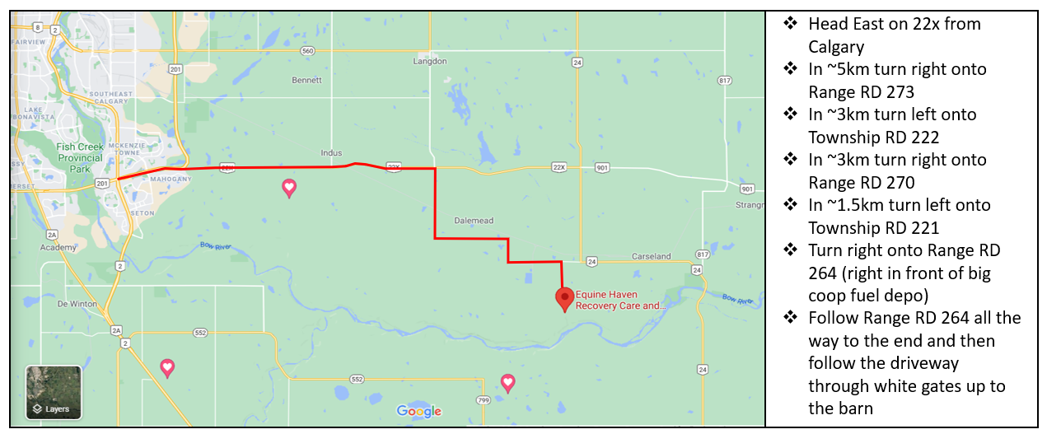
Please contact Heidi at 403-973-9693 if you require help with directions.

