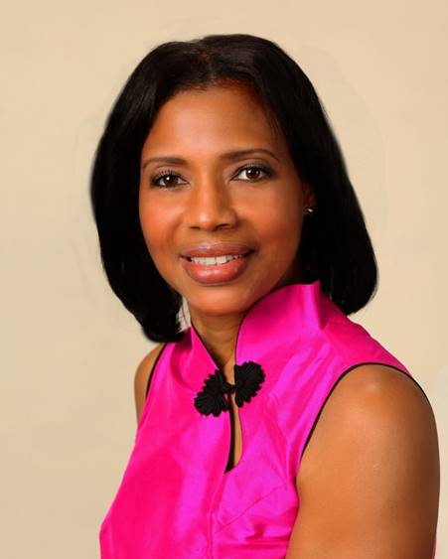
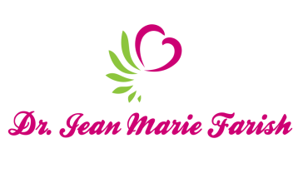

LOVE LIGHT NewsLetter

I am excited to host my VoiceAmerica Empowerment Show-LOVE LIGHT with amazing Guests to cultivate a lifestyle of love and wholehearted connections through worthiness. My show is aligned with my mission to live an altruistic and heart centered life.

MEET LOVE LIGHT GUEST

CHRISTOPHER AUNE
Master Life Coach

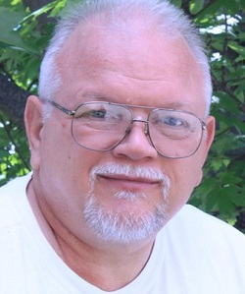

MARCH 13, 2020
KEYS TO LIVING A SPIRITUAL LIFE
He explains the reality of spirituality in terms of simplified physics. It will end confusion, and we will learn how to practice spiritual living with deep understanding.

ABOUT CHRISTOPHER AUNE

Christopher means “carrier of spirit energy”. Christopher Aune is a decorated veteran, published author, and Master Life Coach. He’s one of those people who, when you hang out with him, the wisdom of the ages sort of rubs off on you. And he might have just the thing for people who are seeking the key to a better life. Christopher admits that he was confused by religion for a long time, so he went to the source. He read the ancient scriptures in their original language. He untangled religion and spirituality by writing a series of essays that became a book. For the last 12 years he’s been a teacher of what he calls “the reality of spirituality.” He says that ancient spiritual writings and modern quantum physics talks about the same reality, only using different terms. He applies cutting-edge science to understand ancient spiritual writings. He seems to have discovered some keys to living a less crazy, better life. Now, he’s writing a new book with the working title, Magic in the Making: The Master’s Way. It explains how to live in spiritual reality.

What does Jesus really teach? Christopher Aune’s groundbreaking new book, The Simple Way of Jesus, examines the original words of the Bible as Jesus used them. When 2,000 years of religion, dogma, and doctrine are stripped away, the real meaning of the original Greek is revealed. What he finds will surprise you.

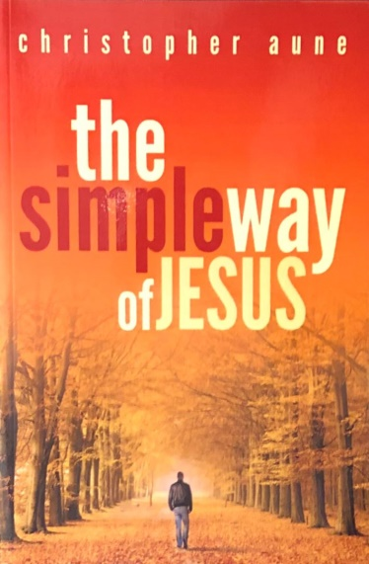
Contact Information
ChristopherAune-Master LifeCoach@GrandpaChristopher
https://christopher-aune.blogspot.com/
Twitter @Christopheraune
LinkedIn at Christopher Aune

Christopher’s Message
“We are energy beings. We are love. We are light.”

