Table of Contents
1 OVERVIEW 3
1.1 Historical Perspective 3
1.2 Effective Use of Electronic Files 3
1.3 Separate Form for Designs Requirements and Operating Parameters 3
1.3.1 Advantages of Separate Form Content 4
1.4 Basic Philosophies 4
1.5 Multiple Edit Sessions and Revision Management 4
1.5.1 Continuing Reminder to Resolve All Properties or Identify as Not Applicable 4
1.5.2 Enhanced Data Formatting Assist Commenting 5
1.6 Typical Documentation Requirements 5
1.7 Suitable for Intended Use Concept 5
1.7.1 Responsible Organization identification is Clearly Documented 5
1.7.2 Title Block with User Specified Subtitle 6
1.7.3 Specification Identifications Required Document Number 6
1.7.4 Administrative Identification Modeled Hierarchy Properties 6
1.7.5 Service Identifications Project Specific Suitable for Use Concept 7
1.7.6 Component Design Criteria Project Specific Suitable for Use Concept 7
1.7.8 Material Flow Conditions Data Suitable for Use Concept 8
1.7.9 Material Flow Conditions for Preliminary Sizing Calculations 8
1.7.10 Process Design Conditions Data Suitable for Use Concept 8
1.7.11 Material Properties Design Conditions Data Suitable for Use Concept 9
2 PROCESS OPERATING CONDITIONS FORMS 9
2.1 Line Process Data 9
2.2 Line Operating Parameters Form 10
2.2.1 Process Variables for all Flow Applications and Representations 10
2.2.2 Copy Data from Line to a Flow Device Operating Parameter Form 11
2.2.3 Copy Data from Line to Temperature Device Operating Parameter Form T1001 12
2.2.4 Copy Data from Line to Valve or Regulator Device Operating Parameter Form C1001 12
2.2.5 Copy Data from Line to Off-line Flow Device Operating Parameter Form F1001 13
2.2.6 Copy Data from Line to Off-line Pressure Gauge Device Specification Form P2001 13
2.2.7 Copy Data from Line to Analysis Device Operating Parameter Form A1001 14
2.2.8 Copy Data from Line to Analysis Device Operating Parameter Form A1002 15
2.3 Level Measurement Process Data 15
2.4 Level Operating Parameters Form 15
2.4.1 Process Variables for all Level Applications and Representations 15
2.4.2 Level Material Conditions Data Suitable for Use Concept 16
2.4.3 Level Material Conditions for Sizing and Measurement Range Calculations 17
2.4.4 Level Process Design Conditions Data Suitable for Use Concept 17
2.4.5 Copy Data from Level Form to Temperature Device Operating Parameter Form T1001 17
2.4.6 Copy Data from Level Form to Pressure Device Operating Parameter Form P1003 18
2.4.7 Copy Selected Data to Instrument Index Data Table 18
2.5 Simple Device Specification Form Operating Parameters 18
2.5.1 Directly Entering Process Data into Simple Device Specification Forms 18
2.5.2 Process Variables Optimized for the Form Title Component Type 19
2.5.3 Copy Data from Operating Parameter Form to Simple Device Specification Form 19
2.6 Complex Device Specification Form Operating Parameters 19
2.6.1 Directly Entering Process Data into Complex Device Specification Forms 20
2.6.2 Copy Data from Operating Parameters Form to Complex Device Specification Form 20
3 General or Special Requirements 20
4 Data Exporting for External Applications 20
Appendix A - Definition of terms 21

1 OVERVIEW
Instrument Specs and Index aims to provide crowd sourced tools for instrument device design documentation to optimize the “suitable for use” determinations and facilitate documenting a complete device specification.

1.1 Historical Perspective

A perspective of the magnitude of available Operating Parameters specification forms over the last 40 years is identified by comparison to two major publishing as shown below.

Form Basis | ISA 20  1981 | ISA-TR20-00.01 | InstrumentSpecsandIndex  2020
 |  | 2001
Operating Parameters forms | 0 | 10 | 18

These specification documentation work processes and user interface techniques have been in use for decades in large integrated software applications but are unknown to previously have been available for individual form files.

1.2 Effective Use of Electronic Files

These specification forms utilize dropdown list of preferred data values for most fields, which enables the originating specifier, collaborators, or packaged equipment suppliers to complete the forms with operating property terminology that is highly consistent and normalized. Therefore, the effective information exchange between the specification originator and the recipient, should be these electronic Word specification document files. These files can be easily edited with full functionality by any external party using Word.

Electronic specification form files enable the following:

- Work sharing which incorporates the recipients expertise in an efficient work process
- Import copying of electronic data which avoids significant errors that are prevalent in manual data entry or copying

1.2.1 Numeric Data Validation

Numeric data validation is enforced for such properties that can have their numeric values Electronically Data Interchange (EDI) with external files that require valid data types.

When the user enters text data into such validated numeric data entry fields and tries to exit that field; the application will produce a warning sound and the status bar at the bottom of window will display the following message:
The user will then need to enter valid numeric data before moving to another location.

These macros enabled Microsoft Word® specification forms are designed for electronic file editing and integration with Microsoft Excel® and external software applications, using integrated XML technology. For their effective use, all files need to be located at a drive and folder location accessible to all intended internal project users.

1.3 Separate Form for Designs Requirements and Operating Parameters

The Operating Parameters forms enable the user to document process conditions for an instrument or line and use the data as a reference source for instrument Device Specification forms. Its data is generally entered and owned exclusively by the Responsible Organization’s various departments.

1.3.1 Advantages of Separate Form Content
- Alignment and data management of responsible organization or departments/disciplines, with technology and required process engineering documentation.
- Consistently capture process operating and design conditions limits while appropriate technical resources are readily available.
- Tabular presentation of coincidental process values underneath their case identification, maximizes understanding of requirement for related data rather than absolute values.
- Efficient review and approval of major or schedule critical device documentation without distraction of device construction and configuration properties present on forms that combine operating conditions and device specification.
- Work sharing or collaboration where initialized or partially completed forms will be sent to an internal or external partner for process design activities.
- Consistent location for preliminary sizing calculation results, often required to select a device type.
- Used as part of project cost estimate, schedule, and bidding for subsequent detailed design phase design, which frequently occur much latter in the projects life and often fails to materialize.

Operating Parameters terminology and content attempts to maintain “technically correct”, most recent revision, terminology of national, international, and recognized sizing calculation programs. Drop-down auto-seek pick list values originate from such organization sources; whenever available.

- Note: API standards frequently use the unit symbol prefix of “M” to mean one thousand, and “MM” to mean one million. This can cause confusion with the unit symbols of the SI and US standard’s use of “M”, meaning one million. Therefore, it is recommended to not use this prefix, and instead enter the full value without any prefix for the process data values.

1.4 Basic Philosophies
The instrument device design documentation is to ensure the plant owner’s expectations for compliance with documentation of recognized and accepted good engineering practices and compliance with codes and regulations. A major task of the engineering organization that is acting as the representative of the plant owner, is to provide the owner with documentation that identifies the design basis and the implemented solutions to providing a safe plant.

1.5 Multiple Edit Sessions and Revision Management

Most forms will need to be reviewed or edited after its initialization, to complete their data or add revision chronicle data, often by users that are different from the one who created the document. Therefore, consistent form file naming, location and retrieval will be facilitated with a Form Loader Dashboard provided as the common interface for access to all forms and their data storage folders.

1.5.1 Continuing Reminder to Resolve All Properties or Identify as Not Applicable
Word’s Content Controls utilize Web style placeholder text (PHT) that is automatically displayed, for all Text Box and the Combo Box controls that have not had data entered. Each editing session will resolve some properties with entered data, while still identify other properties that need to be resolved or identified as not applicable.

1.5.2 Enhanced Data Formatting Assist Commenting
Word’s full capabilities to enhance the display of data entry values are available. This can be especially useful to convey when data has been changed or needs special attention.

1.6 Typical Documentation Requirements

29 CFR PART 1910--OCCUPATIONAL SAFETY AND HEALTH STANDARDS,
Subpart H--Hazardous Materials, Sec. 1910.119 Process safety management of highly hazardous chemicals

- Information pertaining to the hazards of the highly hazardous chemicals in the process.

- Toxicity information (GHS health hazard)
- Physical data (Device Specification body section)

(2) Information pertaining to the technology of the process.
- Maximum intended inventory (Level Process Design Conditions)
- Safe upper and lower limits for such items as temperatures, pressures, flows or compositions (Process Design Conditions)

(3) Information pertaining to the equipment (includes associated instruments) in the process
- Materials of construction (Device Specification body section)
- Piping and instrument diagrams (P&ID's) (P&ID/Reference drawing)
- Design codes and standards employed (Device Specification Compliance standard)
- Material and energy balances (Material or Material Flow Conditions)

- Although the above documentation is specifically identified as required for highly hazardous chemicals in OSHA 1910.119, it frequently is also required to meet other codes and consensus standards as described below.

1.7 Suitable for Intended Use Concept

The basic concept of determining if an item is suitable for its intended use, is the basis used to judge if good engineering practices are being followed. OSHA defines codes, and consensus standards as the minimum criteria for determining the suitability for use. The Operating Parameters specification forms are effective consensus tools for documenting the design basis conditions and the calculations based upon that data.

1.7.1 Responsible Organization identification is Clearly Documented
The Responsible Organization is the device owner’s representative responsible for documenting compliance with all legal requirements and “Good Engineering Practices”. This responsibility often is shared, based upon many different criteria, but generally can be established for the content of any specific document. That Responsible Organization’s logo, company name and company address should be documented in this section.

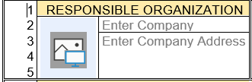

1.7.2 Subtitle Identification of Main (Device) Component Type
The very generalized form Title Block subject is augmented with a user selected component type name, which allows varying degree of precision appropriate to the intended use of the forms content.

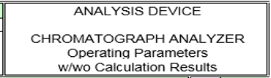

1.7.3 Specification Identifications Required Document Number
The Document number is required key information used for document retrieval in:

- The Form Loader Dashboard
- The integrated Instrument Index Data spreadsheet and browse interface
- Microsoft SharePoint and most other Document Management Systems
- Most software applications that manage electronic specification forms

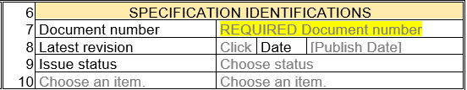

1.7.4 Administrative Identification Modeled Hierarchy Properties
Larger projects normally subdivide the equipment and instruments into hierarchical groupings to manage work activity and cost reporting consistent with the corporate requirements. The visible field prompts of this section are compatible with US and International standards and the line 17 user defined subgroup of nine additional groups, also originate from such standards. These values are generally used as filter conditions in the Instrument Index Data spreadsheet and therefore their consistent usage can be critical to such record queries.

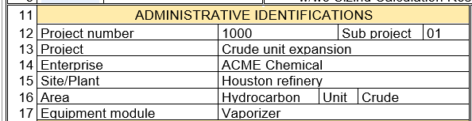

- Note: The standard’s definition for many of these properties can be viewed by pressing the Alt + F2 keys when focused on a content control.

1.7.5 Service Identifications Project Specific Suitable for Use Concept
Instrument devices that are mounted in-line or connected to a line or equipment, generally must meet, or exceed the design specifications for their associated line or equipment. Project disciplines generally develop design specifications for classes of lines or equipment that define code and consensus standard’s interpretation, relative to their installed location and governing bodies.

The Service Identifications section fields are used to document such project design requirements for both the process side of instruments and the electrical side, if appropriate.

- Note: Such project specific design specifications generally need to be interpreted in the context of the specific line or equipment before the data can be entered into the below fields.

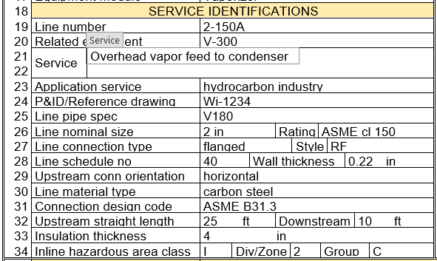

1.7.6 Component Design Criteria Project Specific Suitable for Use Concept
Project disciplines generally develop generalized design specifications for classes of instrument types based upon previous experience of applications and successful design implementations.
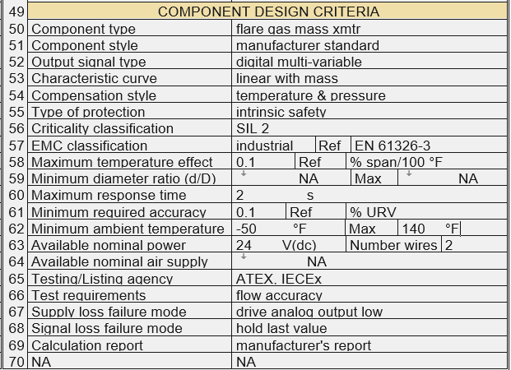

Such design criteria may vary for differing Administrative Identification property values and hazardous area classifications, identified in the Service Identification section.

- Note: Such project specific design specifications generally need to be interpreted in the context of the specific instrument before the data can be entered into the above fields.

1.7.8 Material Flow Conditions Data Suitable for Use Concept
Multiple cases of flowing condition data should be documented to define the envelope of proposed operating conditions that the instrument must be suitable to meet the requirements for various production capacities.

Although the Flow case identification pick lists provide the traditional ambiguous relative terminology as shown above, it is recommended that design capacity-based terminology be used as shown below.

- Note: More cases may have been studied than these forms can document. The cases which establish the minimum and maximum sizing calculation results, should be documented on this form.
All process variable values must be at the coincidental conditions of the named case. (They are entered in the vertical column underneath their case name.) This should not be a problem if the data is available from full process modeling or material balance calculations.

1.7.9 Material Flow Conditions for Preliminary Sizing Calculations
After documenting the process operating conditions, it is frequently desirable to perform preliminary instrument sizing calculations. Since many applications require significant turndown requirements, sufficient process variables to complete such calculations may be required for multiple cases. However, frequently only a single case, such as normal or design capacity is fully modeled, and a design turndown or turnup criteria is defined.
While the capacity related process variables can be proportionally calculated with such data, the other process variable values are likely related to variables other than the capacity. Therefore, they generally will be assumed and entered as identical to the documented case or proportional to other process variables.
Such assumed values may be adequate for the purpose of a preliminary calculation, but they should be recognized as not owned by the initial Operating Parameters data source. It is recommended that a separate revision chronicle record is documented for such separate work activities.
- Notes: See Quick Start Tour document, paragraph 2.3.4 Calculation Results for Operating Parameters Forms for step-by- step example.

1.7.10 Process Design Conditions Data Suitable for Use Concept
Good engineering practices and piping and equipment codes require a safety margin between operating conditions and design conditions. The Process Design Conditions section data must represent the absolute minimum and maximum conditions of any case, plus the design safety margins, of all operating conditions including those cases that are not documented on this form. Such undocumented conditions include sources of pressure including ambient influences, pressure oscillations and surges, improper operations, decomposition of unstable fluids, static head, and failure of control devices.

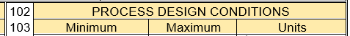

- Note: See Appendix B - Definition of terms, for extensive detail of the basis of design conditions,

1.7.11 Material Properties Design Conditions Data Suitable for Use Concept
The Material Properties section primarily identifies properties at reference conditions but includes the “GHS health hazard” value which is a major safety criterion that must be considered for all designs.

Calculation are generally performed using mass units. Therefore, the following material property values may be required to allow unit conversion prior to calculations if the flow rate value is expressed in volumetric units.

- Base pressure
- Base temperature
- Density at reference temperature

2 PROCESS OPERATING CONDITIONS FORMS
There presently are 18 Operating Parameter forms which are generally based upon their measured or initiating variable. A Form Loader Dashboard is provided as the common interface for access to all templates, forms, Instrument Index files and their data storage folders. The step-by-step procedures documented in the Quick Start Tour document section 2, explains how to select the appropriate form.

2.1 Line Process Data
One of the most effective work processes for entering and managing process data is to enter the data against the line, and then copy that data to instruments associated with the line.

To demonstrate the versatility and reduction of data entry errors resulting from this preferred work process, an extreme process application of five instruments associate with a single line as shown below; will be covered in this document.

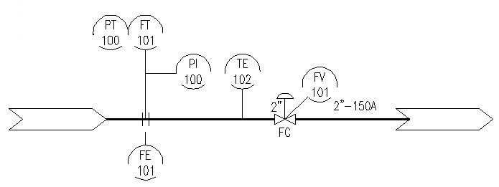

2.2 Line Operating Parameters Form
Create a Line Operating Parameters form F1101, following the step-by-step procedure documented in the Quick Start Tour document, section 2.1. The results of that data entry are exemplified in the sections shown above, except for the Component Design Criteria that does not apply to a line.

- Note: Practices for establishing the breaking point for line numbers vary significantly between organizations and their software applications. This example assumes that all the instruments depicted are assigned to the same line number. If the line number breaks at the control valve, then 2 Line Operating Parameters forms would be required.

2.2.1 Process Variables for all Flow Applications and Representations
The Material or Material Flow sections, Process Design Conditions and Material Properties section are configured to support all process variables including their alternate representations, on consolidated forms based upon their measured or initiating variable. This approach results in maximum consistency of data entry location for all instruments but results in many variables that are not applicable to any specific single application.

Entering “NA” in the process variable Units column, generally communicates that the variable is not applicable for the application and therefore no numeric value is required.

- Note: The unit symbol of “NA” is recommended for US practices for dimensionless variables, although the historic practice is to not show any unit symbol which can be simulated by typing a blank character in the field.

- Note: Numeric data validation is enforced for such properties that can have their values Electronically Data Interchange (EDI) with external files that require valid data types.

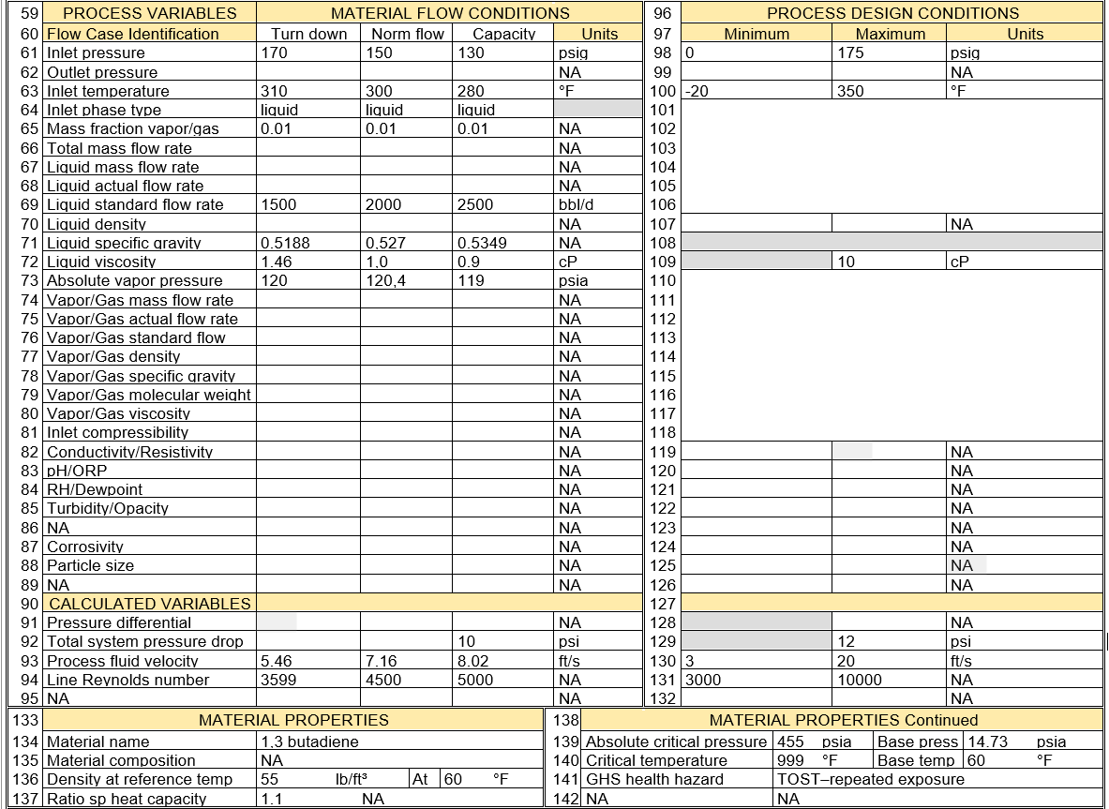

2.2.2 Copy Data from Line to a Flow Device Operating Parameter Form
There are 3 available forms for flow measurement devices with usage that is generally self-evident based upon their form titles:
- F1001 Flow Device
- F1002 Gas Flow Device with Composition Parameters
- F1003 Bulk Solids Flow Device

Load the general purpose Flow Device Operating Parameters form F1001, for the orifice plate flow element FE 101 and copy the Line Operating Parameters form data for line 2-150A. Follow the generic Flowing Condition step-by-step procedure documented in the Quick Start Tour document, section 2.3.2.
- All sections of data will be copied from the line to the Flow Element’s form.
- All line process data properties will be applicable to this flow element because the flow element is directly inline and is the upstream device in the line.
- The Calculated Variables section properties can be entered following the documented in the Quick Start Tour document, section 2.3.4.
- The Tag no/Functional ID and the downstream line properties in the Service Identification section can be added to the upstream properties that have been copied from the line and the hazardous area class properties corrected for this instrument type.
- The Component Design Criteria section properties can be entered as appropriate to the orifice plate
- The form header section properties in the Responsible Organization and Specification Identification can be added as appropriate

2.2.3 Copy Data from Line to Temperature Device Operating Parameter Form T1001
Load a Temperature Device Operating Parameters form T1001, for the temperature element TE 102 (or TW 102) and copy the Line Operating Parameters form data for line 2-150A. Follow the generic Flowing Condition step-by-step procedure documented in the Quick Start Tour document, section 2.3.2.
- All sections of data will be copied from the line to the Temperature Element’s form.
- The temperature elements pressure data may need to be reduced by the permanent pressure drop that occurs at the upstream flow element, or it may be left unchanged if the line pressure data was entered as a typical value over the length of the line segment for which the data was entered.
- The Calculated Variables section properties can be entered following the documented in the Quick Start Tour document, section 2.3.4.
- Enter the Tag no/Functional ID, Line connection length and device insertion length properties in the Service Identification section.
- The Component Design Criteria section properties can be entered as appropriate to the selected Component type, such as RTD element.
- The form header section properties in the Responsible Organization and Specification Identification can be added as appropriate

2.2.4 Copy Data from Line to Valve or Regulator Device Operating Parameter Form C1001
Load a Valve or Regulator Operating Parameters form C1001, for the Control valve FV 101 and copy the Line Operating Parameters form data for line 2-150A. Follow the generic Flowing Condition step-by-step procedure documented in the Quick Start Tour document, section 2.3.2.
- All sections of data will be copied from the line to the Control valve form.
- The control valve inlet pressure data may need to be reduced by the permanent pressure drop that occurs at the upstream flow element, or it may be left unchanged if the line pressure data was entered as a typical value over the length of the line segment for which the data was entered.
- Add the Outlet pressure Material Flow Conditions and Process Design conditions data that is required to document operating conditions
- The Calculated Variables section properties can be entered following the documented in the Quick Start Tour document, section 2.3.4.
- Enter the Tag no/Functional ID, and downstream line properties in the Service Identification section.
- The Component Design Criteria section properties can be entered as appropriate to the selected Component type, such as linear motion control valve.
- The form header section properties in the Responsible Organization and Specification Identification can be added as appropriate

- Note: The Inlet pressure, Outlet pressure and Absolute vapor pressure data may need to be updated after evaluating the valve elevated location has been designed, for liquid fluids near their flash point. Such data is generally not available at the time the line data is entered but can be updated before sizing calculations are performed.

- Note: If the line pressure is changed from that of the upstream in-line device, the specific gravity, density, and compressibility data should also be corrected when the fluid is in the Gas/Vapor fluid state.

2.2.5 Copy Data from Line to Off-line Flow Device Operating Parameter Form F1001
Load a Flow Device Operating Parameters form F1001, for the multivariable flow transmitter FT 101 and PT100 and copy the Line Operating Parameters form data for line 2-150A. Follow the generic Flowing Condition step-by-step procedure documented in the Quick Start Tour document, section 2.3.2.
- All sections of data will be copied from the line to the Flow transmitter form.
- The pressure process data properties will be applicable to this flow transmitter because the flow transmitter is directly connected to the inline.
- The transmitter’s inlet temperature data must be reduced because its nonflowing fluid will approach equilibrium with its ambient temperature, if appropriate length impulse lines are used.

- Note: The process design temperature limits are likely still valid if they are inclusive of startup or shutdown conditions or improper filling of the impulse lines.

- If the transmitter’s process temperature is not reduced below about 170-185 °F, most electronic transmitters will not handle the temperature. This could lead to the vendors not providing a quotation for the application.
- The Specific Gravity and Viscosity may be significantly different at the lower temperature; however, these values are NOT used on the instrument specification form and their invalid data should be deleted.
- The Calculated Variables section properties can be entered following the documented in the Quick Start Tour document, section 2.3.4.
- Enter the primary instrument Tag no/Functional ID FT 101.
- The upstream and downstream line properties must be edited to reflect the construction of the impulse lines.
- The Component Design Criteria section properties can be entered as appropriate to the multivariable flow transmitter.
- The form header section properties in the Responsible Organization and Specification Identification can be added as appropriate

2.2.6 Copy Data from Line to Off-line Pressure Gauge Device Specification Form P2001
Simple devices that only require minimal Operating Parameters data, document such data in the consolidated Operating Parameters section of a Device Specification short form.

Load a Pressure Gauge Device Specification form P2001, for the pressure gauge without seal PI 100 and copy the Line Operating Parameters form data for line 2-150A.Follow the generic Flowing Condition step-by-step procedure documented in the Quick Start Tour document, section 2.3.2.
- All sections of data will be copied from the line to the Pressure Gauge form.
- The pressure process data properties will be applicable to this flow transmitter because the flow transmitter is directly connected to the inline.
- The pressure gauge inlet temperature data must be reduced because it nonflowing fluid will approach equilibrium with its ambient temperature if appropriate length impulse lines are used.

- Note: The process design temperature limits are likely still valid if they are inclusive of startup or shutdown conditions or improper filling of the impulse lines.

- Enter the instrument Tag no/Functional ID
- The upstream line properties must be edited to reflect the construction of the impulse lines.
- The Component Design Criteria section properties can be entered as appropriate to the pressure gauge
- The form header section properties in the Responsible Organization and Specification Identification can be added as appropriate

2.2.7 Copy Data from Line to Analysis Device Operating Parameter Form A1001
Load an Analysis Device Operating Parameters form A1001, for an inline analysis sensor and copy the Line Operating Parameters form data for line 2-150A. Follow the generic Flowing Condition step-by-step procedure documented in the Quick Start Tour document, section 2.3.2.
- All sections of data will be copied from the line to the Analysis sensor’s form.
- All line process data properties will be applicable to this analysis element because the element is directly in line.
- The Calculated Variables section properties can be entered following the documented in the Quick Start Tour document, section 2.3.4.
- Enter the Tag no/Functional ID and the fast loop properties should be identified as not applicable.
- The Component Design Criteria section properties can be entered as appropriate to the analysis sensor and output signal properties.
- The form header section properties in the Responsible Organization and Specification Identification can be added as appropriate

For a remote located analysis sensor or Transmitter:

- The sensors inlet temperature data may need to be reduced because its fast loop flowing fluid will approach equilibrium with its ambient temperature if temperature maintenance schemes are not used.

- Note: The process design temperature limits are likely still valid if they are inclusive of startup or shutdown conditions or failure of temperature maintenance schemes.

- If the sensor transmitter’s process temperature is not reduced below about 170-185 °F, most electronic transmitters will not handle the temperature. This could lead to the vendors not providing a quotation for the application.

- The flowrate data will be appropriate if a sample probe is used to separate the fast loop flow from the process line flow.
- The Density and Viscosity may be significantly different at the lower temperature
- The fast loop process variable data generally is required because it represents the conditions at the remote sensor location
- The measured physical property variable data needs to be entered along with their process design condition limits
- The Calculated Variables section properties can be entered following the documented in the Quick Start Tour document, section 2.3.4.
- Enter the Tag no/Functional ID and the fast loop properties when such data is available.
- The Component Design Criteria section properties can be entered as appropriate to the analysis sensor and output signal properties.
- The form header section properties in the Responsible Organization and Specification Identification can be added as appropriate

2.2.8 Copy Data from Line to Analysis Device Operating Parameter Form A1002
Open an Analysis Device Operating Parameters form A1002, for an analysis sensor measuring composition/property values and copy the Line Operating Parameters form data for line 2-150A. Follow the generic Flowing Condition step-by-step procedure documented in the Quick Start Tour document, section 2.3.2

Form A1002 Analysis Device with Composition or Property has its first page identical to form A1001, and therefore the procedures are identical to those described above for the first page. However, this form includes a second page to document the composition/property data and the measurement design range limits. Follow the generic step-by-step procedure documented in the Quick Start Tour document, section 2.3.2

2.3 Level Measurement Process Data

Another effective work processes for entering and managing process data is to enter the data against the level measurement form, and then copy that data to instruments associated with the level measurement.

To demonstrate the versatility and reduction of data entry errors resulting from this preferred work process, temperature and pressure instruments associate with a single level measurement will be covered in this document.

2.4 Level Operating Parameters Form
Create a Level Operating Parameters form L1001, following the step-by-step procedure documented in the Quick Start Tour document, section 2.4. The results of that data entry are exemplified in the sections shown below.

2.4.1 Process Variables for all Level Applications and Representations
The level form’s Material section, Process Design Conditions and Material Properties section are configured to support all process variables including their alternate representations, on a single form. This approach results in maximum consistency of data entry location for all instruments but results in many variables that are not applicable to any specific single application.

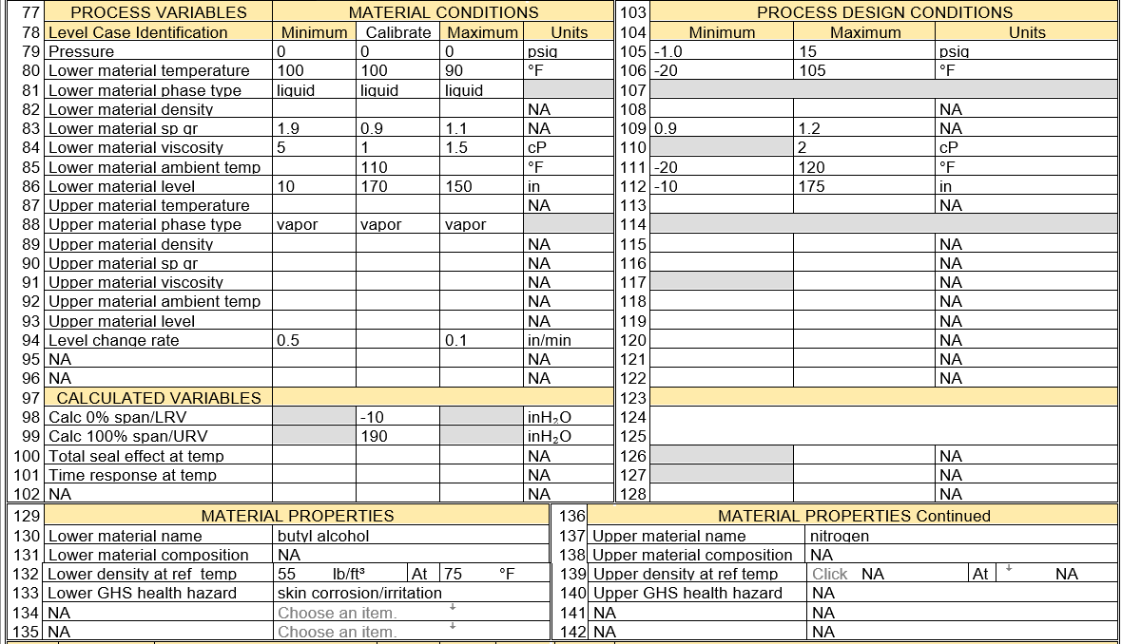

Level process data values should be consistently documented in units of height, rather than ambiguous relative units of % capacity or % height. Device specification forms may scale output signal or scale ranges in relative units to accommodate legacy practices and manufacturers standard scales.

Entering “NA” in the process variable Units column, generally communicates that the variable is not applicable for the application and therefore no numeric value is required.

- Note: The unit symbol of “NA” is recommended for US practices for dimensionless variables, although the historic practice is to not show any unit symbol which can be simulated by typing a blank character in the field.

2.4.2 Level Material Conditions Data Suitable for Use Concept
Level cases are generally related to inventory or maintaining a fixed level, rather than process flow capacity. Therefore, the absolute cases of minimum and maximum have been preestablished and a single case allowed for documenting other cases, such as applicable to level control at a fixed value or calibration.
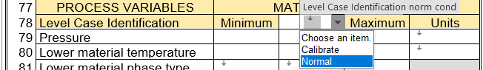

- Note: More cases may have been studied than this form can document. The cases which establish the minimum and maximum sizing calculation results, should be documented on this form.
All process variable values must be at the coincidental conditions of the named case. (They are entered in the vertical column underneath their case name.)

2.4.3 Level Material Conditions for Sizing and Measurement Range Calculations
After documenting the process operating conditions, it is frequently desirable to perform instrument sizing and calculate measurement range limits. Fluid properties are related to temperature which generally has significant variation and can plays a significant role for instruments that contact the fluid.
Therefore, the calculated measurement range should be based upon fluid properties that will produce conservative measurement readout and minimize likelihood of overflow conditions resulting from alarms and shutdown actions based upon nonconservative calibration.
.

2.4.4 Level Process Design Conditions Data Suitable for Use Concept
Good engineering practices and piping and equipment codes require a safety margin between operating conditions and design conditions. The Process Design Conditions section data must represent the absolute minimum and maximum conditions of any case, plus the design safety margins, of all operating conditions including those cases that are not documented on this form. Such conditions include sources of at least fluid temperatures, ambient temperatures, solar radiation, heating or cooling medium temperatures, static head, and failure of control devices.

- Note: See Appendix B - Definition of terms, for extensive detail of the basis of design conditions,
- Note: Vessel design standards frequently limit the working volume to a percentage of actual vessel volume. Therefore, determining the maximum material level likely would need to be back calculated, unless an overflow nozzle is used to establish the maximum working level.

2.4.5 Copy Data from Level Form to Temperature Device Operating Parameter Form T1001
Open a Temperature Device Operating Parameters form T1001 and copy the Level Operating Parameters form data.
- All sections of data will be copied from the level form to the Temperature Element’s form.
- The Service Identification properties will require some editing because the copied process connection properties of the level instrument are likely different that the temperature element.
- The Component Design Criteria properties will require some editing because the copied properties of the level instrument are likely different that the temperature element.

- Additional properties will need to be edited if a thermowell is used and needs calculation documentation.
- The Calculated Variables section properties can be entered following the documented in the Quick Start Tour document, section 2.3.1.
- Enter the Tag no/Functional ID, Line connection length and device insertion length properties in the Service Identification section.
- The form header section properties in the Responsible Organization and Specification Identification can be added as appropriate

2.4.6 Copy Data from Level Form to Pressure Device Operating Parameter Form P1003
Open a Pressure Device Operating Parameters form P1003 and copy the Level Operating Parameters form data.
- All sections of data will be copied from the level form to the Temperature Element’s form.
- The Service Identification properties will require some editing because the copied process connection properties of the level instrument are likely different that the temperature element.
- The Component Design Criteria properties will require soe editing because the copied properties of the level instrument are likely different that the pressure transmitter/
- The Calculated Variables section properties can be entered following the documented in the Quick Start Tour document, section 2.3.2.
- The form header section properties in the Responsible Organization and Specification Identification can be added as appropriate

2.4.7 Copy Selected Data to Instrument Index Data Table
About 80 fields from each specification form are automatically copied to the Excel Instrument Index Data table, whenever a specification document is saved. The Instrument Index Data table has one record for each specification document number and that record will be updated with the latest data at each saving of the document. This tabular data presentation can be instrumental in review for inconsistencies between multiple forms, partial status of the form’s data entry or as an index to identify data related to a tag or functional identification.

- Notes: See Quick Start Tour document, paragraph 8.6 Integrated Instrument Index Data Browser for step-by- step usage.

2.5 Simple Device Specification Form Operating Parameters

Simple instrument devices frequently require extremely limited Operating Parameters data for review and therefore their forms consolidate the Operating Parameters sections into a single consolidated section and add the Device Specification part, and General or Special Requirements part into a combined integrated short form.
- Note: Short forms represent about 40% of device specification forms.

These simple component types generally will not experience the advantages of separate forms for documenting process operating condition, as discussed above in paragraph 1 Overview. Therefore, there frequently is not a source document to copy operating parameter data from.

2.5.1 Directly Entering Process Data into Simple Device Specification Forms
The most significant differences of the consolidated Operating Parameters section are:

- Absence of a tabular presentation of coincidental process values underneath their case identification name
- Subsection titles to distinguish operating conditions from Design Conditions

Therefore, the context of the property variables is implied in the field prompts, such as:
- Prefix Process Design condition field prompts with the terminology “Design”
- Prefix or suffix operating condition field prompts with the terminology “Minimum”, “Normal”, or “Maximum” for variables that are primarily independent of flow.
- Suffix operating condition filed prompts with the terminology “at min flow”, “at norm flow”, or “at max flow” for variables that are highly dependent on flow.

2.5.2 Process Variables Optimized for the Form Title Component Type
The simple device form’s consolidated Operating Parameters properties limit parameters to those applicable to the specific title component types.

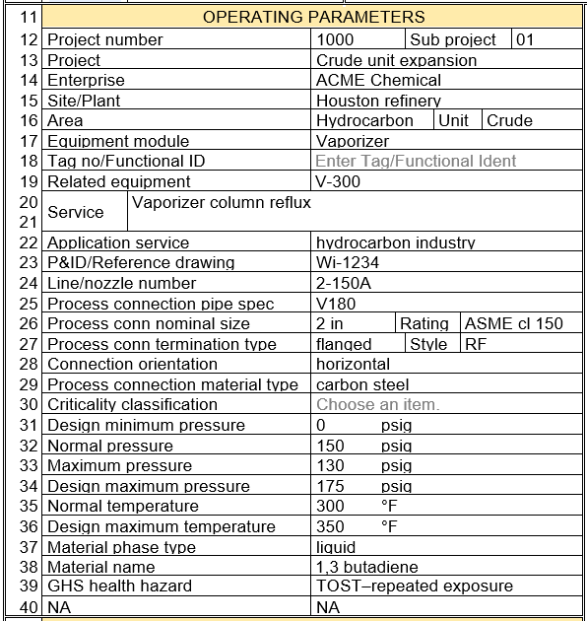

2.5.3 Copy Data from Operating Parameter Form to Simple Device Specification Form
If a standalone Operating Parameters form was previously created, then the data can be copied into the simple device form, using the procedure analogous to that in above “2.2.6 Copy Data from Line to Off-line Pressure Gauge Device Specification Form P2001”

2.6 Complex Device Specification Form Operating Parameters

Complex instrument devices require extensive Operating Parameters data for review. Therefore, their forms duplicate the appropriate standalone Operating Parameters form part and add the Device Specification part and General or Special Requirements part, into a combined integrated form.

2.6.1 Directly Entering Process Data into Complex Device Specification Forms
Many project executions schemes will not need separate forms for documenting process Operating Parameters, as discussed above in paragraph 1 Overview. Therefore, their direct entering of Operating Parameters data on the Device Specification form will use the same procedures used for the standalone Operating Parameters forms.

2.6.2 Copy Data from Operating Parameters Form to Complex Device Specification Form
Open a Complex Device Operating Specification form and copy the corresponding Operating Parameters form data.
- All sections of data will be copied from the Operating Parameters form to the first page of the complex device Specification form.
- The form header section properties in the Responsible Organization and Specification Identification can be added as appropriate

3 General or Special Requirements
All forms include the optional General or Special Requirements Part which documents any significant aspects that are not captured within the other sections and can be used by the specifier or form recipient to clarify such issues that need to be agreed upon for completing the work activity. This form part will not print if no data has been entered. This section allows:

- Direct data entry or copy and paste of extensive formatted content incorporating all of Word’s formatting functionality, including embedded pictures
- Internet URL links to supporting material or Websites
- Heat and Material spreadsheets or reports
- Copy properties which will include their picklist and past multiple times to emulate multi choice pick list selections
Compliance standard | 3A sanitary standard
Compliance standard | ASME BPE
Compliance standard | NACE® MR 0175-2002
Compliance standard | USP CLVI
Compliance standard | 21CFR 177.2600
Compliance standard | FDA

- Functionality to automatically build the required Table of Contents from entered data using Heading 1, Heading 2 and Heading 3, can be activated by clicking the Update Table Icon.

- Let your imagination open to the endless possibilities of Word’s inherent functionality!

4 Data Exporting for External Applications

Data exports are outside the scope of these forms. Data exchange to such programs requires significant knowledge of such applications. Therefore, Word’s XML Mapping Pane which can be used to create Content Control mappings to referenced existing standard XML schemas, is not being used at this time.

However, all the form’s property data can easily be exported using a free third-party add-in “Extract Data from Word Document File”, to many different common file formats.

https://gregmaxey.com/word_tip_pages/extract_data_from_forms.html

Appendix A - Definition of terms

The terminology used in the Operating Parameters Forms is highly technical in nature, with precise definitions that need to be consistent with their usage for instrumentation sizing and application analysis. Most of the definitions presented here are identical to those contained in relevant ANSI standards.

Accumulation:
The pressure increase over the maximum allowable working pressure of a vessel during discharge through the pressure relief device, expressed in pressure units or as a percent. Maximum allowable accumulations are established by applicable codes for operating and fire contingencies.
Alarm setpoint:
The setpoint for the device or function that signals the existence of an abnormal condition by means of an audible or visible discrete change, or both, intended to attract attention. The variable is identified in measured variable units.
Angle of repose:
The inclination of a plane at which a body placed on the plane would remain at rest or if in motion would roll or slide down with uniform velocity; the angle at which the various kinds of earth will stand when abandoned to them-selves.
Base Conditions:
The standard reference (or base) conditions of temperature, pressure and humidity (state of saturation) to be used for measurements and calculations. These standard values generally originate in national or international standards and are frequently the agreed upon basis for commodity transfer in industry and commerce. These standard reference conditions are used to identify the fluid density, specific gravity, and compressibility values at the base conditions, which are used in calculations required by changes in flow units of measure.

Base pressure:
The standard reference pressure condition defined as the basis for calculating standard volumetric flow, and base density.
Base temperature:
The standard reference temperature condition defined as the basis for calculating standard volumetric flow, and base density.
Beta ratio:
The diameter ratio (Beta) is the ratio of the diameter of the constriction to the pipe diameter.
Compressibility:
The fluid compressibility at the coincidental upstream associated flow case set name, flow rate case, upstream pressure and temperature.
Constant back pressure:
Constant superimposed back pressure is the type of back pressure essentially at the fixed value (constant) and exist (superimposed) continuously prior to and during opening of the relief valve.
Critical pressure:
The pressure of the named fluid in its critical point; i.e. when it is at its critical temperature and critical volume.
Critical temperature:
The temperature of the liquid-vapor critical point; i.e. when it is at its critical temperature above which a gas cannot be liquefied by an increase in pressure.
Density:
The fluid density at the coincidental upstream associated flow case set name, flow rate case, upstream pressure and temperature.
Design pressure maximum:
The maximum design pressure for a component shall not be less than the pressure at the most severe instantaneous condition of coincident internal or external pressure and temperature (maximum) expected during service. (See definition for Service conditions). The sources of pressure to be considered include ambient influences; pressure oscillations and surges, improper operations, decomposition of unstable fluids, static head, and failure of control devices.
Design pressure minimum:
The minimum design pressure for a component shall not be less than the pressure at the most severe instantaneous condition of coincident internal or external pressure and temperature (minimum) expected during service. The sources of pressure to be considered include the cooling of a gas or vapor in a system sufficient to create an internal vacuum. In such a case, the design pressure minimum shall be capable of withstanding the external pressure at the minimum design temperature.
Design ambient temperature maximum:
The highest material temperature caused by atmospheric conditions for which a component must be designed, or the highest one-day mean ambient temperature, whichever is greater.
Design ambient temperature minimum:
The lowest material temperature caused by atmospheric conditions for which a component must be designed, or the lowest one-day mean ambient temperature, whichever is less.
Design temperature maximum:
The maximum design temperature of a component is the temperature at which, under the coincident pressure, the greatest thickness or highest component rating is required. In establishing design temperature, consider at least fluid temperatures, ambient temperatures, solar radiation, heating or cooling medium temperatures. This value is generally derived from the line or equipment design limits, or the design ambient temperature maximum conditions.

Design temperature minimum:
The minimum design temperature is the lowest component temperature expected in service. Consideration shall be given to low ambient temperature conditions for displacement stress analysis. This value is generally derived from the line or equipment design limits, or the minimum design ambient temperature condition.
Dielectric constant:
The dielectric constant or relative permittivity is the ratio of the permittivity of the material to the permittivity of free space. The dielectric constant is directly proportional to the capacitance, which is also proportional to the leakage current. A good source for data on this value is:
http://www.asiinstr.com/technical/Dielectric Constants.htm
Environment factor:
The environment factor for external insulation used to estimate heat input fires from pressure relief facilities. (See Table 5 of API 521).

Line number:
The associated line number that is the data source of the Line size, Line schedule, and can be the source of the process data.
Line type:
Sub-classification of lines used to filter the line list.
Line size:
The nominal size designation for the line which uses the older presentation style of the size plus associated units; rather than the modern presentation style of dimensionless NPS or DN designators prefixing the size.
Lower fluid:
The lower fluid name or its related properties in a vessel, relative to the liquid level interface. When only one liquid level interface exists, then the upper fluid is the vapor or gas that exists above that interface. If a liquid-to-liquid interface exists, the upper fluid is that exist above the interface.
Mass flow:
The flow rate expressed in mass flow units.
Maximum flow case
The maximum flow for a given tag or line derived from analysis of the alternate operating conditions, such as cleaning startup, recycle or design future capacity for additional trains.
Maximum shut-off pressure difference:
The maximum design pressure differential for a given tag, or equipment; that represents the design limit that could exist under upset or abnormal conditions. This value is generally derived from analysis of pump deadhead pressure, or maximum service fluid supply pressure, assuming atmospheric downstream conditions.
Minimum flow case
The minimum flow for a given tag or line derived from the turndown design capacity for the system, generally resulting from a calculated material balance.
Molecular mass:
The molecular mass of a substance (less accurately called molecular weight and abbreviated as MW) is the mass of one molecule of that substance, relative to the unified atomic mass unit u (equal to 1/12 the mass of one atom of carbon-12).

Normal flow case:
The normal flow for a given tag or line derived from the design capacity basis for the system, generally resulting from a calculated material balance.
Orifice diameter:
The bore diameter of the cylindrical section of the measuring element. This value is used in instrument flow calculations and is used coincidental with the differential (pressure) range and Full scale flow range values; used in the calculation.
Pipe Material:
The description of the piping material which is consistent with the pipe specification of the line.
Pipe Spec:
The identification code for the line piping specification that identifies the detailed materials of construction, pressure ratings, end connection types, size ranges, corrosion allowance, and piping item descriptions.
Pressure Drop:
The design pressure drop allowance or mechanical design basis, consistent with the line hydraulic calculations, occurring at the identified flow case flow rate.
Pressure loss:
The pressure loss is the difference in static pressure between the pressure measured at the wall on the upstream side of the orifice plate, at a section where the influence of the approach impact pressure adjacent to the plate is still negligible (approximately D upstream of the orifice plate), and that measured on the downstream side of the orifice plate, where the static pressure recovery by expansion of the jet may be considered as just completed (approximately 6D downstream).
Set pressure:
The gauge pressure at the valve inlet, for which the safety relief valve has been adjusted to open under service conditions. In liquid service, set pressure is determined by inlet pressure at which the valve starts to discharge. In gas or vapor service, the set pressure is determined by the inlet pressure at which the valve pops.
Specific gravity:
The fluid specific gravity (relative density) at the coincidental upstream associated flow case set name, flow rate case, upstream pressure and temperature.
Specific heats ratio:
The ratio, Cp/Cv, Specific heat capacity at constant pressure divided by the Specific heat capacity at constant volume; at the coincidental upstream associated flow case set name, flow rate case, upstream pressure and temperature.
Temperature:
The coincidental upstream temperature existing at the associated flow case set name and flow rate. This value is generally derived from the line or equipment operating conditions, only if the instrument is mounted inline or is inserted into the equipment. Remote mounted instrument temperatures will generally be at the local ambient temperature condition
Transparent:
Having the property of transmitting light without appreciable scattering so that bodies lying beyond are seen clearly.

Upper fluid:
The upper fluid name or its related properties in a vessel, relative to the liquid level interface. When only one liquid level interface exists, then the upper fluid is the vapor or gas that exists above the interface. When a liquid-to-liquid interface exists, the upper fluid is that liquid that exists above the interface.
Upstream pressure:
The estimated pressure upstream of the instrument inlet, and ahead of any line reducers that may be implemented to accommodate an instrument size different from the line size.
Vapor pressure:
The pressure (if the vapor is mixed with other gases, the partial pressure) of a vapor (this vapor being formed from molecules/atoms escaping from a liquid/solid), at the coincidental upstream associated flow case set name, flow rate case, and upstream temperature. This is the equilibrium vapor pressure or saturation vapor pressure of that substance at that temperature. The term vapor pressure is often understood to mean the saturation vapor pressure.
Variable back pressure:
Variable superimposed back pressure is the type of back pressure that varies or changes over a range from the minimum to maximum, or vice versa. The actual back pressure at any specific time depends on conditions in the piping system to which the outlet of the relief valve is connected. The maximum variable back pressure should be used in designing the relief system.
Velocity:
The time rate of change of position of the fluid in the direction of motion. This is typically calculated from the flow rate of the fluid and the hydraulic diameter of the fluid conduit.
Vibration:
The state of being vibrated or in vibratory motion. Generally, conditions of less than 1.0g are not a concern for most instruments. All instruments associated with rotating equipment that have vibration monitoring specified, should have a “Yes” value store in the “Vibration” database field.
Viscosity:
The coincidental upstream viscosity existing at the associated flow case set name, flow rate, and temperature.
Volumetric Flow:
The flow rate expressed in volumetric flow units that are additionally identified by its type classification of; @ flow, @ normal, @ standard or @ base.
Wall thickness:
The actual dimension of the line wall thickness expressed in the units of measure identified for the line size.
Zero datum reference:
The identification of the vessel reference point, which defines the zero datum point for vessel dimensions and liquid level values

