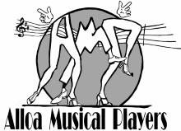
Annual Report
2018-19

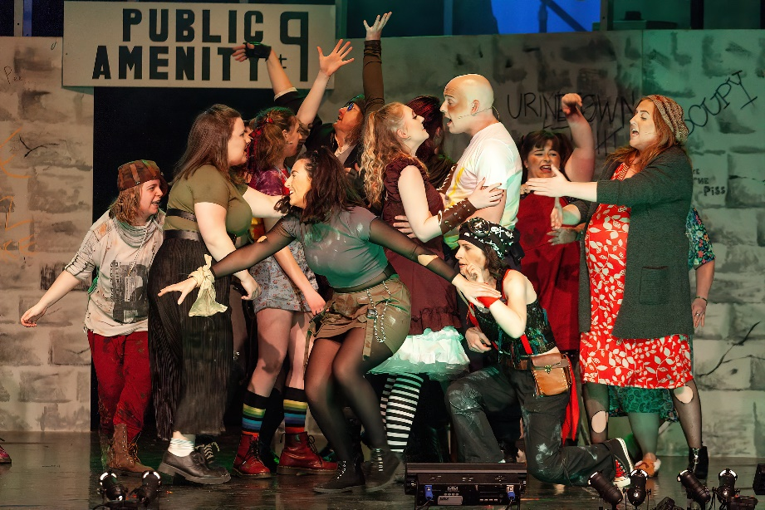
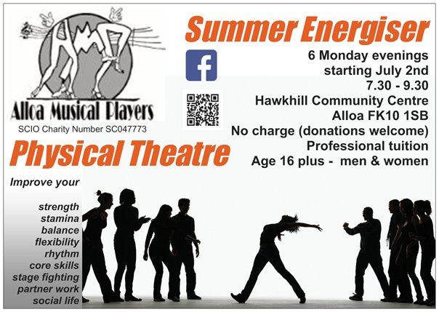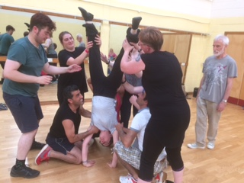

Trustees Annual Report

The Trustees have pleasure in presenting their Report together with the Financial Statements for the year ended 31st May 2019
Activities, achievements and performance
2018
May
The end of our first year as a SCIO (Scottish Charitable Incorporated Organisation). “9 to 5 The Musical” was well-received by our audiences in March 2018 and income and expenditure on the show was finely balanced, with a small surplus.
We took part in a training day on GDPR (General Data Protection Regulation) run by Senscot Legal, facilitated by Clackmannanshire Third Sector Interface (CTSI) and have upgraded our procedures and policies accordingly.

June
The Hugh Fraser Foundation donated £1,200 to pay for an upgrade of our website.

The Gordon Fraser Charitable Trust had already donated £500 to allow us to run 6 “Summer Energiser” workshops – free to participants – with the aim of recruiting new performers and challenging current ones.

At the CTSI Volunteer Awards, Janette Wilson was nominated for her work in the Box Office and Lindsey Spowage was nominated by fellow-Trustees as Trustee of the Year - and was a runner up in this category.

July
Our Summer Energiser workshops began on 2nd July and ran for 6 successive Monday evenings tutored by Kaye Finlay and located in Hawkhill Community Centre. These were well attended by members and newcomers (10 men and 10 women). Interestingly two recently-arrived Syrian young men took part – they were living within our community as part of our refugee programme. Also interestingly two of the newcomers stayed with us and went on to play principal roles in our March 2019 production.

On 22nd July AMP ran a social event – a Car Treasure Hunt – which proved to be great fun.

We were sorry to lose the services of Aileen Sweeney as MD, due to her need to focus on her studies. However, on 19th July we secured the services of Steven Segaud as Musical Director for “Urinetown”. Steven had been involved in the show twice before and knows the material well.

A small group of members raised money for AMP by taking part in Alloa Rotary’s Nebit Hill Challenge (on a sweltering hot Saturday!)

We were represented at the OSCR “Meet the Charity Regulator” presentations in Stirling as further training for our Trustees.

August
Our first AGM as a charity took place on 20th August. One Trustee retired and two new Trustees were appointed. We now have 8. There was no change to office bearers. A “Welcome to AMP” night took place on Monday 27th August in Alloa Rugby Club.

Work began on the new AMP website with Scott Jamieson of SwitchedonIT as the chosen provider of technical support and training for Vice President Lindsey Spowage who then went on to load material and begin to archive our history. This will be a work in progress for some years – there is a lot of archive material!

September
Our first rehearsal of “Urinetown” took place on 3rd September – the second on the 5th and we were off and running! We have retained Kaye Finlay as Artistic Director – a very popular decision and we continue to rehearse in Alloa Rugby Club.

October
Auditions for principal parts were held and the show was cast. It would be wonderful if we could interest more men in this work – but we carry on regardless! We love the 7 we have! Kaye wanted a Steam Punk look for this show and member Jennie Spowage agreed to take on the costumes – making most of the detailed accessories – along with Willow on props – and sourcing other items on line or in charity shops. Our own wardrobe also provided a number of useful items.
We continue to store a certain amount of costumes, props, furniture and set at the premises of the Wee County Crafters in Alva.

November
Rehearsals for Urinetown continue – making great progress and having fun. AMP sings some songs to entertain the crowds at the Christmas Lights Switch On in Alloa – learning some Makaton in the process!

December
Monday 17th was not a rehearsal, but a Christmas party for the cast and crew of Urinetown – with some truly hilarious party games.

2019

January
Rehearsals began again after the Christmas break.

On 26th, AMP was invited to provide the musical entertainment at the Alloa Rugby Club Burns Supper, which we were proud to do, with the help of former Musical Director Hugh MacDonald playing harp. This generated a welcome donation to our funds.

February
This was our very busiest time with preparations for set, costume and front-of-house activity hotting up and everyone making a massive effort to promote ticket sales for Urinetown. The title is proving a hard sell being unknown to most people and being a show about public toilets – I mean really?? Cast and crew are having a ball and loving this clever script and the wide range of musical styles. The steam punk look is spot-on.

We obtained a licence to perform Disco Inferno in 2020.

March
As anticipated, come show week, ticket sales were slow so income will suffer. In every other respect, however, the production was a great success and there are no regrets – we need to ring the changes and refuse to stick to tried and tested favourites – we need to challenge ourselves every now and then! Reviews were good and particularly appreciated from those who know and love musical theatre.

Financial pressures cause AMP to spend a lot of time making grant applications and community fundraising plans in the closing weeks of March.

April
On 15th April we held a company wash-up meeting to discuss our recent activity, our financial risk and our future plans. Our AGM is set for August 14th and the new rehearsal year will begin on August 19th.

We are happy to say that as our year came to a close we were successful in obtaining funding from The Gordon Fraser Charitable Trust to run a second summer of Energiser Workshops. We also were awarded £5,000 by the National Lottery (Awards for All) to cover our rehearsal hall hire, our production team costs and our marketing budget for the 2020 production.

Grant Funders
Alloa Musical Players are grateful to the following funders:

- The Gordon Fraser Charitable Trust donated £500 for Summer Energiser workshops

- The National Lottery (Awards for All) awarded £5,000 to help stage our 2020 production

Friends of Alloa Musical Players

The following members of our community have generously supported AMP as donors:

Gold Friends
Dick Clark
Alistair Spowage

Silver Friends
Nancy Irvine
Margaret Cowell
Vera Shenton
Catherine Garvie
Mrs S Mason
Jack Storrie
John Cunningham

Bronze Friends
Marion Fitzpatrick
Harold & Madge Kettles
Lesley Kettle
Taylor Williams

Other Friend Donations
John Adamson
Craig Adamson

Table Sponsors
A number of local businesses sponsored tables at Urinetown, helping us to keep ticket prices down
and make our shows as affordable for our audience as possible. We are grateful to:

SMS Tyre & Exhaust Centre
Mr Singh’s
Norland Joiners
Ladybird Tearoom
CTSI
MacFarlane Jewellers
Alloa Rugby Club
Dunmar House
The Royal Oak Hotel
Bar Aldo
PWT Corporate Wear
JKS Scotland Honbu Dojo

Obituaries
AMP said goodbye to a founder member this year. We remember with great fondness:

David Hunter – June 2018

Reference and Administrative Information

Charity Name
Alloa Musical Players (SCIO)

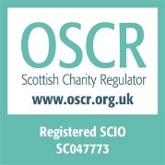
Registered Address

Glenochil Bungalow
Menstrie
Clackmannanshire
FK11 7EG

Trustees

Rob McDermott, President
Lindsey Spowage, Vice-president
Antony Carter, Secretary
Leanne Cook, Treasurer
Lesley Kettles
Kirsty Gillies, Membership
Paige Allan
Caitlin Smith

Structure, Governance and Management
Constitution

The charity is a Scottish Charitable Incorporated Organisation (a SCIO). It was registered in its current legal form on 25th September 2017. The charity was previously an unincorporated association (since 1952) but changed its legal form to a SCIO. The assets of the unincorporated association were transferred to the SCIO on 1st October 2012. It has a two-tiered structure consisting of:
- the MEMBERS who have the right to attend members' meetings (including any annual general meeting) and have important powers under the constitution; in particular, the members appoint people to serve on the board and take decisions on changes to the constitution itself;
- the BOARD - who hold regular meetings, and generally control the activities of the organisation; for example, the board is responsible for monitoring and controlling the financial position of the organisation.
The people serving on the board are referred to in this constitution as CHARITY TRUSTEES.

Appointment of Trustees

The Management Committee, which meets as and when necessary, but at least four times per year, are the charity’s Trustees. All Members are eligible to be Trustees. Trustees, of which there must be at least 5 but no more than 8, step down at each AGM, but are eligible for re-election. The AGM is generally held in August. Trustees control the activities of the organisation; for example, the Board of Trustees is responsible for monitoring and controlling the financial position of the organisation, protecting it, ensuring legal and charitable compliance, and providing leadership and direction.

Members are those who sign up to agree to abide with the rules and values of the organisation.
Membership is no longer associated mostly with performance on stage but is for all who wish to join in any voluntary capacity to support AMP’s aim, vision, mission and charitable purpose. There is no charge, but Members are encouraged to become donors. There are as many volunteers supporting our activities off-stage as take part in performances on-stage.

Key Volunteer Roles

Stage Management/crew
Props and Set
Costumes
Prompt
Front of House
Tickets on line
Tickets over the counter
Box Office
Hospitality
Programmes
Marketing Materials
Sponsorship
Grants
Community Fundraising
Social Media and Website
Theatre Bar
Scores and Librettos
Patrons and Friends

Alloa Musical Players has the following Honorary officials:

Honorary Presidents: Joyce Stalker, Margaret Cowell, Avril Hughes, Lynda Young and Kate Paterson

Objectives and Activities

AMP provides opportunities for local people to fulfil their potential, growing and learning through musical theatre, both as participants and as audience, and we share skills by working in partnership across our community. Our vision is of a friendly, inclusive community, both of place and of interest, where the performing arts and supporting crafts and technology support the wellbeing of our citizens.

Purposes
The organisation’s charitable purposes are the advancement of the arts, heritage, culture or science through the provision of recreational facilities, or the organisation of recreational activities with the object of improving the conditions of life for the persons for whom the facilities or activities are primarily intended.

And in furtherance of the above purposes, we carry out the following activities:

  - provide a range of opportunities for local people to enjoy participation in musical
  - theatre and to develop their knowledge and skills at all levels
  - develop audience awareness and appreciation of community-based musical theatre
  - play a useful role as a community partner to other local organisations

From September to February we rehearse twice a week on Mondays and Wednesdays – with additional Sunday afternoon rehearsals in January and February. We then present our musical in Alloa Town Hall in late February or early March. In summer we sometimes rehearse a less ambitious performance for autumn performance, or, as this year, we run theatre workshops. Also, in summer we review our situation and if necessary, recruit new sessional professionals as Artistic, Dance or Musical Directors. Fundraising of all kinds continues across the year as well as social activities, and involvement in other organisations’ initiatives.

Throughout the year we also work to research and select future material for performance, taking suggestions from our Members and seeking Performing Rights for short-listed shows. We try to think two years ahead and ring the changes in style and vintage of musicals.

Financial Review

Our main source of income as planned is our sale of tickets for performances we give. Due to a drop in ticket sales in 2018/19 we have also worked to gain grants to enable our work to continue into 2019/20. We secured sponsorship of tables at our Town Hall show and we achieved a slight increase in numbers of Friends of AMP. Members continue to be encouraged to donate to their organisation as far as they are able. Performing members are required to contribute to the cost of hired music and costumes, and this can be done in instalments across the year.

Our Accounts for 2018 – 19 are posted on the OSCR website at https://www.oscr.org.uk/about-charities/search-the-register/charity-details?number=47773

We have successfully applied for two grants for specific projects to be carried out in 2019/20.

Reserves Policy

At the close of our Financial Year we held £xxxxxx cash in the bank representing around xxxxxxx of annual turnover. The Trustees’ policy is to work to retain a minimum of one quarter of annual turnover to meet commitments and cover any unexpected expenditure. The organisation has no staff and no long-term rental agreements. AMP is insured against the costs of unforeseen cancellation of performances, and sessional staff contracts have tapering arrangements should they need to be ended early.

Plans for the future

In the coming financial year, 2019/20 our main activity will be to stage the musical Chicago in late February 2020. Back in February, we had selected “Disco Inferno” for 2020, but were given the opportunity in April to buy the licence for “Chicago” for that date. Due to our need to boost ticket sales to improve our financial position, we decided to make the change and perform Chicago, postponing Disco Inferno until 2021. Chicago has greater box office potential, which is crucial to AMP this year. Recruitment of a Production Team is complete and casting for our show will take place in September. Volunteering is going well, with new volunteers taking on marketing materials, Friends of AMP, Membership, Costumes and Box Office. Membership is youthful, although diverse across age, gender and walks-of-life. We received warm praise for Urinetown in our local newspaper and good reviews from the National Operatic and Dramatic Association (NODA) so we believe a good year lies ahead. If there is something we would like to do better, and this continues from last year, it is to be ready and prepared to give small concerts as the community asks for this help often. We are still seeking a volunteer to co-ordinate this and a local musician to play and to train our members for this specific purpose.

Contact information

Website www.alloamusicalplayers.org Email info@alloamusicalplayers.org

Find us on Facebook and Twitter 07765 638687 (please leave a message)

Bank Details
Bank of Scotland
Account No. 00335686
Sort Code 80-05-28

