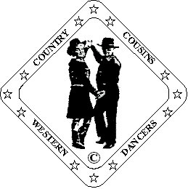
Ron & Ann Williams.
D & G Fully Qualified Instructors
B-W-D-A
023 9234 1758 ronannwilliams@ntlworld.com

New Horizons

Partner Dance (64 Count)

Choreographed By Ann Williams. Country Cousins Western Dancers. 06/12

Music: “A Whole New World” By Colin Raye.
CD: “Country Stars Disney Classics” Available iTunes & Amazon.
“Places I’ve Never Been” By Mark Wills.

Beats/Step Description.
Start in Sweetheart facing L.O.D. Same footwork except where stated.

Cross Rock. Recover. Chasse’ Left. Cross Rock. Recover. Chasse’ Right.
1-8 Step and cross rock left over right. Recover onto right. Chasse’ left stepping on left, right, left.
Step and cross rock right over left. Recover onto left. Chasse’ right stepping on right, left, right.

¼ Turn. Behind. ¼ Turn. Shuffle. Step. Pivot. Step. Pivot.
9-16 Turn ¼ right stepping onto left. Cross right behind left. Turn ¼ left into left shuffle forward.
Step right forward. Pivot ½ turn left. Step right forward. Pivot ½ turn left.
Release left hands, raise right over lady’s head and lower behind man’s back.
Rejoin left hands in front, release right, raise left hands over lady’s head, rejoin right
hands back in Sweetheart.

¼ Turn. Behind. ¼ Turn Shuffle.
17-20 Turn ¼ left stepping onto right. Cross left behind right. Turn ¼ right into right shuffle forward.
Release left hands, raise right over lady’s head. Rejoin left hands in Sweetheart.

¼ Turn. Together. Cross. Hold. Side. Together. Cross Shuffle. Side. Behind. ¼ Turn Shuffle.
21-32 Turn ¼ right stepping onto left. Step right beside left. Cross left over right. Hold.
Now in Indian position facing O.L.O.D.
Step right to right side. Step left beside right. Cross right over left into right cross shuffle.
Step left to left side. Cross right behind left. Turn ¼ left into left shuffle forward.
Now facing L.O.D. in Sweetheart position.

Rock. Recover. Shuffle ½ Turn. Shuffle ½ Turn. Rock. Recover.
33-40 Rock forward on right. Recover onto left. Turn ½ turn right on right shuffle.
Release left hands, raise right.
Turn ½ turn right on left shuffle. Step and rock back on right. Recover onto left.
Rejoin hands in Sweetheart after second ½ turn shuffle.

¼ Turn. Together. Cross. Hold. Side. Together. Cross Shuffle. Side. Behind. ¼ Turn Shuffle.
41-52 Turn ¼ left stepping onto right. Step left beside right. Step and cross right over left. Hold.
Release left hands, raise right over lady’s head, rejoin left in Reverse Indian.
Step left to left side. Step right beside left. Cross left over right in left cross shuffle.
Step right to right side. Cross left behind right. Turn ¼ right into right shuffle forward.
Release left hands, raise right. Rejoin hands in Sweetheart after ¼ turn shuffle.

Man: Step. Pivot. Shuffle ½ Turn. Rock. Recover Shuffle.
Lady: Rock. Recover. Shuffle ½ Turn. Step. Pivot. Shuffle.
53-60 Man: Step left forward. Pivot ½ turn right. Turn ½ turn right on left shuffle.
Rock back on right. Recover onto left. Right shuffle forward.
Lady: Rock forward on left. Recover onto right. Turn ½ turn left on left shuffle.
Step right forward. Pivot ½ turn left. Right shuffle forward.
On counts 53-54: Raise right hands, keep left low.
On counts 55&56: Raise left hands, lower right.
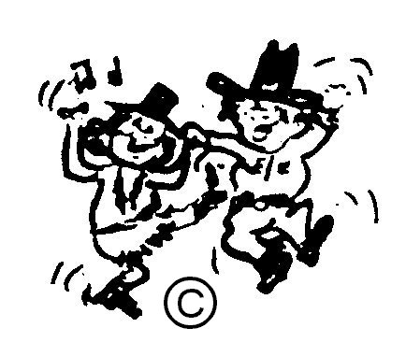
On counts 57-58: Go into Sweetheart when facing L.O.D.

Walk. Walk. Cross Rock. Recover.
61-64 Walk forward stepping on left, right. Cross rock left over right. Recover onto right.

HAPPY DANCING

