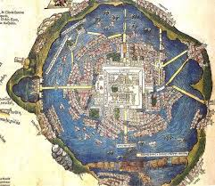 PBL: LIVING LARGE!
Within your flexible groupings…
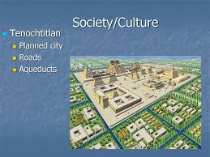
ROLES: Designate who is going to be responsible for various tasks.
RESEARCH: What is the purpose? What does it look like? What information is to be
provided? What questions are to be asked? How is it to be distributed?
RECORD: Itemize a list of specifics for your final product; materials, resources?
RESPOND: Make a plan of action to create your living large story line. Steps,
timeline, duties, etc… Create! Produce, direct your plan!
DELIVER: Present your final product.
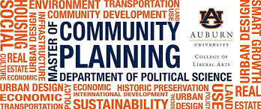
Get to it! You are going to be working together to create a community using the Learning Objectives and Essential Questions for the chapter – that would be applicable for the setting (time & place) of your topic. The special focus of your community plan is to provide insights into what social conditions exists/existed and how you could/would structure a NEW living community that would provide justice, liberty, prosperity, human rights and security for all members of the community. First, you must know the problems, their causes and effects of communities. BEFORE / AFTER visual! Then, you must provide realistic solutions to the problems. finally, how will your community members sustain their just and wholesome living environment? Keep in mind your historical context! What about additional marketing and business opportunities?

Scoring Rubric Guidelines: Accuracy, Completeness, Neatness, Originality, Presentation

