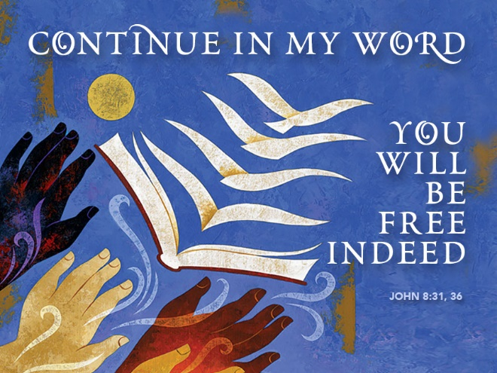

Knowing the Truth Is Remembering God
October 29, 2017
John 8:31-36
Reformation Sunday
Grace and peace to you from God our Father and from the one who makes you free, the Lord Jesus Christ, amen.
Truth and freedom and Jesus the trifecta, or the great hat trick if you prefer soccer terminology. A special Gospel message for a very special day in the life of the Lutheran Church, and in the lives of five young Lutherans sitting right up front here this morning. Today is Reformation Sunday. 500 years ago, our Dear Doctor Martin Luther started a firestorm by suggesting 95 issues for discussion within the Church. In publishing his ideas on a newfangled device called the printing press, Luther not only became the first bestselling author, his ideas literally changed the entire world and are still the basis for what we Lutherans believe about Jesus and how we read the Bible. It’s totally appropriate for us to commemorate the anniversary of such an important date in Church history. Today we remember Doctor Martin Luther and the Reformation he began on October 31st, 1517. Luther discovered or I should say re-discovered the truth about God’s grace that we receive as a free gift through trusting in the work and promises of Jesus Christ. This gift sets us free from sin, death, and the devil. So then, what is this truth that sets us free?
To help us understand what Jesus means by “truth,” I’ve got a story... Two middle-aged couples were enjoying friendly conversation when one of the men asked the other, “Fred, how was the memory clinic you went to last month?” “Outstanding,” Fred replied. “They taught us all the latest psychological techniques, such as visualization, association and so on. It was great. I haven’t had a problem since.” “Sounds like something I could use. What was the name of the clinic?” Fred went blank. He thought and thought, but couldn’t remember. Then a smile broke across his face and he asked, “What do you call that flower with the long stem and thorns?” “You mean a rose?” “Yes, that’s it!” He turned to his wife, “Hey Rose, what was the name of that memory clinic?”
In Psychology, memory is an organism’s ability to store, retain, and recall information and experiences. In the Bible, the Greek word to remember is aletheia. Aletheia literally means to "not forget." In most English translations, the word aletheia is translated as “truth.” So, truth in the Bible, literally means to not forget. To know the truth means to remember. Another way to think about this is to use a computer as an example. Every computer has two different kinds of memory. There’s the hard drive. That’s the storage disk where all my files and documents go when I click on save. The computer saves them someplace on that hard drive. Later when I need that information I can tell the computer to retrieve that file or document and it brings it back onto my computer screen. The other kind of memory in a computer is called RAM or Random Access Memory. This is the place where the computer put the information it needs right now. When I’m working on the sermon the document is in the computer’s RAM because it’s “thinking” about that information right now. Then I save the document and close it down it’s removed from the RAM and stored on the hard drive. Our brains work much the same way. All our memories are stored in our subconscious brain where they mostly can be recalled when we need them. Those things we’re thinking about right now are kept right up front here in the frontal lobe. The frontal lobe is sort of like the RAM in the computer. This Greek word aletheia has the sense or keeping the things of God right up here in the frontal lobe of our brain and never letting them go back into the memory section of our hard drives.
The truth is, the only way for us to have freedom from sin, death, and the devil is to always remember and never forget all the mighty acts of love and sacrifice God has done for us. That’s why we never stop offering education classes and even if you’ve already been through classes on every book of the Bible and you completed catechism with flying colors, to be free we must continuously remember the mighty actions and the great promises of God. Promises like forgiveness of your sins, salvation, and eternal life. Mighty actions like rescuing God’s chosen people from slavery in Egypt and sending Jesus who died for our sins, was resurrected from the dead and ascended into heaven where he sits at the right hand of the Father and will come again to judge the living and the dead. Then there’s the best promise of them all, the promise Jesus made that He would come again and take us all to His Father’s house where he has gone ahead to prepare a place especially for each and every one of us. Those are some pretty great actions and even better promises and all of them are worth remembering.
In a few minutes we’re all going to do some remembering. I’m going to be asking Ky, Maya, Emma, Landon, Katie the same questions that were asked of their parents and sponsors a long time ago when they were baptized as infants. We’re going to remember the promises, not that Jesus made for them, but promises made by parents and sponsors for them because they couldn’t speak for themselves. Ky, Maya, Emma, Landon, and Katie you are now old enough to understand these promises and to speak for yourselves. You’ve spent 2 long years discovering what these promises mean. You’ve been examined and are able to tell me what your faith means to you now, after all of that study and searching. I know you are ready to take on even greater responsibilities as fellow workers here in God’s Kingdom. I’m really proud of each of you in the way you’ve grown in faith and the love of God. Here’s the truth. Your Christian education doesn’t stop here. Today isn’t graduation from Sunday School. If that’s the way you see it, then I’ve failed you and Jesus. Hopefully, I’ve given you the tools to continue discovering and rediscovering all the great acts and wonderful promises of God.
George Barna wrote The State of the Church in 2002. Barna conducted a survey of self-professed Christians and here’s what he found about their knowledge of the Bible. Bear in mind Barna surveyed Christians, not atheists or just average citizens, these are statistics gathered from all 100% people claiming the identity of Christian...
• 48% could not name the four Gospels.
• 52% cannot identify more than two or three of Jesus’ disciples.
• 60% of American Christians can’t name even five of the 10 Commandments.
• 61% of American Christians think the Sermon on the Mount was preached by Billy Graham.
• 71% of American Christians think “God helps those who help themselves” is a Bible verse. (It isn’t!)

George Barna said, “Americans revere the Bible, but by and large they don’t know what it says. And because they don’t know it, they have become a nation of biblical illiterates.” Just as the people in this Barna poll are woefully biblical illiterate, Christians are far too ignorant of the Word of God. No wonder 21st century Christians by the thousands are falling prey to false teachers and prophets of our day. When we don’t study the Bible for ourselves, we’re being feed junk food and don’t feed ourselves on the Word of God. To know the truth and not forget everything Jesus did and taught we desperately in need a solid diet of good food, Scripture. Back in Luther’s time people were Bible illiterate because there were no Bibles written in their language. All Bibles were in Latin. Luther changed all that when he translated the Bible from the Greek and Hebrew into German. The people had no excuse not to read their Bible. I wonder if we’re not complacent because we’ve become used-to having the Bible so readily available…
Ky, Maya, Emma, Landon, and Katie; may you never forget the truth of how much God loves you. May you always remember the tools you have been given through your catechism and may you find joy as you use the intellect God has given you to discover and rediscover all the ways God has demonstrated his love and all the promises God has in store for you that are yet to come.
May we all give thanks and praise to God for raising up great reformers of the Church. By constantly returning to the scriptures may we remember our God and his great love for us and how God freed us from our bondage to sin, death and the devil. Now that we’re freed and forgiven, let us serve God by serving our neighbor and spreading this incredibly good news we have in Christ Jesus. Amen.

