September/October 2021
We now seem to notice a different “feeling” in the air…..fall is approaching; leaves on the trees are beginning to change color & soon there will be a “nip” in the air changed from the one of summer! This “new” season brings an opportunity of different indoor & outdoor activities and we hope you enjoy them all!

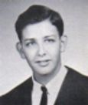

We were recently notified by Jane Meisterics, wife of alum, John Meisterics, that John passed away April 26, 2021. While a student at GHHS, he participated in Intramurals & Latin Club. John was a U.S. Army veteran; his love of camping & fishing began with his father. It was a love that he happily passed to his sons & grandchildren. He was a good person & friend to many & willing to help anyone.

John is survived by his wife of 47 years, Jane, and children John & Brian. He is a grandfather of four.

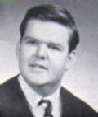
Gregory Widmar passed away in Put-in-Bay, Ohio, on September 29, 2021. Greg was a former student of Chanel High School before attending GHHS. He is survived by brothers Gary & Jeffrey, and was a dearest uncle to four. A prayer service was held at the baseball field next to the Mother of Sorrows Catholic Church in Put-in-Bay on October 16th.

Our sympathies are extended to John & Greg’s families and friends. They will certainly be missed!!
********************************

Alumni “On the Go”: Peggy Terry Berteau, with husband, Bob, were in Michigan September 7th to see their granddaughter begin 7th grade; Bill Williams attended the Medina car show on September 11th where 125 cars were entered. The show was a combined effort of the Eagles & American Legion Post #202.
Ruth Mendala Thompson & husband, Ed, began a “tour of the West” – they visited Monument Valley, the Grand Canyon, Canyonlands, Bryce, Arches & Zion National Parks, along with many other points of interest. Ed truly researched & planned the entire trip. Helen Steblinski Cejer vacationed in September at the Aruba Beach Club in Aruba. Tom & Janice Wroblewski Hola were in Florida mid-September, as was Pam Poveroni Conrad with husband, Joe.
Nancy Levis Knowlton was in Minneapolis visiting her grand-niece, as well as her grand-nephew who just turned the age of two; Nancy hasn’t seen him due to COVID. Karen Soika Palker was in Charleston, SC, September 25th with family visiting the 400 year old Angel Oak Tree that stands in a wooded area on John’s Island outside of the city.
Traveling in October were Dan Mihalik, with wife, Mary Ann, who visited family in California; Floyd & Gayle Glowick Konet who were in Scottsdale, AZ, October 5th; Rhea Jones Ashmore also visited Glacier National Park; Amy Roman Kostka & husband, Bill, were in Columbus, OH, to visit their son & then were off to the Stonewall Jackson Resort State Park, Karen Kuderna Kudley traveled to Boston, and Gail Russler Meyer with husband, Barry, traveled to New Bern, NC, for its annual Mum Festival, which was a great introduction to fall.
Anniversary Kudos To: Rosemarie Martinovich Spatny & husband, Jim, who celebrated their 52nd wedding anniversary September 13th; Guy Papa & wife, Karen, partied on September 29th for their 50 + 1 anniversary (the 50th was cancelled due to COVID); Leslie Mroz Readinger with husband, Jeff, shared 50 years together as of September 24th; Sharon Travagliante Weitzman & hubby, Paul (Skip), celebrated their 27th anniversary on September 30th, Tom Atherton with wife, Linda, had their 44th anniversary October 7th and Bill Williams & wife, Cathy, will share their 52nd anniversary on October 25th.

Congratulations, Everyone, with many more years to share together!

Faculty Kudos: To former faculty member, William Toneff,, who still keeps going at the ripe age of 102! Three graduates from the Class of ’65 were in touch with him recently. See the Facebook post below:

And faculty member Dennis Blue had a chance to take his grandson charter fishing before his grandson returned to Ireland for his junior year of college. He attends Liberty University in Dublin.
Condolences to: Mary Kotowski Cross & family upon the death in August of Mary’s father, Eugene Kotowski, age 92. Mr. Kotowski was father to seven, grandfather to eight, and great-grandfather to four, and to,
Douglas Morell & family upon the August 27, 2021, passing of his mother, Angela M. Morell, age 94. Mrs. Morell was mother to four, grandmother to six and great-grandmother to three.
Our prayers are certainly with all of you and your extended family!
“Death leaves a heartache no one can heal. Love leaves a memory no one can steal”.
( HELP! Upon receiving the news of the death of Mrs. Morell, we attempted to extend our class condolences via card to Doug, but that sympathy card was returned as an “invalid address”. Does anyone presently keep in contact with Doug? He had resided in the State of Washington. While we have emailed Doug about his contact information, he has not responded; therefore, if anyone might know of his whereabouts, we would be eager to know about it. Thanks!)

Newsy Reflections & Tidbits: The “Lady Bulldogs” once again are meeting for lunch. An October luncheon was held on the 16th at 1pm at Danny Boys in Broadview Heights. The photo below shows those who attended (with a few of them thinking “Halloween”): Leslie Mroz Readinger, Amy Roman Kostka, Helen Steblinski Cejer, Gayle Glowick Konet, Ruth Mendala Thompson, Nancy Levis Knowlton, Audrey Sopko, Linda Maciaszek Fauble, Karen Soika Palker, Pam Poveroni Conrad, Linda Wike Calkins, Kathy Schneider Nowack & Janice Wroblewski Hola.
Check our facebook page (Class of ’67 GHHS Lady Bulldogs) for details concerning the next lunch. Join us if you can!

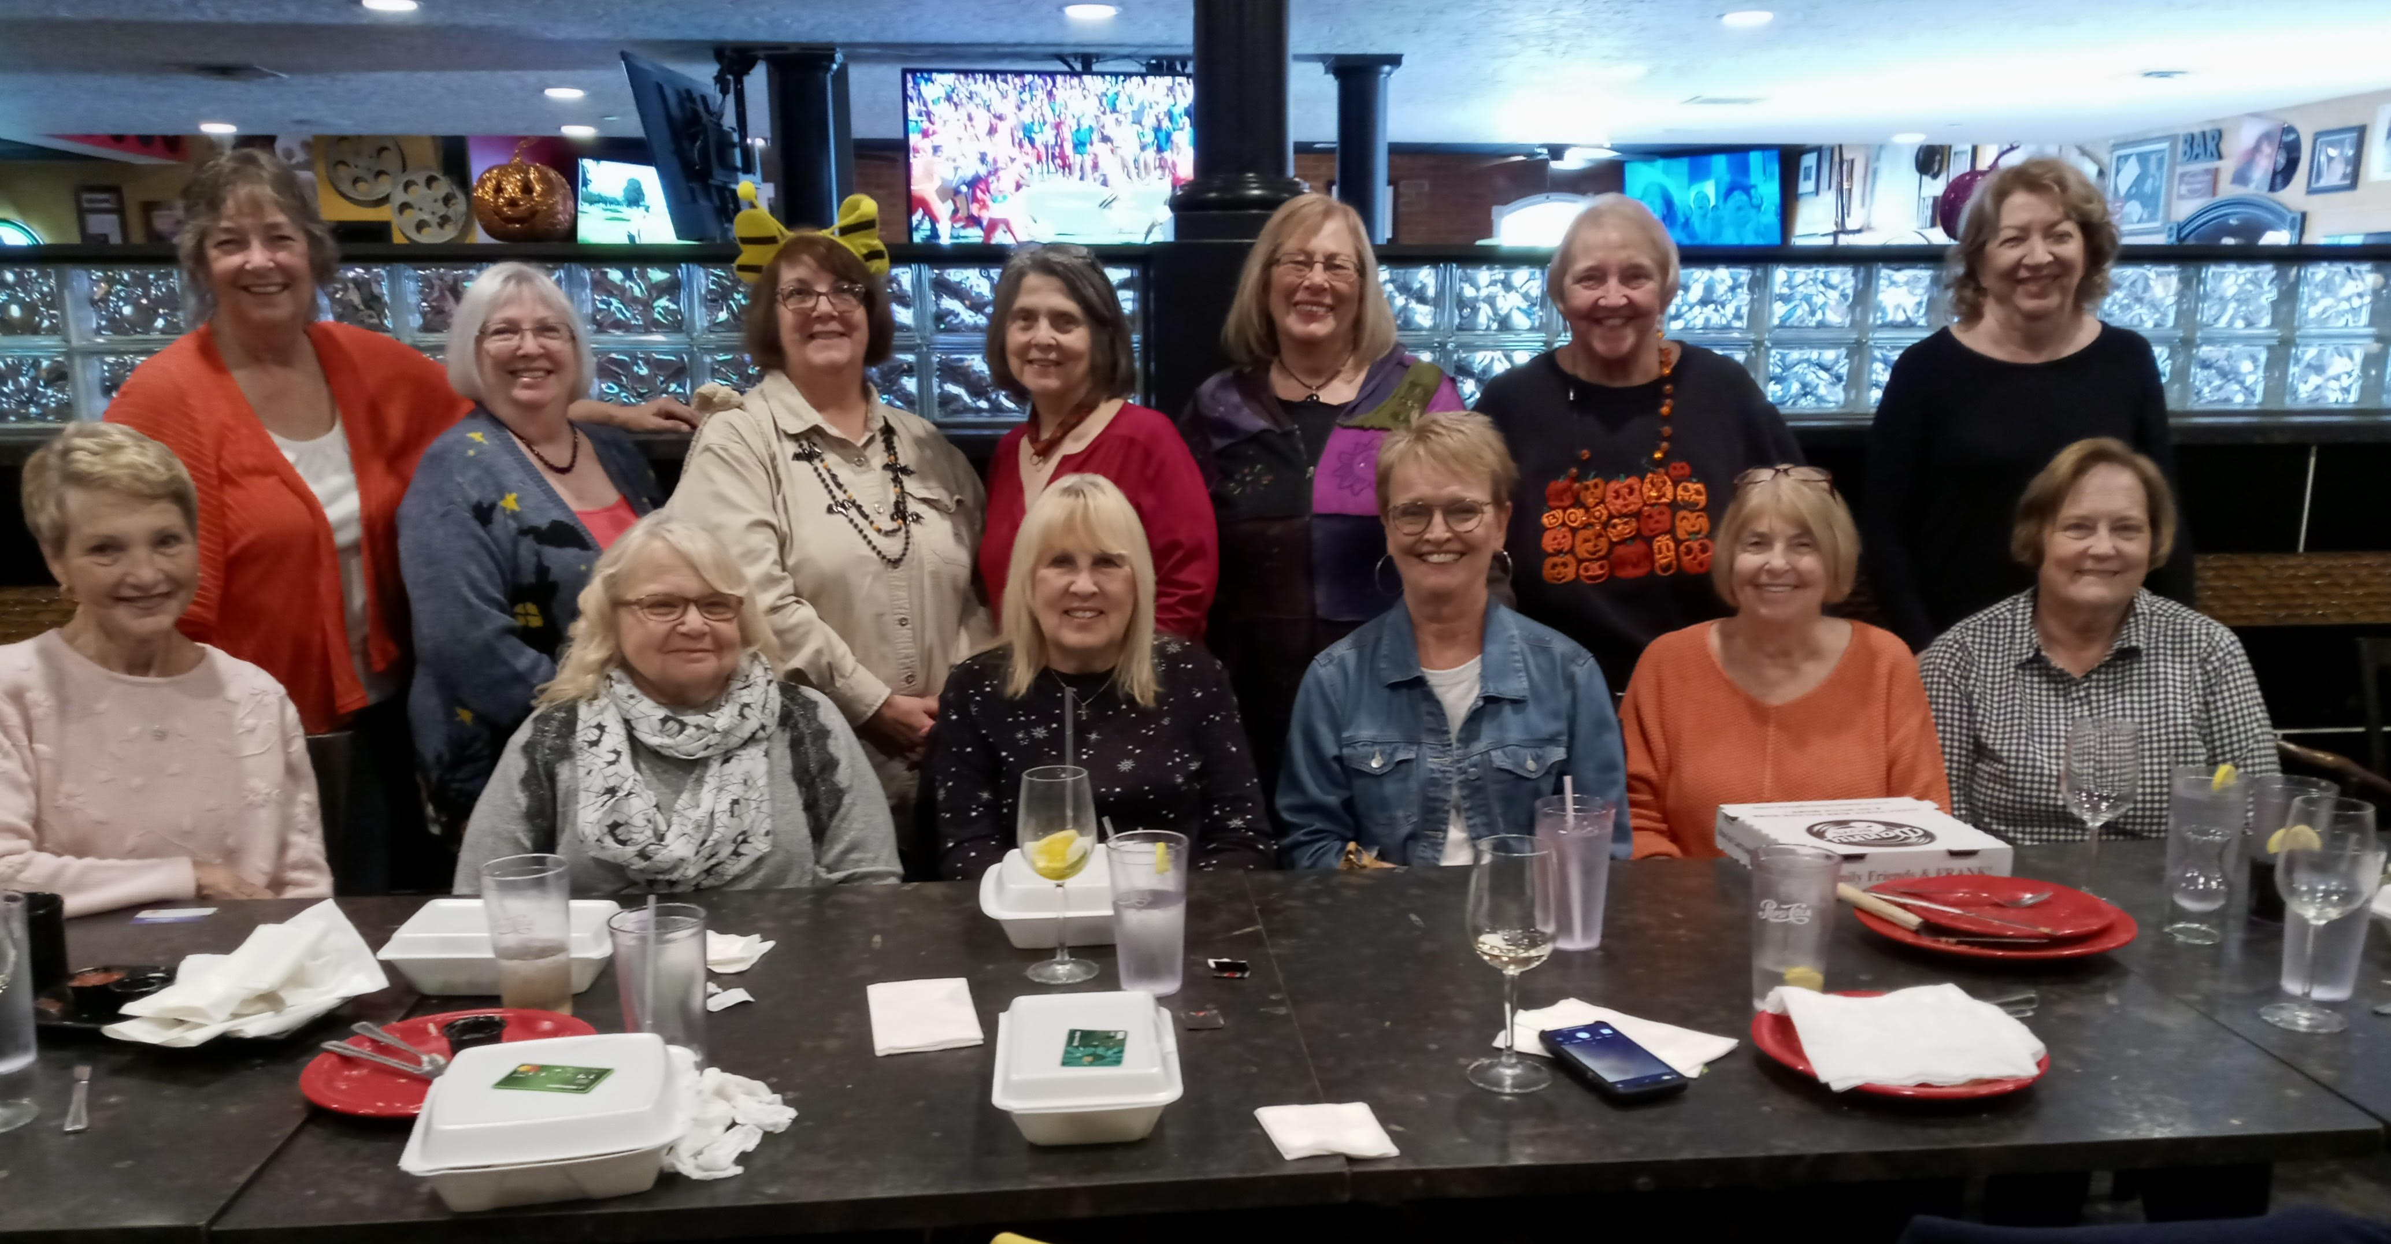

*********************************************

Zoom meetings have also been organized to try & keep alums in contact with each other. Since the last one was in March, 2020, Audrey recently organized another one on October 4th at 2pm. Six folks joined her: Ann Marie Kovalik Ayers, Ron Kosey, Kathy Schneider Nowack, Stan Slempa & Bill Williams. Since there was a small number, there was plenty of time for each one to talk. Some of their discussion included the fact that Ron walks regularly; Bill & wife, Cathy, organized their garage to fit in Cathy’s car for the winter, as Bill’s truck can take the weather; Stan still loves to teach, and Kathy said husband, Ken, is home getting physical therapy; he was in rehab after being in a nursing facility for muscle fatigue. Hopefully, he will be back on his feet soon!

Invitations for zoom sessions are sent to all alumni. Should you like to participate, simply send Audrey Sopko an email (asopko@sbcglobal.net). She will even provide a help session beforehand! Zoom sessions are invitation only and use a waiting room, to avoid zoombombing.

**************************************

Because of COVID, alumni events have been few & far between. However, on October 7th at 6pm, a total of 26 alumni & partners were finally together at the Tavern of Independence on Brecksville Road for dinner & camaraderie. Those participating were Tom Atherton, Linda Wike Calkins, Ron Clark, Linda Maciaszek Fauble, Lora Finocchi Garrett, Tom & Jan Wroblewski Hola, Mark & Linda Sindelar Kavaras, Bill & Amy Roman Kostka, Phil Magro, Dan & Mary Ann Mihalik, Karen Soika Palker, Tom & Janice Pavlinsky, Frank & Rose Mary Sanuk Remesch, Buddy & Cindy Ruggerio Rifici, Audrey Sopko, Skip & Sharon Travagliante Weitzman, & Bill & Cathy Williams.

Check out the photo below of this happy bunch!

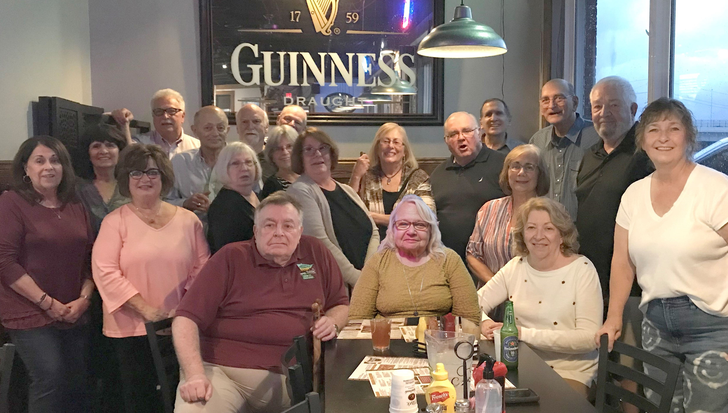

☺ ☺ ☺ ☺ ☺ ☺ ☺ ☺ ☺

Some Interesting Trivia: For those of you who attended Elmwood Elementary School, do you remember any of the participants of the undefeated basketball team as shown in the photo below? Bob Whewell of the GHHS Class of ’65 posted this photo.

AND, if you are going to be choosing a pumpkin for carving this year, here are a few “tips”:

- Reject a pumpkin that has soft spots as they cause the pumpkin to deteriorate quickly;
- Hollow the pumpkin if the inside is going to be exposed or if you plan to light the pumpkin from the inside. You can hollow it out from a hole in the back instead of the top, so that the look of the face isn’t affected. If you are illuminating with a candle, you need to hollow from the top to allow the heat & smoke to escape.
- To achieve a 3-dimensional appearance, carve the entire pumpkin & exaggerate the features. If the pumpkin is frowning, carve wrinkles under the mouth; to add character, carve a lot of “crow’s feet” lines around the eyes.
- Pumpkins are actually a fruit and not a vegetable; 90% of it is water so after carving they usually last only 3 days to a week. One that has a surface carving will last longer than one cut all the way through. Putting a candle or light inside will shorten its life span, as the heat that results will reduce its longevity to a matter of hours.
- For a bright, shiny finish, spray Armor All on the pumpkin & rub it in. Paint will not preserve it, but if you use a paint, chose a water-based latex paint & wait at least an hour after carving so that the cuts made in the pumpkin have a chance to dry.
- Good luck!

***************************

Stay tuned for our next newsletter and the antics of a couple of train-loving alumni!

And with those comments, this newsletter has ended. Until the next issue, Go Bulldogs!!!

Your loyal editor,
Gail Russler Meyer

P.S. The undefeated Elmwood basketball team members in this photo were: Chuck Bulina (’64), Mike Remesch (’64), Dan Gaicki (’64), Bob Whewell (’65), Jim Kelley (’64) & Coach, Frank Stanevich.

