Grace and peace to you from God our Father and from Jesus the Crucified Lord who gave everything for us.
The cost of our salvation was more than we can imagine. On this Christ the King Sunday it would be good for us to remember and at least try to imagine just what our King was willing to endure for you and for me. The following is an account of what a human body, what Jesus’ human body must go through when it is subjected to the cruel torture known as crucifixion. Please relax and try to picture the scene…
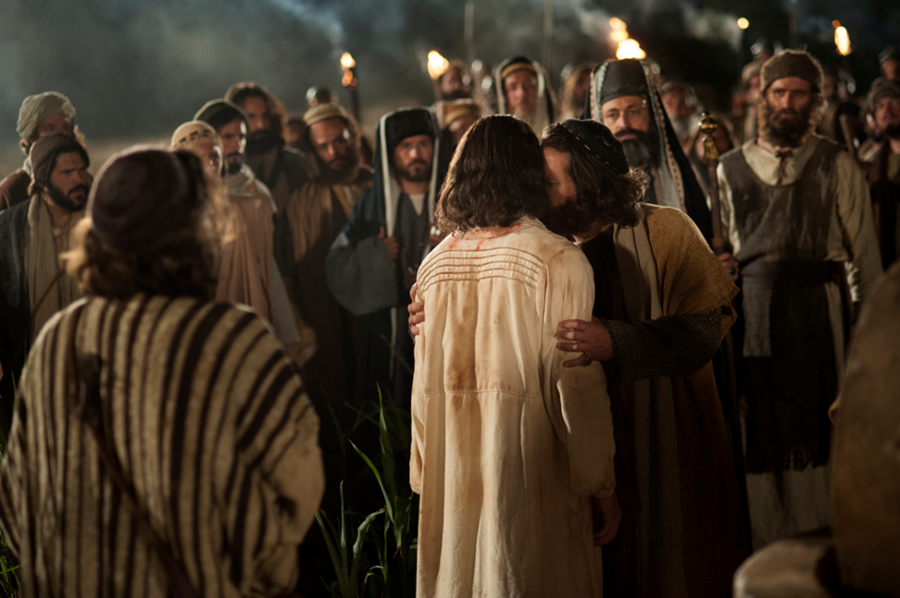
After Jesus was arrested in the middle of the night, he was brought before the Sanhedrin and Caiaphas, the High Priest; it was here that the first physical trauma was inflicted. A soldier struck Jesus across the face for remaining silent when questioned by Caiaphas. The palace guards then blindfolded Him and mockingly taunted Him to identify them as they each passed by, spat on Him, and struck Him in the face.
In the early morning Jesus, battered and bruised, dehydrated, and exhausted from a sleepless night, is taken across Jerusalem to Herod. You are familiar with Pilate's action in attempting to pass responsibility to Herod. Jesus apparently suffered no physical mistreatment at the hands of Herod and was returned to Pilate. It was then, in response to the cries of the mob, that Pilate ordered Barabbas released and condemned Jesus to scourging. Preparations for the scourging are carried out.
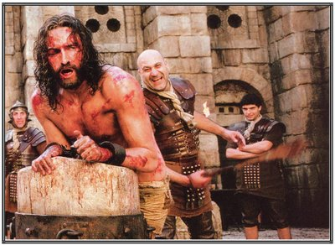
The prisoner is stripped of His clothing, and His hands tied to a post above His head. The Roman legionnaire steps forward with a short whip in his hand. This short whip consists of several heavy, leather thongs with small balls of lead or pieces of bone, attached near the ends of each. The heavy whip is brought down with full force again and again and again ..... across Jesus' shoulders, his back, and his legs 39 times. At first the heavy thongs cut through the skin only.
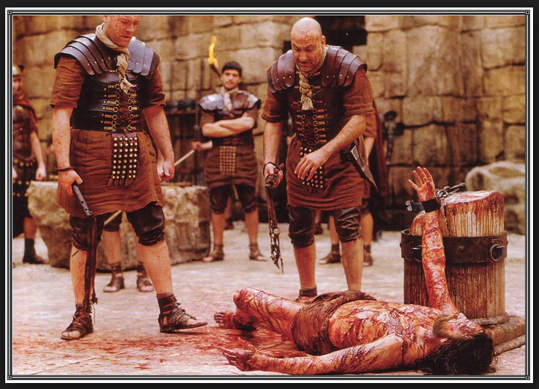
Then, as the blows continue, they cut deeper into the tissues, producing first an oozing of blood from the capillaries and veins of the skin, and finally more open bleeding from vessels in the underlying muscles. The small balls of lead first produce large, deep bruises, which are broken open by subsequent blows. Finally the skin of the back is hanging in ribbons and the entire area is an unrecognizable mass of torn, bleeding tissue. When it's determined by the centurion in charge that the prisoner is near death, the beating is finally stopped.
The half-fainting Jesus is then untied and allowed to slump to the stone pavement, wet with His own blood. The Roman soldiers see a great joke in this provincial Jew claiming to be a King. They throw a robe across His shoulders and place a stick in His hand for a scepter. They still need a crown to make their travesty complete. A small bundle of flexible branches covered with long thorns (commonly used for firewood) are plaited into the shape of a crown, and this is pressed into His scalp. Again there is more bleeding. After mocking Him and striking Him across the face, the soldiers take the stick from His hand and strike Him across the head, driving the thorns deeper into His scalp. Finally, they tire of their sadistic sport and the robe is torn from His back. The robe had undoubtedly already become adherent to the clots of blood and serum in the wounds, and its removal, just as in the careless removal of a surgical bandage, causes excruciating pain .... almost as though He were again being whipped ....and the wounds again begin to bleed.
In deference to Jewish custom, the Romans return His garments. The heavy cross beam of the cross is tied across His shoulders, and the procession of the condemned Christ, two thieves and the execution detail of Roman soldiers, headed by a centurion, begins its slow journey along the Way of Sorrows. In spite of His efforts to walk erect, the weight of the heavy wooden beam, together with the shock produced by copious blood loss, is too much. He stumbles and falls. The rough wood of the beam gouges into the lacerated skin and muscles of the shoulders. He tries to rise, but strength has been pushed beyond endurance. The centurion, anxious to get on with the crucifixion, selects a stalwart North African onlooker, Simon of Cyrene, to carry the cross. Jesus follows, still bleeding and sweating the cold, clammy sweat of shock. The journey from the fortress to Golgotha is finally completed. The prisoner is again stripped of His clothes, except for a loin cloth, which is allowed the Jews.
The crucifixion begins. Simon is ordered to place the cross beam on the ground and Jesus is quickly thrown backward with His shoulders against the wood. The legionnaire feels for the depression at the front of the wrist. He drives a heavy, square, wrought-iron nail through the wrist and deep into the wood. Quickly, he moves to the other side and repeats the action, being careful not to pull the arms too tightly, but to allow some flexion and movement. The cross beam is then lifted in place at the top of the cross and the title reading "Jesus of Nazareth, King of the Jews!" is nailed in place.
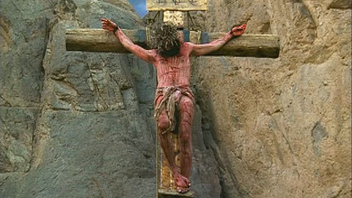
The left foot is pressed backward against the right foot, and with both feet extended, toes down, a nail is driven through the arch of each, leaving the knees moderately flexed. The Victim is now crucified. As He slowly sags down with more weight on the nails in the wrists, excruciating, fiery pain shoots along the fingers and up the arms to explode in the brain ....the nails in the wrists are putting pressure on the median nerves. As He pushes Himself upward to avoid the stretching torment, He places His full weight on the nail through His feet. Again there is the searing agony of the nail tearing through the nerves between the metatarsal bones of the feet. There is a saddle board upon which the crucified could half sit, but the design of it was intended as much to inflict pain in yet another area as to aid the victim and prolong the agony.
At this point, another phenomenon occurs. As the arms fatigue, great waves of cramps swell over the muscles, knotting them in deep, relentless, throbbing pain. With these cramps comes the inability to push Himself upward. Hanging by His arms, the pectoral muscles are paralyzed and the intercostal muscles are unable to act. Air can be drawn into the lungs, but cannot be exhaled. Jesus fights to raise Himself in order to get even one short breath. Finally, carbon dioxide builds up in the lungs and in the blood stream and the cramps partially subside. Spasmodically, He is able to push Himself upward to exhale and bring in the life-giving oxygen. It was during these periods that He uttered the seven short sentences ...."Father, forgive them for they know not what they do." To the penitent thief, “Today you will be with me in Paradise." To John (the beloved Apostle), "Behold your mother," and to Mary, His Mother, "Woman, behold your son." Then the cry from the beginning of the 22nd Psalm, "My God, My God, why have you forsaken me?" His cry indicates an agony even more painful than the inexpressible physical torture-- in His sin-bearing for us Jesus endures the excruciating trauma of being cut off from His Father God.
Hours of this limitless pain, cycles of twisting, joint-rendering cramps, intermittent partial asphyxiation, searing pain as tissue is torn from His lacerated back as He moves up and down against the rough timber. Then another agony begins .... a deep crushing pain deep in the chest as the chest cavity slowly fills with serum and begins to compress the heart.
It’s almost over now. The loss of tissue fluids has reached a critical level. The compressed heart is struggling to pump heavy, thick, sluggish blood into the tissues. The tortured lungs are making a frantic effort to gasp in small gulps of air. The markedly dehydrated tissues send their flood of stimuli to the brain. Jesus gasps His fifth cry from the cross, "I thirst." A sponge soaked in cheap, sour wine which was the staple drink of the Roman legionnaires, is lifted to His lips. He apparently doesn't take any of the liquid. Jesus now can feel the chill of death creeping through the tissues. This realization brings out His sixth saying from the cross, possibly little more than a tortured whisper, "It is finished." His mission of atonement complete. Finally He can allow His body to die.
With one last surge of strength, He once again presses His torn feet against the nail, straightens His legs, takes a deeper breath, and utters His seventh and last cry, "Father, into your hands I commit my spirit." How costly the grace of God as we see it in the One crucified for us! God’s grace - free, but certainly not cheap!
As we remember Christ Our King let us never forget the price Jesus paid for you. Thank you doesn’t seem adequate, yet that’s all we have. Thank you Jesus, amen.

