TRINITY UNITED METHODIST CHURCH
The Rev. Doug Benton ___ Minister
July 4, 2021 Color: Green
SIXTH SUNDAY AFTER PENTECOST
"We welcome you to our service this morning and pray that your time with us will be a blessing to you"
THE ORDER FOR WORSHIP
Prelude Mr. Eddie Welborn
The Prelude is a time for silent preparation for worship.
Welcome and Announcements Mr. Grady Senn
The Chiming of the Hour Mr. Eddie Welborn
The Lighting of the Candles
The Processional of the Cross
“On the stool with Pastor Doug”
The Call to Worship Rev. Doug Benton
Opening Prayer Rev. Doug Benton
The Children’s Time Rev. Doug Benton
The Hymn of Adoration: “For the Beauty of the Earth” Page 92
*The Apostles Creed Page 881
*The Gloria Patri: “Glory Be to the Father”
Prayer Concerns and Praises Mr. Grady Senn
The Pastoral Prayer Rev. Doug Benton
Tithes and Offering Ushers / Mr. Grady Senn
*The Doxology: “Praise God From Whom All Blessings Flow”
*The Hymn of Preparation: “Happy the Home When God is There” Page 445
First Reading: 2 Samuel 5:1-5, 9-10 Mr. Grady Senn
Second Reading: Psalm 48 Mr. Grady Senn
*Sermon Scripture: 1 Corinthians 1:3-9 Rev. Doug Benton
Transitional Music
The Sermon: “Family Matters” Rev. Doug Benton
Sacrament of Holy Communion - All are Welcome at the Lord’s Table -- See Pew Card
*The Hymn of Service: “Blest Be the Tie That Binds” Page 557
*The Returning of the Light

*The Benediction Rev. Doug Benton

*Three-Fold Amen Mr. Eddie Welborn
*The Postlude Mr. Eddie Welborn
*All who are able stand. The altar is open for prayer during the last hymn.
Technician: Miss Caroline Senn

The Altar Flowers are given to the Glory of God and
in honor of Pastor Doug by the Trinity Church Family..

Next Sunday – July 11

Altar Flowers: Open; Scripture Reader: Kelly Morris; Technician: Josh Pitts

Our Faithfulness
Live Streaming, June 20: 74
Live Streaming, June 27: No Live Streaming on this Sunday
Worship Attendance for June 27, 2021: 54
Total Budget for 2021: $ 149,647.00
Weekly Offering Needed: $ 2,877.83
Offering Received June 20, 2021: $ 1,222.00
Offering Received June 27, 2021: $ 2,067.00
2021 Average Weekly Offering YTD: $ 2,286 .00

The Concerns of Trinity
Our Known Hospitalized:
Recent Hospitalizations and/or Surgeries:
Nursing Home: Gloria Brehmer (Springfield Place)
Continued Prayers: Robert Pollard, James and Jeanette Poag, Cheryl Longshore, Shirley Berry, Rebecca Bundrick,, Frieda Kesler, Wayne Black, Mary Forrest, Ashley Wilson

Family and Friends of Trinity: Blake Hendrix, Phillip Sanders, Wilson Bowles, Charlotte Berry, Megan Wainwright, Diane Merchant, Neil Thomas, Francis Leopard,
Sal Welborn

Upcoming Events at Trinity

July 4: Pastor Benton’s first Sunday at Trinity
July 12: Administrative Council meeting – 6:30 pm
July 20 & 21: VBS - Barnyard Roundup - Please see information sheet
in Narthex

If you would like to place flowers in the church, please leave Peggy Bogart,
secretary, a note or an altar flower form on wood table desk in Narthex.

WELCOME VISITORS

Thank you for coming today! We are delighted you are here! We hope
you will join us again as we continue to discover the difference God’s love makes in our lives. If you have questions or desire to become a member of Trinity UMC, please speak to pastor. We’re blessed because you’re here.

Trinity United Methodist Church Please visit our website for bulletins & newsletters:
1160 Trinity Church Road www.trinityumcnewberry.net
Newberry, SC 29108
Rev. Doug Benton, Pastor
803-276-1245 (Church Office)
803-768-7687 (Church’s cellphone)
803-543-0082 (Pastor’s Cell)
dobenton@umcsc.net

Trinity
United
Methodist
Church

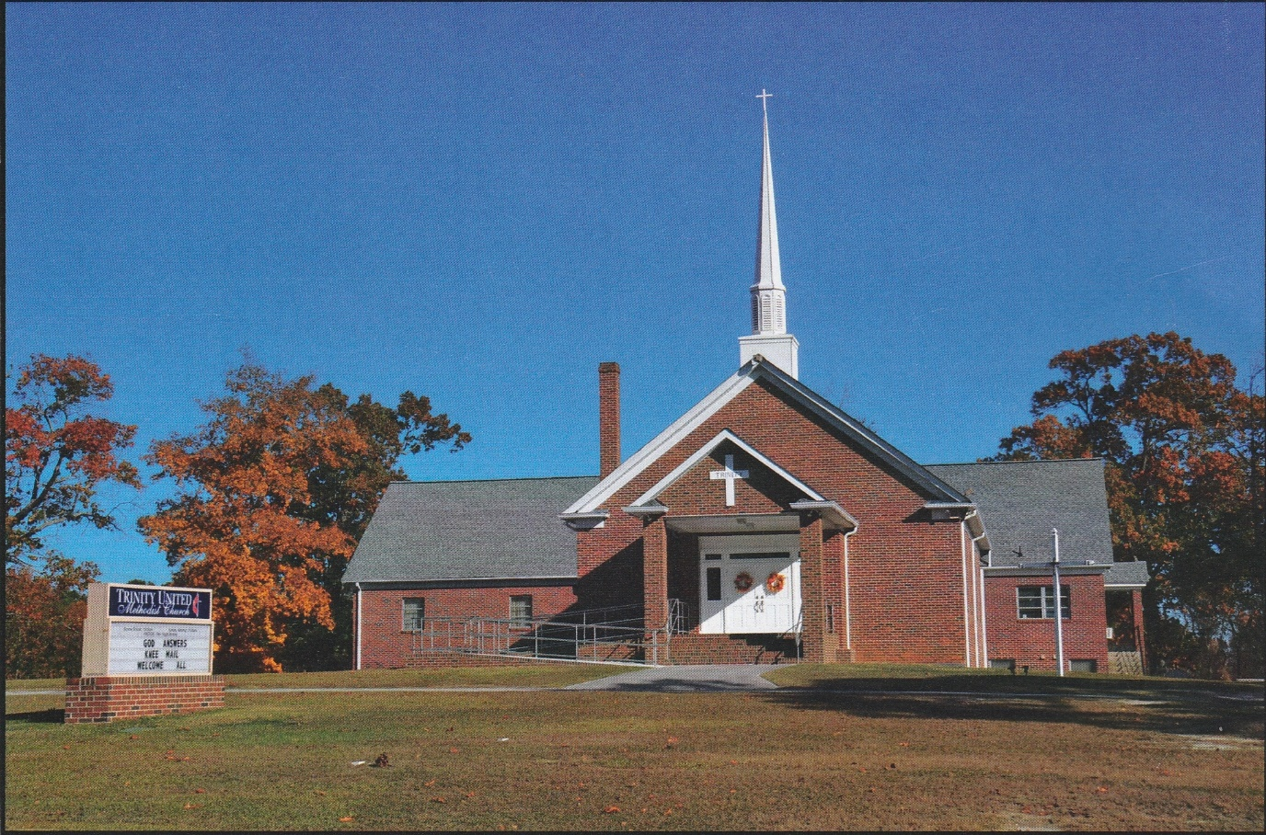

1160 Trinity Church Road
Newberry, SC 29108
Trinityumcnewberry@gmail.com

