University Women of Cambria
PO Box 1621
Cambria, CA 93428

www.universitywomencambria.com
Our Mission Statement
The purpose of the University Women of Cambria is to encourage and enjoy the pursuit of higher education. To this end, the organization awards annual scholarships to qualified graduating seniors of Cambria high schools, promotes and participates in community endeavors with an emphasis on education, and fosters fellowship among its members.
A Message from the Co-Presidents Margie Sesser and Cindy Bitto
We are both so happy to serve as your presidents this year. Our enthusiastic board has made the year exciting and we have engaged many new members. We will be sending the dues renewal separate from this newsletter and are so grateful that there was a 2/3 vote to increase dues to $40 per year. This will allow us to be more generous with our scholarships! Thank you so much for being a part of this fantastic group of women dedicated to education.
New Membership
Happy Spring! We are so happy to welcome 16 new members! They are as follows: Nancy Allen, Juli Amodi, Sharon Delp, Robin Donaldson, Casey Erikson, Allison Hayward, Gayle Jenkins, Penny Johnson, Sharon Jordan-Evans, Joan Lawrence, Jennifer Lawson, Debbie Markham-Humphries, Tigg Morales, Louise Mazerov, Denise Schaupp and Jeanette Vandenbergh. The Board will be welcoming them at a tea on Sunday, April 29th at the home of Margie Sesser.
Scholarships
We are looking forward to awarding new scholarships at our luncheon at Cambria Pines Lodge on May 21. We will be meeting our award recipients and learning about their aspirations and dreams! Kudos to our amazing scholarship Committee Chair Jean Chinnici, and committee members Donna Crocker, Darlene Bowe, Sue Nash, and Diane Dougherty. They had the difficult task of interviewing and selecting our scholarship award winners from a diverse group of worthy students. Our holiday fundraiser, monthly drawings and luncheon/activities donations brought in $11,182. Thank you to our membership for voting to increase our dues so that we may offer more students scholarships to assist with their college expenses. The vote was passed by a 2/3 majority vote of the total membership 78 to 10 as required by our bylaws. We are able to award $12,000.00 in scholarships! Thank you Rosemary Flamion for taking care of the logistics of the vote and all of your other duties that you do with such style and skill!

Programs
Our line-up of programs this year was organized by our First Vice-President Co-chairs, Cori Zinn and Hilary Townsend. They developed a roster of interesting events that 305 members and their guests attended this year. Thank you, Cori and Hilary, for all of the time, talent and creativity that you put into this wonderful lineup of programs.
September 18, 2017 Ted Siegler -NCAC Robin's
October 16, 2017 Stepladder Creamery Tour Stepladder Ranch
November 13, 2017 Wine Tasting 101 Madelines
December 4, 2017 Holiday Celebration and Cambria Pines Lodge
Scholarship Benefit Auction
February 21, 2018 Home Sweet Anywhere Harmony Cafe
March 18, 2018 Thoroughly Modern Millie Coast Union H. S.
To be announced Hearst Arabian Horse Ranch Hearst Ranch
May 21, 2018 Scholarship Awards Luncheon Cambria Pines Lodge
June 18, 2018 Interactive Craft Activity and
Gourmet lunch Bassetti Ranch
Holiday Fundraiser
Our Holiday Fundraiser was coordinated by Rebecca Hendricks and assisted by Treasurer Rosemary Flamion. The fundraiser was a huge success. The music was provided by Rebecca and her talented group Lyra and the relaxed format of the event allowed more shopping and more mingling of guests. The students were so much fun delivering the merchant drawing gifts, and we are looking forward to another amazing event in December. Thank you, Rebecca, for your talents and the ability to sing during the event and coordinate the day on a scooter!
Interest Groups
University Women Interest Groups are open to all our members. We have two book groups and a bridge group. New members are always welcome. Both book groups meet on the first Monday of the month. The morning group reads a mutually agreed upon book for everyone to discuss. Kathy Hurrle is the facilitator (927-2271). The afternoon group is a free-read; members report on books they have recently read and recommend. Diane Young is the facilitator (927-8798). Our last interest group is social Bridge. They play on the 2 and 4 Mondays at 1 pm. Call Dianne Dougherty for information (927-5093). They welcome members who want to join – substitutes are always needed. Thank you to Kathy Hurrle for her work as secretary of our group, and her involvement in the groups.

Honoring our Volunteers
The board has started a new tradition this year, to acknowledge members who go above and beyond in volunteering to assist us with our mission. We want to recognize and show appreciation for our members who go the extra mile. This year we have honored the following members who have given so much of their time and talents: Marge Sewell, Eunice Wilson, and Donna Crocker. We will continue this tradition of recognizing our outstanding members.
Facebook
Like us on Facebook! We are now on Facebook due to our talented treasurer, Rosemary Flamion. Go to Facebook and ask to friend Rosemary Flamion and she will approve you on to our University Women of Cambria’s Facebook page! She has also provided some creative visuals for our members in her treasurer’s report!
Membership List
Last year the membership voted on to discontinue printing the membership handbook to have more funds for scholarships. Rosemary has been updating the membership roster monthly so we are current with our membership list. We will continue this format for the next year and would like to add everyone’s emails to the contact list. Please let Rosemary know if you do not wish to have your email listed (rflamebird@aol.com).
Web Master
A special thank you to our amazing Diann DePasquale who has been the web master for many years and got us up and running on PayPal. She will be leaving the board at the end of the June, and we so incredibly grateful for her talents and dedication. We have a great need for a Web Master, so if you are able to help us with this, please contact Margie or Cindy.
Final Event – Bassetti Ranch
Our final event of the year will be at Bassetti Ranch on June 18 where we will have an interactive craft activity and gourmet lunch. During our summer hiatus the board will be working on an more amazing programs and activities for our next year. We look forward to hearing from you on events you enjoyed that you would like to repeat and new events that you would like to see offered. Thank you for an amazing year from your Board:
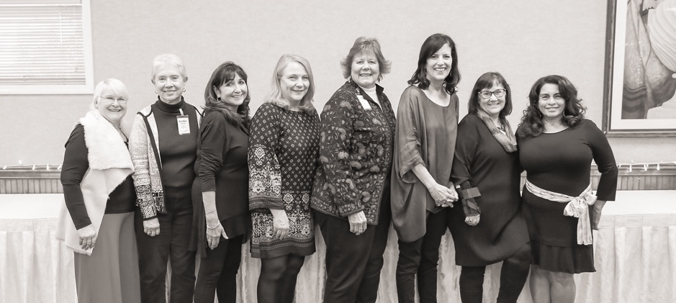
Pictured left to right: Rosemary Flamion, Kathy Hurrle, Margie Sesser, Cindy Bitto, Cynthia Lee, Hilary Townsend, Rebecca Hendricks, Cori Zinn

