fresh deals
Wednesday, June 1st-Tuesday, June 14th

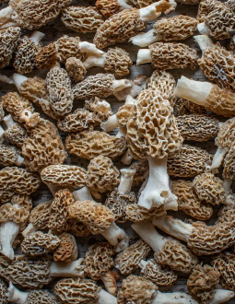
$24.99/lb.

MOREL MUSHROOMS

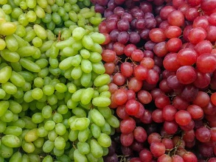
$3.99/lb.
RED AND GREEN GRAPES

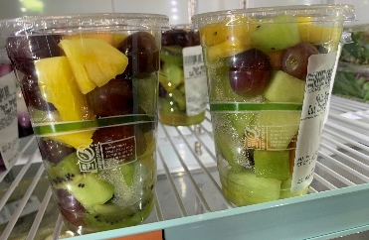
$2.49/ea
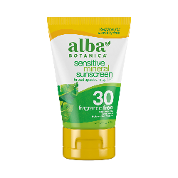
$8.49/ea
ALBA BOTANICA SUNSREEN
Stock up on this summer
Essential!
4 oz, selected varieties.

FRUIT CUPS

Fresh and cut by our deli staff!

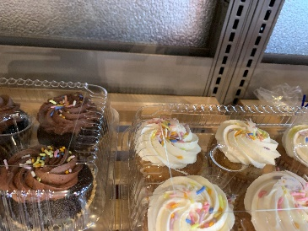
$6.99/ea
VEGAN CUPCAKES

*Sales good while supplies last. | 44 W. Main, Spokane, WA • www.mainmarket.coop | Mon-Sat 8am–8pm Sun 10am-7pm

