Well there is no danger of these three banging heir heads on back of the pews in the Chancel. Fred and Paul McGiven look on as the Architect considers detailed plans to remove the offending ridge.
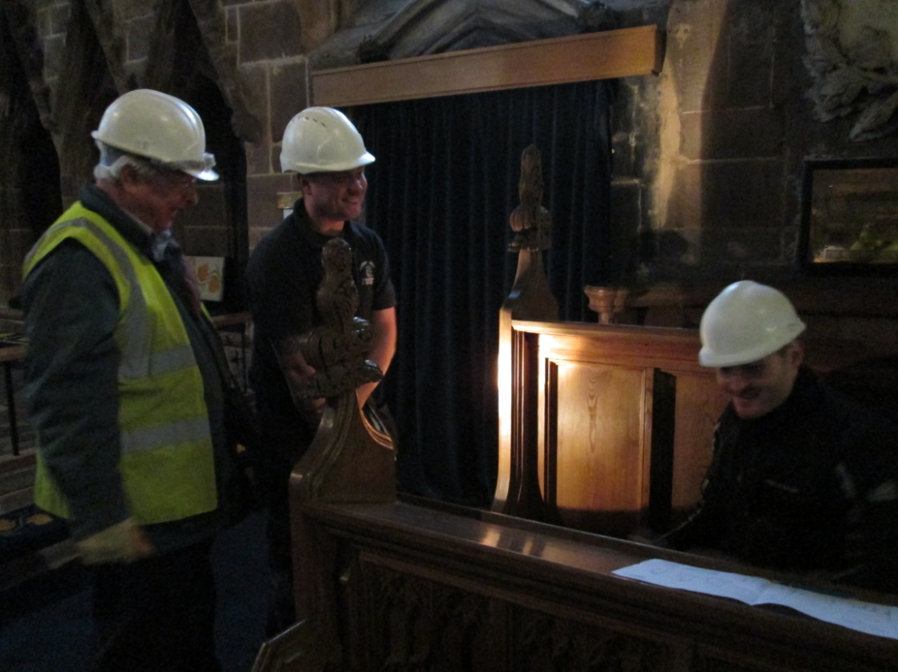

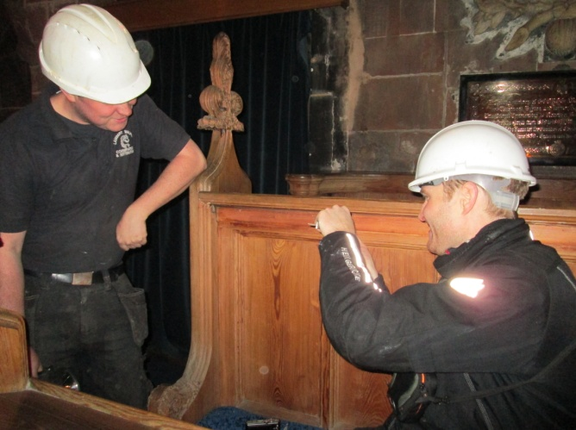
Could it be …..
final measurements and
photos in preparation
for the modification of
the woodwork for our
future comfort …..
may be!
Skilled carpenters will be engaged to adopt these fine pews to regular adult use. Comfortable seating covers will also be part of the enhanced seating arrangements in the Chancel.
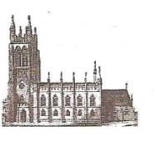
St Mary’s in the Marketplace.

Issue No 11 (30th September 2012)
“Securing the future for the next 100 years”
and the launch of our 2012/13 Appeal
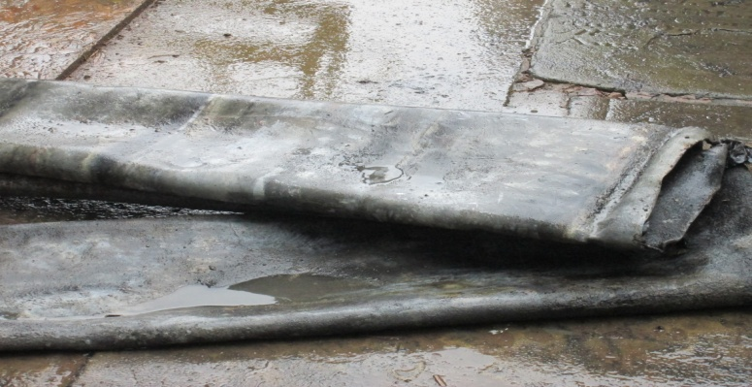
Our contractors remain busy – the main activities this
week are still on the roof as the lead is stripped and
removed, professionally!

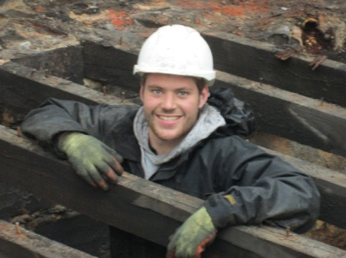
Launched this week our 2012/13 appeal to raise funds to enable us to complete (as far as we can) Phase 1 of the interior by February 2013. We will issue a leaflet shortly to breakdown the costs and explain to everyone what the money is required for.
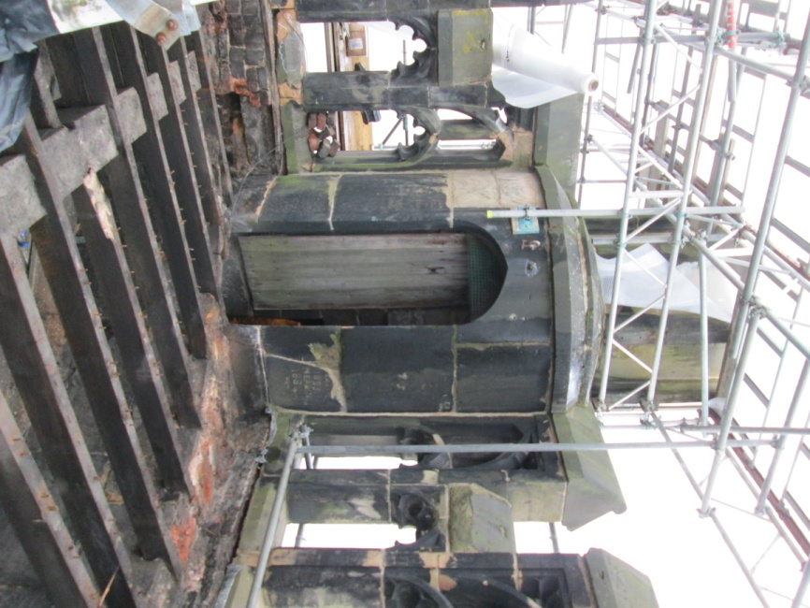
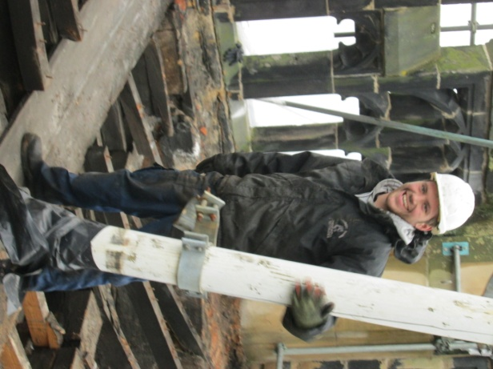

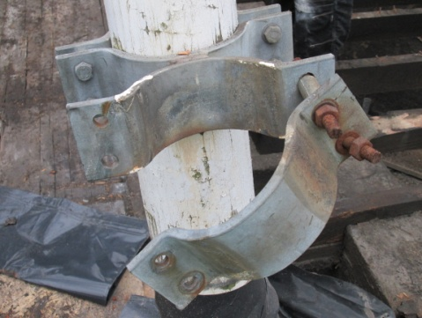

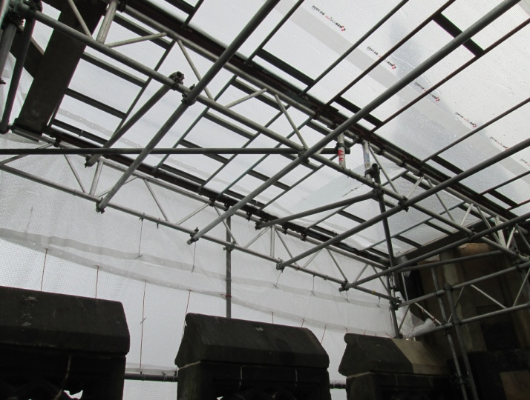

Thanks to Roger for
going up the tower
and taking these
photos for us – a
view we would
otherwise never
have seen.
A4 size prints of “work in progress” are on display in the tower entrance and will be changed on a regular basis. We hope that you will find these of interest as work continues. The Stonemasons (including Chris seen here) are already at work preparing the East face of the Tower for the major stone restoration on that side and the replacement of the iron tie bar around the top of the Tower – a massive operation
Meanwhile back in the kitchen...
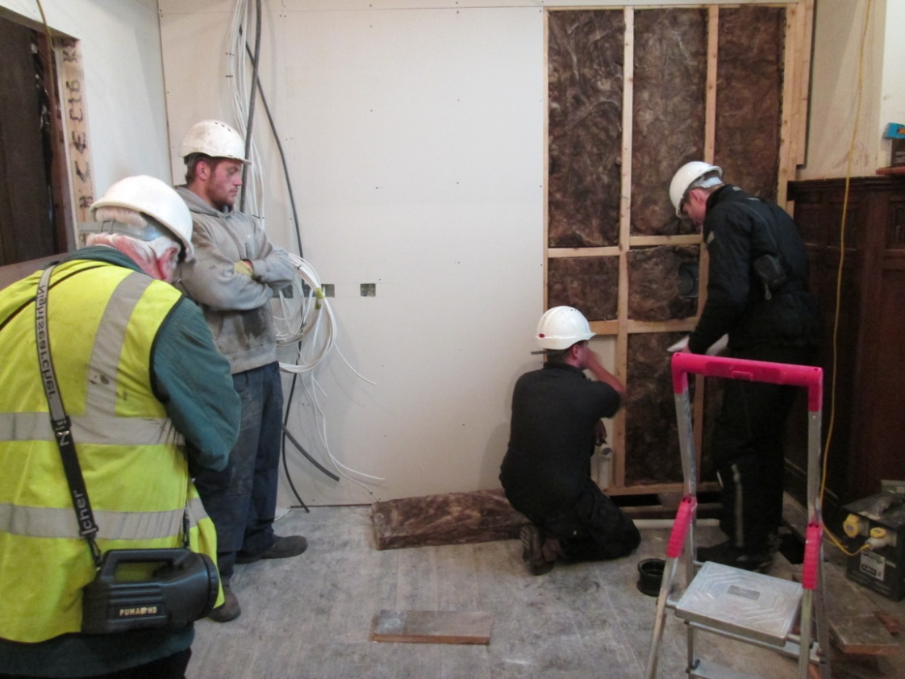
… things are moving on… insulation … wires (the electrical wiring is now in place) and of course the water and draining needs for our semi-professional kitchen. Our Architect James Sibson and Structural Engineer Fred Tandy have been (seen here) on site to check work in progress. Alex, the plumber still has work to do below the floorvoards!
