2021-2022 Member Interest Survey (MIS)
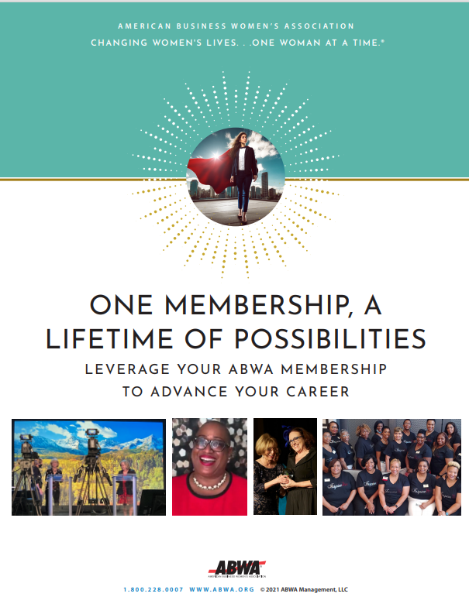
The completion of this survey is optional. The purpose of this survey is to capture information about your needs and interests as it relates to your membership in the American Business Women’s Association and, in your league.

The league leaders will utilize the aggregate information (i.e., results compiled from all members participating in this survey) in order to gauge the program topics, activities and initiatives that are best aligned with the needs and interests of its membership community.

Before completing this survey, we recommend that you first reflect on the ONE MAIN GOAL (OMG) you hope to achieve in the next twelve months. To get you started, consider using the Professional Development Template included in the One Membership a Lifetime of Value Guide. This guide may be downloaded from the National Resources in the Community Connections portal. Thank you for taking the time to share with us your needs and interests.

After completing this survey, print and return to: Click or tap here to enter text.
Member Name: | Click or tap here to enter text.
Member Signature
Date Completed | Click or tap here to enter text.

- The reason I chose to become a member of the American Business Women’s Association (ABWA) is because: (Choose all that apply)

I wanted to network with other professional women in and outside of my industry.
I wanted to acquire new knowledge and skill sets that will accelerate my career advancement and wages.
I wanted to take advantage of the online learning content that is available in the Apex Campus.
I want to earn CEUs that I need to maintain my license/certification.
My employer was willing to pay my annual dues if I joined.
Other (please specify) ______________________________________________________

- The most important reason for renewing my membership in ABWA and in this league is…
(Note: If you are a new member of ABWA, move onto survey question number 3)

Click or tap here to enter text.

3. I’ve been an ABWA member for:
Less than 1 year.
Between 1-5 years.
Between 6-10 years.
Between 11-20 years.
Between 21-30 years.
Between 31-40 years.
Between 41-50 years.
Between 51-60 years.

4. My current job position can best be described as:
Teacher/Professor.
Business Trainer or Consultant.
Professional Speaker.
Entrepreneur/Business Owner.
Senior Manager (CEO, COO, CFO, Director, Vice President).
Supervisor/Manager, Sales Account Representative, Sales Executive, Sales Consultant, Sales Agent.
Marketing/Communications and/or Public Relations Professional.
Human Resource Professional.
Engineer.
Information Technology or Web Designer.
Customer Service Professional.
Administrative Professional.
Other.
5. In the next twelve months, my ONE MAIN GOAL (OMG) is to:
Find a new job in the same industry.
Get promoted with my current employer.
Start a new career in a different industry.
Grow my current business.
Complete my academic education.
Earn a certification that will advance my career.
Update my professional portfolio (resume, cover letter, references) in preparation for a job change.
Retire.
6. What do you know about ABWA’s Career Connections and how have you used it? (Choose one)
I know ABWA’s Career Connections is a job portal however, I am not looking for a new job nor a new career at this time.
I’ve taken advantage of ABWA’s Career Connections job portal by posting my resume to the site and monitoring it regularly for new job postings.
Wow! I didn’t know that ABWA had a job portal located on the National website. I plan to research ABWA’s Career Connections at www.https://careers.abwa.org.
6
7. The knowledge, skill sets and experiences I will need to achieve my ONE MAIN GOAL (OMG) in the next twelve months are:
I will need to acquire knowledge about Click or tap here to enter text.

I will need to acquire and these skill sets: Click or tap here to enter text.

I will need to acquire more experience in the area(s) of: Click or tap here to enter text.

- What do you know about ABWA’s Apex Campus and how have you taken advantage of this member only benefit?
I know the ABWA’s Apex Campus is an online learning portal that offers members over 60 affordably priced courses however, I am not interested in registering for these courses at this time.
I know the ABWA’s Apex Campus offers members a robust curriculum of relevant courses that are affordably priced and even a monthly complimentary course is named! I’ve taken advantage of ABWA’s learning portal by completing at least one course in the past twelve months that will support me in achieving my ONE MAIN GOAL (OMG).
No, I didn’t know about ABWA’s Apex Campus and as such, have never taken advantage of the online curriculum. I plan to check it out at www.myapexcampus.org.

- List and prioritize from highest to lowest impact, six program topics that will be benefit you in acquiring the knowledge and skill sets you need to achieve your ONE MAIN GOAL (OMG). The information you provide in this survey will be useful in determining the types of programs that will be delivered at our league’s Regular Monthly Meetings.

Highest Impact | Lowest Impact
1. Click or tap here to enter text. | 4. Click or tap here to enter text.
2. Click or tap here to enter text. | 5. Click or tap here to enter text.
3. Click or tap here to enter text. | 6. Click or tap here to enter text.

- The following volunteer leadership positions that will help me acquire the experiences I need to achieve my OMG are: (Choose all that apply)
Membership Recruitment Committee | SBMEF - Scholarships Committee
Fund-Raising Committee | American Business Women’s Day Committee
Newsletter Chair | New Member Orientation Committee
Publicity Committee | Hospitality Committee
Auditing Committee | Best Practices Committee
Nominating Committee | Local Awards/Committee (e.g., Woman of the Year, Protégé’)
Programming (Professional Development) Committee | Top Ten Business Woman Nominee Committee
- Every year, ten members are recognized as the Top Ten Business Women of ABWA. We would like for you to take an inventory of your ABWA contributions so we can assist you in meeting the eligibility requirements to be considered for this prestigious national honor in the near future. (Choose all that apply)
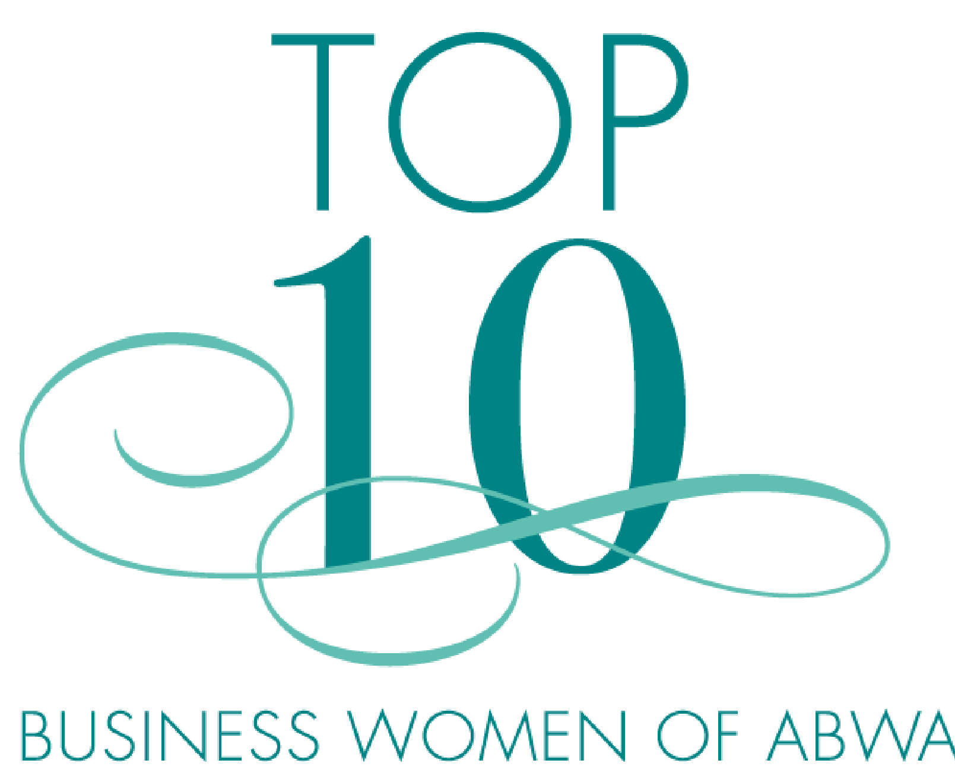
I’ve completed at least one course in the Apex Campus in the past twelve months. | Since 2019, I’ve served as a league officer and/or committee chair in an ABWA league.
I’ve attended at least two nationally sponsored ABWA events (regional and/or national conference) since 2019. | I’ve sponsored at least three new members since 2019.  I will be affiliated with this league for at least one year as of May 15, 2022.

Note to League Officers:
If you have additional questions that will be useful in meeting the needs and interests of your members, add them to this section of the survey.

