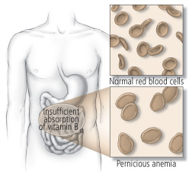
Pernicious Anemia ... also known as vitamin B₁₂ deficiency anaemia

- is a disease in which there are not enough red blood cells due to a lack of vitamin B₁₂.
- When suspected, diagnosis is made by blood and, occasionally, bone marrow tests. Blood tests may show fewer but larger red blood cells, low numbers of young red blood cells, low levels of vitamin B₁₂, and antibodies to intrinsic factor
- The term "pernicious" means "deadly" and was used because before the availability of treatment the disease was often fatal.
Causes:
Pernicious anemia results from not enough intrinsic factor. Lack of intrinsic factor is most commonly due to
- an autoimmune attack on the cells that make it in the stomach.
- it can also occur following the surgical removal of part of the stomach
- or from an inherited disorder.
- Other causes of low vitamin B₁₂ include a poor diet, celiac disease, and a tapeworm infection.
Symptoms:
- The most common initial symptom is fatigue.
- Other symptoms may include shortness of breath, pale skin, chest pain, numbness in the hands and feet, poor balance, a smooth red tongue, poor reflexes, and confusion.
- If treatment is not provided, some of these problems may become permanent
What to do:
- To produce optimally healthy red blood cells, optimal protein is required in the body. Shaklee Life Shake and Soy Protein are excellent choices.
- Vitamin B₁₂ deficiency may be prevented with a balanced diet or with supplements.
- Pernicious anemia can be easily treated with vitamin B₁₂.
- Start with Vita Lea and B Complex daily
- If the bloodwork still shows a deficiency of B12, then purchase a B12 sublingual pellet that you put under your tongue, and take every day along with your B Complex.
- Often treatment is life long. With proper treatment most people live normal lives.
- Due to a higher risk of stomach cancer, those with pernicious anemia should be checked regularly for this.

