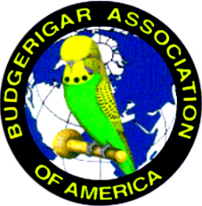
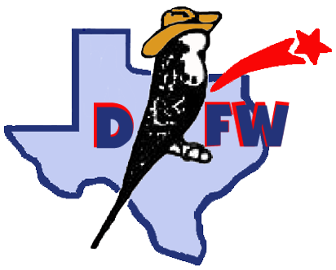
DFW Annual Budgie Show

June 23rd & 24th, 2018
Ables Springs Volunteer Fire Department
30000 FM 429 N
Terrell, TX 75161

Hosted by: Dallas - Fort Worth Exhibition Budgie Club
Affiliated with: Budgerigar Association of America
All Divisions – Rare, Junior, Novice, Intermediate, Champion
BAA Panel Judges: Robert Marshall and John Joyner
Entry - $3/bird, $30 max (per day) or $5/bird, $50 max for both days

Schedule of Events:

FRIDAY noon- 6:00 PM Show how open for Setup and Check-in
6:30 PM Dinner to be announced

SATURDAY 7:00 AM Show Hall Opens
9:00 AM Bird check in and entry complete. Staging of entries
10:00 AM Judging Begins
12:00 PM Lunch – Club will provide main meal. Please bring desserts and sides.
~ 6:00 PM Dinner to be announced

Sunday 8:00 AM Show Hall Opens
9:00 AM Judging Begins
Noon - 1:00 PM Lunch, Raffle & Budgie Auction – All donations are appreciated
6:00 PM Show Hall Closes – Awards, wrap up, and clean up. All help is appreciated

Information: Joshua Anthony (225)-907-9376 joshda12101984@gmail.com
Show Hall Contact: Julie Willis (469)-524-9700 juliebelle57@gmail.com
***Pre-register electronic entry to Julie Willis – juliebelle57@gmail.com ***

Sales Division, Raffle Extraordinaire and Budgie Auction

Local hotels – LaQuinta, Best Western, Holiday Inn Express

