There has of course been the opportunity for some “fun items” during the week and for Roger to “dress” for the occasion!
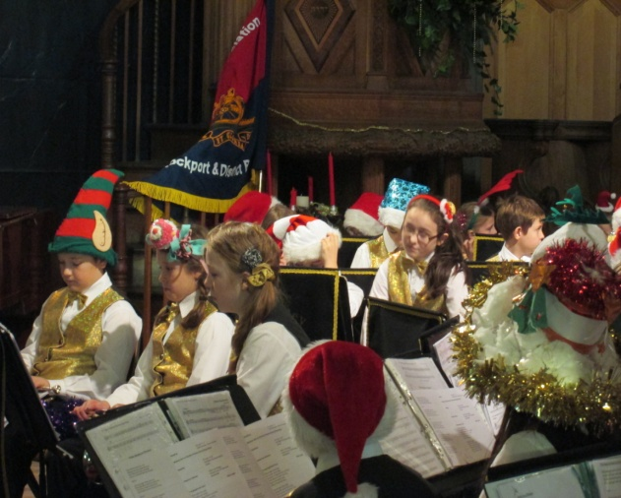
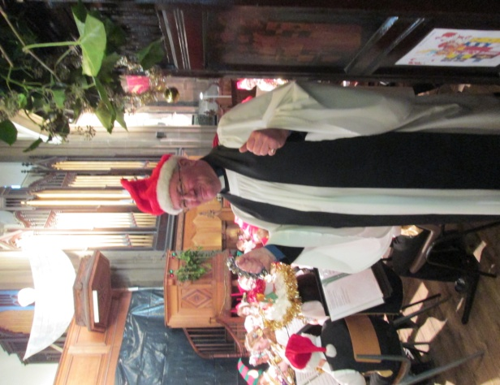

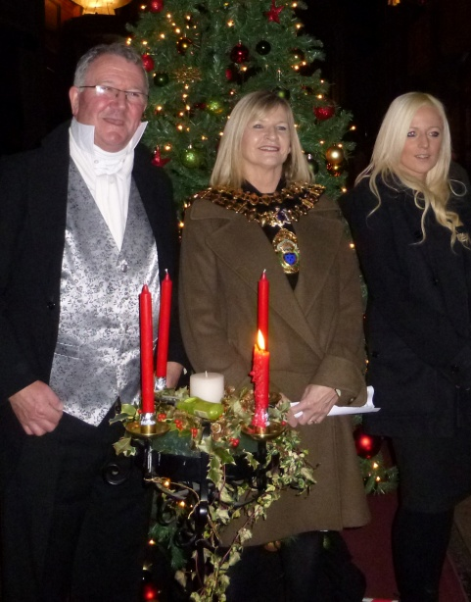
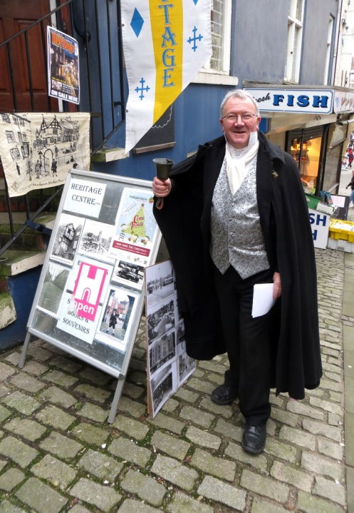
There have been some lovely festive musical numbers played by our visiting schools – what talented children we have in the Borough. It is thanks to Phil for emailing the photo of Roger (below left) taken outside the Heritage Centre. He is in Dickensian dress. Advertising the Dickensian Christmas” Carols in the Nave” event – a first for us, singing around the Christmas tree whilst drinking mulled apple juice and eating mince pies.

St Mary’s in the Marketplace.
Issue No 22 (16th December 2012)
“Securing the future for the next 100 years”
Everything is working out well – and to think that a few months ago we thought that it may be necessary to close the Church during the building works! Nothing of the sort – it certainly is “business as usual” at St Mary’s. For it has been another action packed week. Our contractors and sub-contractors have continued to work on the interior, as well as on the tower, whilst we have continue with our Christmas Programme.
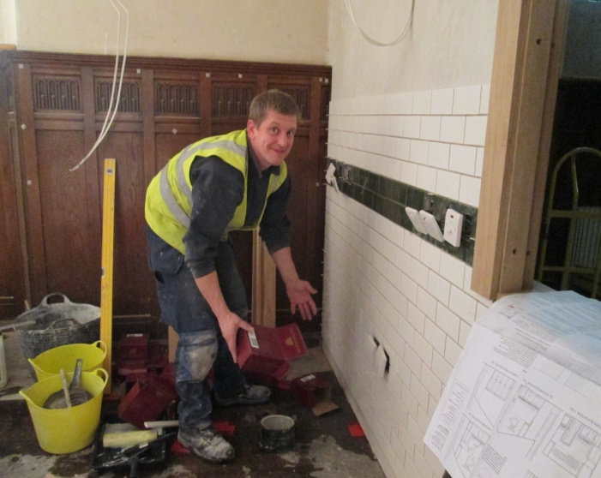
Although there is no general programme of re-wiring in this first phase of the interior re-ordering, the work on the electrics in the kitchen continues with the fitting of a rather complex distribution board and with electrical sockets and switches being put in place. The tiles are also going up and it is all starting to take shape.
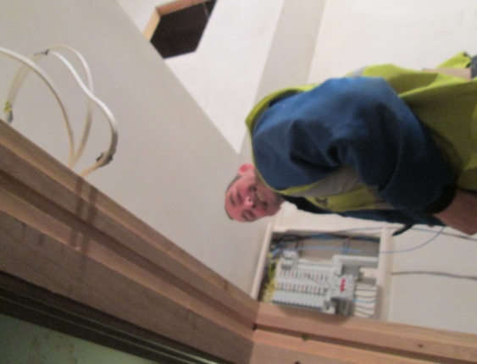

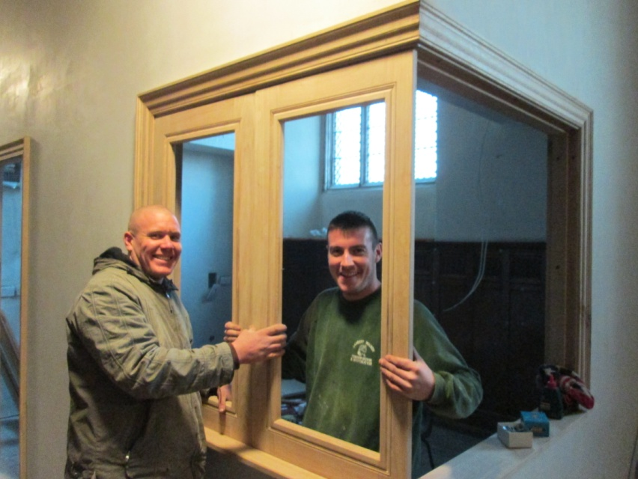
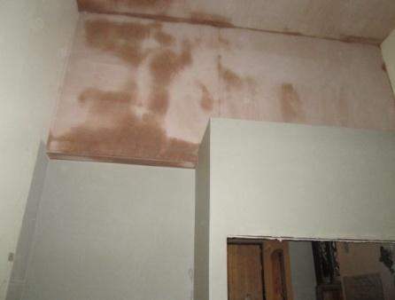
The framework is being put in place to the serving hatch area, so things are certainly coming on. At the far end of the north aisle the plastering is just being complete giving that
end of the building a totally new
look.

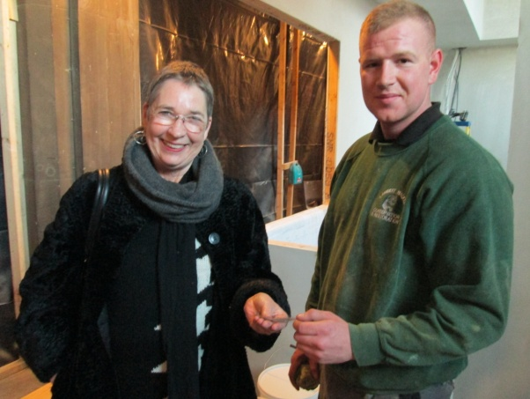
Visiting St Mary’s
Anne Coffey – MP
for Stockport. An opportunity not to
be missed to show
her the work being
undertaken.

The Project team continues to keep a watching-brief on the work being undertaken, continues to work behind the scenes making further grant applications, paying the bills and monitoring the budget to ensure we remain on track. The “red tape” continues to be cut through, as we look forward and into 2013, moving closer towards achieving our aims and objectives for this first phase of the re-ordering (or refurbishment as I prefer to call it).

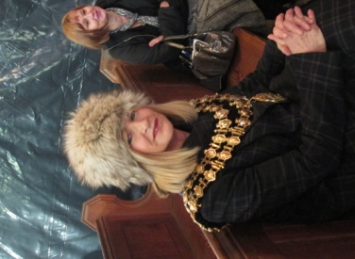
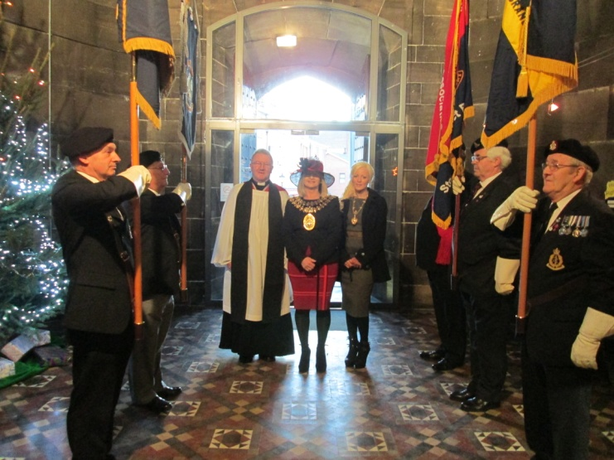

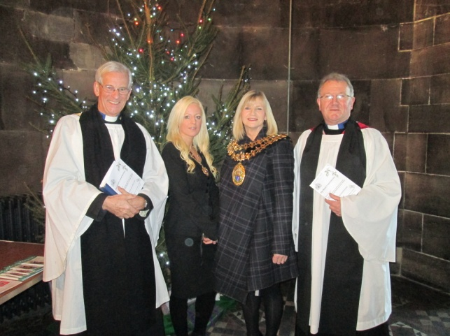

It has been another busy
week at St Mary’s with the
Mayor attending many of
our services – Dickensian
Christmas, Ex-Services Carol
Concert with Hazel Grove
Brass Band, Stockport MENCAP Christmas Celebration, and her own Mayor of Stockport Carol Service with Romiley Primary School. We have seen a packed church once again this week, on a couple of occasions, which has of course been fantastic. We have undertaken a range of seating “set-ups” from sitting around the Christmas tree to more formal arrangements. We have welcomed children from various schools,
seen the return of the Affinity Show Choir and have been delighted to have with us Warren Smith, Lord Lieutenant of Greater Manchester, at the Beechwood Cancer Care Carol and Dedication Service. We have another packed week ahead leading us into Christmas, and are looking forward to welcoming lots more visitors and regulars to St Mary’s.

