From the Deacons
Dear Grace Hills Members:
In deep appreciation for the twelve years at Grace Hills Baptist Church we thank Rev. Dr. Adam J. Tyler. We would like to highlight a few of his accomplishments, in addition to preaching, teaching, visitation, committee involvement, and church leadership from 2009-2021:
- Huddles-a small discipleship experience-involved many in the congregation. Out of the Huddle experience came Good Neighbor Center and the church’s community garden.
- Impact Virginia-the church hosted impact in 2012 and helped with input in the community in 2017.
- College-level Biblical Classes were taught in 2011-2012
  - With his undergraduate major being History, he was a master of understanding and explaining scripture
- Panama-church first international mission trip-2014.
- Ghana mission connection -2013-2017-planted a church named Grace Hills
- Strategic Vision Process in 2014.
- Tornado recovery-County Chairman-2016-2018.
- Appomattox Ministerial Association
  - Involvement in community Lenten services-2010-2021
  - Interdenominational Easter Service-2012-2021
  - Benevolence Treasurer-2012-2021.
- BGAV service
  - 2012-2015-Va. Baptist Mission Board
  - 2015-2016-2nd Vice-President
  - 2016-2018-lst Vice-President
  - 2019-2021-President
- Covid-19 Response
  - Developed ministry plans with lay leaders and implemented/improved plan over past 19 months
  - Introduced technology infrastructure.
  - Accommodated everyone who were more comfortable with outside services and continued inside services, at no extra charge.
  - Having Covid-19 himself and prepared/presented services twice while being quarantined.
  - Insisted on CDC guidelines.
- Sponsored the Church’s Ten-Year Celebration and networked with the World Baptist President as our guest speaker.
- Completed Doctorates while working with church.
As Deacons, we acknowledge Adam Tyler’s accomplishments over the past twelve years and wish Adam, Cadance, Jonathan, and Phoebe the best in their future ministry.
Now that we are without a minister, let’s hope and pray that we move forward according to God’s Will and adopted Grace Hills Baptist Church policy.
Love in Christ,
Pat, Deacon Chair
Grace Hills Early Learning Center News
Director: Leslie Galloway Bookkeeper: Lisa Dawson
Phone: (434) 352-2273 Email: gracehillselc@aol.com
Attendance: Full Time Students: 85 School Age Students: 50

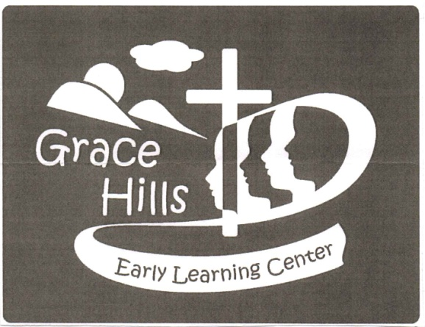
Grace Hills ELC News
Praying all is well with everyone during these unpredictable times.
Director: Leslie Galloway Bookkeeper: Lisa Dawson
Phone: (434)352-2273 Email: gracehillselc@aol.com
Attendance: Full-Time Students: 85 School-Age Students: 50
October Happenings:
The month of October we joined the United Way to collect items for local families for the holiday season.
We have been talking about fire safety and what to do in case of a fire. We had a visit from the Fire Department.
Since we could not go to the Pumpkin Patch the Pumpkin Patch came to us! The children were able to pick pumpkins and enjoy barrel rides.
We ended the month with trunk or treat for our ELC students. Many of our ELC families volunteered to help make this event a success.
Our ELC is blessed with loving families always willing to support and volunteer.
Each month all of our preschool classes have colors, numbers, shapes, and letters they work on to prepare them for the next class. Each class also has monthly Bible Verses!
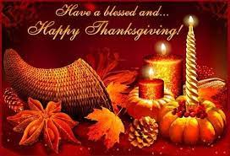
Happenings at the Good Neighbor Center November 2021

…Let us love one another. 1 John 4:7
Remember that Good Neighbor will sponsor the Centra Mammography Unit on November 29, 2021. Shirley Walton announced 15 appointments are scheduled. Thanks to all who have supported this important effort for 10 years.
The GN Pies for Seniors program will continue for the second year. If you or someone you know would enjoy a pie delivery to their home on November 23, please let the Good Neighbor Team know.
During October, Good Neighbor responded to requests for food, family assistance. furniture, and other requests for access to resources.
We continue to seek furniture and appliances for several families in need. If you are able to help, please contact a member of the Good Neighbor Council.
We are so blessed to serve as a mission of Grace Hills Baptist Church.
Your Good Neighbor Team
____________________________________________________________________________________________
Grace Hills Baptist Church
gracehillsbaptist.com
PO Box 807 (for mail) (434) 352-8847
4320 Pumping Station Road ghbcoffice@yahoo.com (Monica)
Appomattox, VA 24522-0807

