Fibrocystic Breasts: (lumpy, tender, uncomfortable breasts)

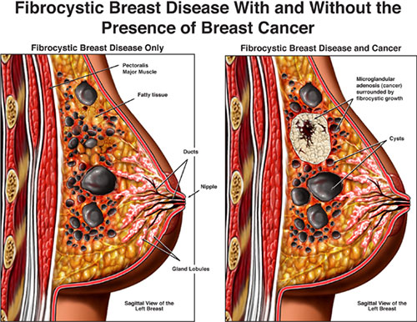

Causes:
▪ estrogen dominance
▪ lack of detoxification (especially liver)
▪ nutrient deficiencies (very common deficiencies include Vitamin D3, magnesium, potassium, antioxidants,
phytonutrients, etc.)
▪ heavy metal accumulation (a hair analysis will reveal if this is an issue)
▪ xenobiotics ... environmental exposure to chemicals ... another reason why it is critical that we intentionally detoxify

Suggestions:
▪ many girls are in need of natural progesterone cream 2x daily for 12 days following ovulation to prevent
estrogen dominance
▪ make sure bowels are moving properly (bulk-in should equal bulk-out) ... many people choose to enhance
optimal bowel function with water, fibre and Shaklee Herbal Laxative
▪ detoxify the liver
- Shaklee Liver DTX … a milk thistle formula ... daily
- do a liver cleanse spring & fall
▪ exercise to provide adequate cellular tissue oxygenation … increase lymphatic drainage by frequent use of the chi
machine or rebound exercise
▪ lots of Vitamin E
▪ avoid coffee, sugar, and trans fats
▪ eat an excellent diet
1. include raw nuts & seeds (ground flaxseed is excellent)
2. include Shaklee Soy Protein

Other Suggested Supplements:
1. Shaklee Vitalizer
2. Vitamin D3
3. GLA (Omega 6 supplements)
4. Vivix
5. Many girls require more magnesium & potassium … if so, use Shaklee VitalMag which contains both

