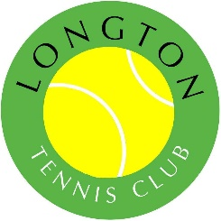
LONGTON MEMORIAL TENNIS CLUB

Membership 2023

I/We wish to join with the following tennis membership(s):

(Please select the appropriate membership)

[ ] Family Membership…………£120 [ ] Over 65s………………£40
[ ] Adult Membership…………..£60 [ ] Over 75s………………£20
[ ] Student Membership……….£40
[ ] Junior Membership (11-18yrs old)……….£30
[ ] Mini Membership (under 11yrs old)……...£15

See www.longtontennisclub.com for membership category definitions & our data retention policy

Adult Name(s)……………………………………………………………………………….
……………………………………………………………………………………………...

Junior/Mini Member Name(s) U11 / U14 / U16?
………………………………………………………………… ……………………
………………………………………………………………… ……………………
………………………………………………………………… ……………………

Address……………………………………………………………………………..............
...................................................................................................................................

Contact Number……………………………………………………………………………..

Email Address……………………………………………………………………………....

- add my email address to the club email list?............................................YES or NO

- add my number to the club WhatsApp social group?.............................. YES or NO

By joining Longton Tennis Club, you agree to follow the club code of conduct. You can view this on our website – www.longtontennisclub.com

*Our LTA Insurance Risk Assessment requires we must have the following information from all members*

Emergency Contact Name & Relationship

………………………………………………………………………………………………………….

Emergency Contact Number………………………………………………………………………

Declaration: I am fit to play tennis and I am / am not, playing against medical advice

PayPal (preferred): Online at www.longtontennisclub.com
Cheques payable to: Longton Memorial Tennis Club
Cash & Forms to: Ron Webster, 4 The Coppice, Longton, Preston, PR4 5HQ. Tel: 07793422507

Floodlight Keys & Cards are available at £2 for keys & £5 per card (each card lasts 1 hour)

