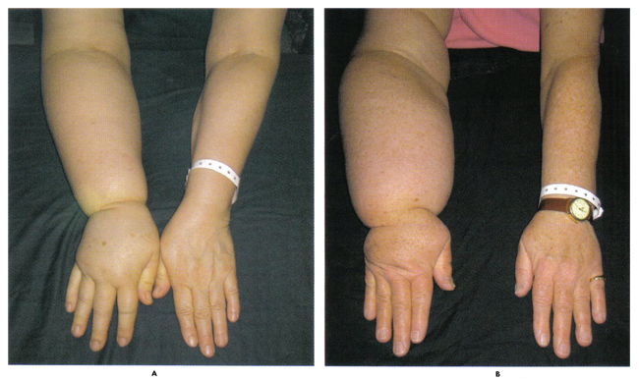
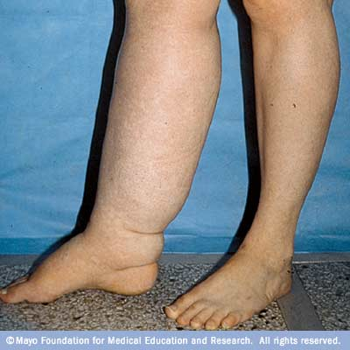

Lymphedema

- Lymphedema refers to swelling that generally occurs in one of your arms or legs.
- Sometimes both arms or both legs swell.
- Lymphedema is most commonly caused by the removal of or damage to your lymph nodes as a part of cancer treatment.
- It results from a blockage in your lymphatic system, which is part of your immune system. The blockage prevents lymph fluid from draining well, and the fluid buildup leads to swelling.

Supplements for Natural Support:
- Alfalfa helps the body to regain chemistry balance and helps to reduce fluid retention (use aggressively). Alfalfa is also anti-inflammatory, which greatly impacts lymphedema
- Optimize Vitamin E (up to 1,200 I.U. daily)
- Essential Fatty Acids (Shaklee OmegaGuard)... supports circulation which is reduced by the swelling from lymphedema ... also keeps the blood slippery, which will reduce the risk of clotting
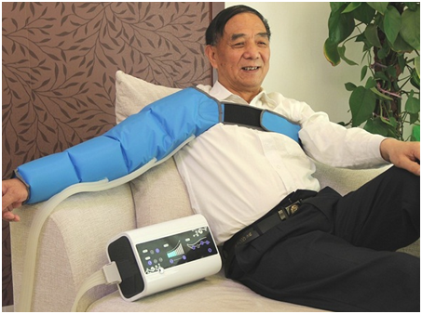
- CoEnzymeQ10 ... Empowers the heart (Shaklee CoQHeart)
- Performance ... also helps the body deal with chemistry imbalance
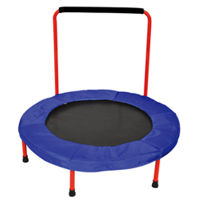
Lifestyle:
- Keep well hydrated
- Exercise
- Compression boots or arm sleeves
(support better lymph valve funciton)
- Chi Machine or Vibrator
(excellent for circulation)
- Trampoline
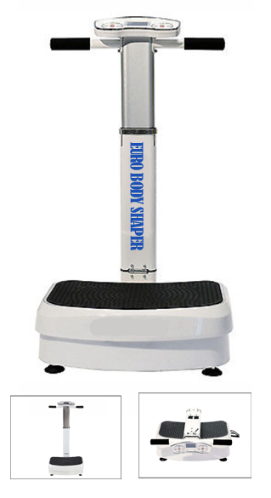
(forces lymphatic activity due to the
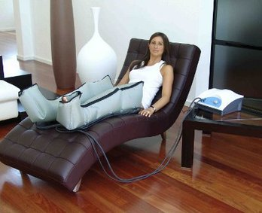
up-down activity)



