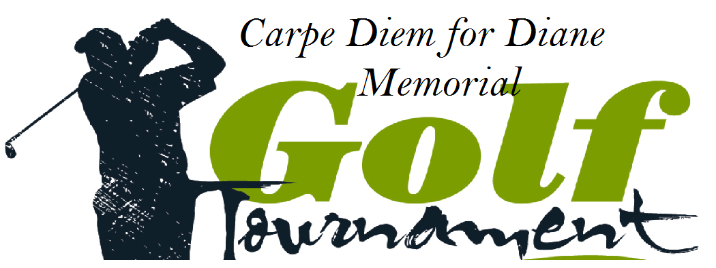

7th Annual Golf Tournament

Thursday, May 26th, 2022

Candia Woods Golf Links – Candia, NH

**SILENT AUCTION & RAFFLE DONATION FORM**

Please complete this form and mail or e-mail to:

Amanda Ferdinando

c/o Carpe Diem for Diane

112 English Range Road

Derry, NH 03038

E-mail: [aferd23@gmail.com](mailto:aferd23@gmail.com)

Website: [www.carpediemfordiane.org](http://www.carpediemfordiane.org)

**Donor Name: _____________________________________________**

**Organization name: ________________________________________**

**Mailing address: __________________________________________**

**________________________________________________________**

**Phone: __________________________________________________**

**E-mail: __________________________________________________**

**Please provide a brief description of the item you are donating: ___________________________________________________________________________ ___________________________________________________________________________ ___________________________________________________________________________ ___________________________________________________________________________ ___________________________________________________________________________ ___________________________________________________________________________ ___________________________________________________________________________**

**Please provide an approximate retail value: $___________________**

We appreciate your Support! Thank you!

*All money raised will be donated to local ALS (Lou Gehrig’s) and Alzheimer’s charities in loving memory of Diane Park Whatmough (formerly Ferdinando)*

*11/24/61 – 8/19/14*