# Korean Panax Ginseng 5000mg (60 Tablets) Strongest Legal Ginseng Extract 100% Pure Certified

* Maximum strength 500mg Korean Ginseng Extract 10:1 (5000mg whole herb equivalent) 20% Ginsenosides
* Powerful adaptogen restores balance to alleviate stress and anxiety while improving focus and memory.
* Naturally increases muscle efficiency and aerobic capacity
* Each component of BioPharmX advanced formulation has been highly refined and exceeds the HIGHEST pharmaceutics purity standards.
* Manufactured in an FDA and MHRA approved facility for your highest level of safety.

## Product Description

### Korean Ginseng Tablets - 60 Tablets (60 Day Supply)

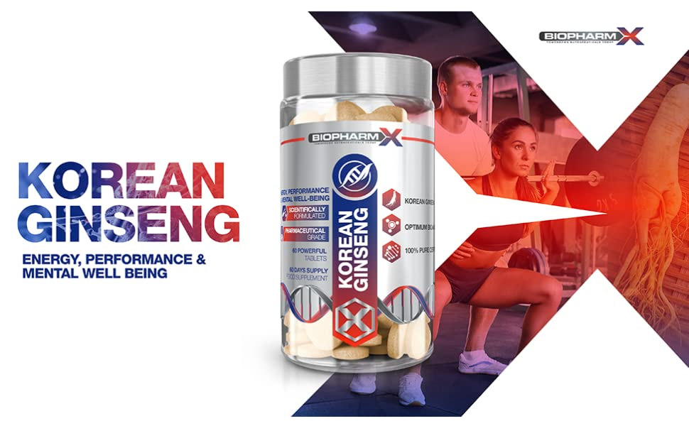

Korean Ginseng, also known as Panax Ginseng has been used for thousands of years in traditional and natural medicine to effectively treat a wide variety of physical and mental health disorders. There are different species of Ginseng found across the world, all of which have varying concentrations of these active compounds. Korean ginseng is commonly referred to as the “true ginseng” – being the most potent, researched and clinically proven from the family of ginseng plants.

Pharmacological studies have enabled medical researchers to confirm Korean Ginseng as one of the MOST POTENT, MULTI-PURPOSE MEDICINAL HERBS AVAILABLE.

### The following benefits have been identified in published scientific studies and clinical reports surrounding Korean Ginseng and its numerous bioactive compounds.

|  |  |  |  |
| --- | --- | --- | --- |
| **korean ginseng** | **korean ginseng** | **ginseng** | **ginseng** |
| Stress, Anxiety & Low Mood Korean Ginseng has demonstrated its ability to have anti low mood and anxiety effects by increasing monoamine levels within the brain. Monoamine neurotransmitters are also essential for the maintenance of cognitive functions including learning, memory, concentration and reasoning! | Immune System The immune system is our first line of defense against illness causing viruses and bacteria; it works to produce immune cells and antibodies to destroy foreign cells that could be potentially harmful. It is composed of diverse cells with their own specific functions, with each type responding different to Korean Ginseng treatment in clinical studies. | Fatigue & Energy If you suffer from extreme tiredness both physically and mentally even after a full night’s sleep, you’re suffering from fatigue. BioPharmX Korean Ginseng is ideal for those wanting to fight fatigue at a cellular level and feel more energized and mentally sharp throughout the day | Ginseng for Men Although Korean Ginseng supplementation is beneficial for everyone, in Chinese medicine one of its traditional uses was to enhance male health and performance of men. Studies have shown Ginseng supplementation to improve all aspects of reproductive function and reproductive health. |

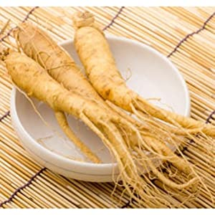

### What is Korean Ginseng?

The root was first recognized for its medicinal benefits over 2000 years ago as a part of traditional Chinese medicine. It has since become one of the most widely used and scientifically acclaimed herbs in the world. There are many different Ginseng varieties cultivated around the world; their differences come down to varying concentrations of active compounds PLUS how the root is treated after being harvested. The Ginseng roots need treating to kill harmful pathogens before being consumed, but some Ginseng varieties are treated in a way that destroys the powerful active compounds, essentially rendering the root powerless.

Each BioPharmX Korean Ginseng tablet contains maximum strength 500mg of Korean Ginseng Extract 10:1 – 5000mg whole herb equivalent (20% Ginsenosides). Maximum potency is achieved by concentrating the ginseng root through a unique process that completely preserves the active compounds while ensuring the unwanted contaminants are removed.

### BioPharmX: Superior Standards in Nutritional Supplements

|  |  |  |
| --- | --- | --- |
| **korean ginseng** | **korean ginseng** | **korean ginseng** |
| Leaders in Nutrition BioPharm-X has the goal of enhancing the well-being of their customers around the world by delivering premium quality, best value nutritional supplements.  Each tablet has been formulated to safely provide significantly more then other Korean Ginseng supplements on the market. | Premium Quality Every bottle is manufactured in a fully licensed facility, using only premium graded ingredients.  Rest assured that we would never consider manufacturing an item that did not fully meet these requirements. | Directions for Use Adults: As a supplement begin by taking 1 tablet in the morning on an empty stomach with at least 8fl oz of water.  Do not exceed stated dose in a 24-hour period.  Use only as directed. |

### Ingredients

Korean Ginseng Extract 10:1 (500mg)