Quit Smoking Program:
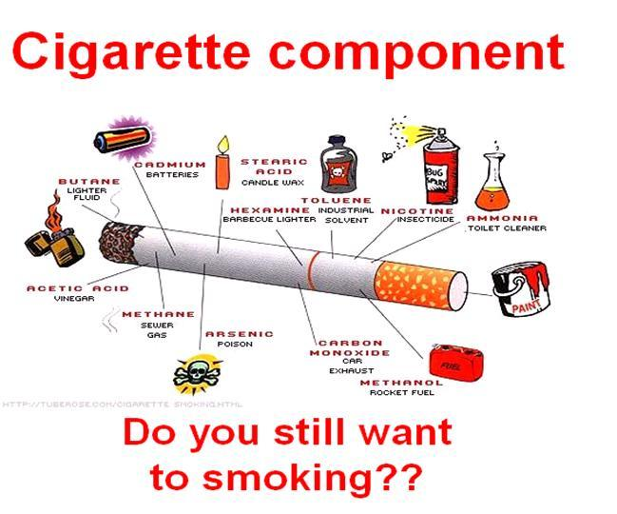

Basic Program: Vita Lea (Multiple Vitamin/Mineral)
B Complex
Calcium Magnesium
Alfalfa
Cinch Shake

Better Program: Replace Vita Lea with Vitalizer
Extra B Complex
Extra Calcium Magnesium

Best Program: Follow Better Program, PLUS
- Vivix
- DTX
- Stress Relief Complex

NOTE: Withdrawal will be more complete if you decide to do some body detoxification programs as well. We recommend the Rejuvenating Body Cleanse.

SMOKING
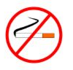

- Over 25% of the population smoke – that’s over 6 million Canadians.

- Each year at least 35,000 die early because of smoking.

- Smoking reduces the life expectancy by 15 minutes per cigarette.

- Tobacco companies often direct their advertising to children, especially young girls (their technique: to associate smoking with glamour, beauty & thinness.)

- There are over 1200 chemicals in cigarettes:
- The Strangler: Carbon Monoxide – a poison that takes the place of oxygen in the blood
- The Hook: Nicotine – a deadly poison & and addictive drug.
- The Killer: Tar – causes cancer & makes breathing harder – also stain fingers & teeth
- Others:
  - Cyanide – a potent poison – inflames the lining of the bronchi
  - Arsenic – a poison used to kill weeds & insects
  - Formaldehyde – a poison used to preserve dead animals
  - Ammonia – used in fertilizer, explosives, & cleaning fluid

- Cigarettes contain traces of lead, cadmium & mercury, all of which are cancer causing. The lead content of cigarettes varies from one half to five parts per million per cigarette.

- The risk of heart attack doubles when you smoke, & the risk of cardiac death increases four times. The moment you begin to inhale:
- your heart beats an extra 10 to 25 beats per minute (nicotine causes the release of catecholamines into your system, forcing your heart to beat faster.
- your blood pressure goes up from 10 to 20 points (increasing risk of stroke)
- fatty acids are released into the blood stream contributing to the deposit of fatty substances on arterial walls.
All of the above inhibits circulation, making the heart work much harder to pump blood through more narrow passages.

- The chemicals in cigarettes, when condensed, form a gooey sludge called tar. In one year, over eight ounces of tar are deposited in the lungs of a pack-a-day smoker.
- Tars in cigarettes cause cancer of the mouth, tongue, throat, voice box, lungs, colon, pancreas, bladder & cervix.
- The tars are deposited throughout the respiratory system, becoming glued to the breathing passages, which causes bronchitis & emphysema.

- Tobacco smoke affects the mucous membranes which line the respiratory tract. These membranes contain millions of cilia (hairlike projections) which move back & forth at the rate of 250 times a minute, cleaning & sweeping out undesirable substances such as air-borne pollutants, viruses & bacteria. One deep breath of tobacco smoke stops their activity for as long as a full 60 minutes. This is why smokers have a higher risk of catching a cold or flu.

- Carbon monoxide is a gas formed when tobacco is burned (same gas found in your car exhaust.) Carbon monoxide lowers the amount of oxygen carried in your blood – as the carbon monoxide content of your blood increases, more & more of your body begins to starve for oxygen, including your heart & brain.

- Radioactive substances (such as polomium-210 & lead-210) are concentrated on particles of tobacco smoke. According to the University of Massachusetts, those who smoke a pack and a half a day received a radiation dose equal to 300 chest x-rays per year.

- Smoking reduces the rate of absorption of Vitamin C as well as destroys Vitamin C (75 mg per cigarette), thereby, depressing the immune system.

- Cigarettes contain sugar (which is used to cure tobacco). Every time you light up you expose your system to a dose of sugar. You become just as addicted to your sugar fix as you do to your nicotine fix. When you miss your regular dose of both you’ll experience an intense craving or “nic fit”. (When you choose to quit you are kicking both a sugar & nicotine habit!)

- Tobacco companies are permitted to put 2% of habit-forming narcotics in the syrups they use to treat cigarette tobacco. Heroin & cocaine are common additives, & therefore, smokers are often hooked on more than nicotine & sugar!

- Smoking damages the tiny blood vessel that supply blood to the penis. Therefore, smoking causes low penile blood pressure in men which contributes to the inability to have an erection.

Smoking and Pregnancy:
  - Smokers have more difficult pregnancies & have more miscarriages.
  - Increases the risk of baby being underweight & dying in infancy.
  - Active & Passive smoking affects the unborn by damaging the fetal arteries.
  - Two-thirds of crib deaths are linked to parent’s smoking – over 250 per year in Canada (that’s one in 2,000 births).
  - Exposure to cigarette smoke during childhood increases cancer risk by 60%
  - Watch out: four cigarette butts can kill a baby!

Second-hand Smoke (Passive Smoker)
- If you are around smokers, the air you breathe can be equivalent to smoking two cigarettes a day.
- Although the passive smoker receives a quantitatively lower exposure to the smoke than the active smoker, that exposure is qualitatively richer in many smoke constituents in the sidestream or gas phase from a smoker:
  - there is 3 x as much benzo(alpha)pyrene
  - there is 6x as much toluene and more than 50x as much dimethylnitrosamine
  - Smoke from an idling cigarette put 5x more carbon monoxide into the air than if it were bring smoked!

Quit Smoking: (the decision to quit has to be made deep inside – once this decision is made, the biggest part of the battle is over)
- The morning wheezing, hacking & coughing disappears quite quickly.
- You won’t be out of breath so quickly after slight exertion.
- Your breath will be fresher & the taste of foods will be heightened.
- After a year of not smoking your risk of heart attack goes down sharply.
- After two years of not smoking your risk of lung cancer is lessened.

How to Quit Smoking:
1. Say to yourself: “I choose not to smoke”.
2. Take a warm bath or shower to relax you (it’s pretty hard to smoke in the
shower)
3. Drink 6 glasses of water between meals. (The more liquids you can down, the quicker the nicotine is flushed out of your body.)
4. Get abundant rest the first 3 to 5 days.
5. Do not drink alcohol, tea, coffee or cola. Avoid all sedatives & stimulants, in order to build up your nervous system quickly & shorten the withdrawal.
6. After meals, get outside, walk & breathe deeply for 15-30 minutes. Do not sit in your favorite chair after eating – this is the time you will want most of all to smoke.
7. Eat all you want of fruits, grains, vegetables & nuts. (Fruits are body cleansers!)
8. Do soda & lemon baths to detoxify more quickly.
9. Choose wise supplementation (especially B Complex, Vitamin C, Garlic & Calcium/Magnesium) to assist the central nervous system during your withdrawal.
10. Pray: Ask God to help you.

