***Try The Most Complete Creatine Formulation Ever Created***

***New Powder Version * HUGE 5000mg Dose * 45 Servings Per Tub * Worlds Best Creatine + Unbeatable Value!***

Decabolic Creatine has been engineered specifically to meet the needs of even the most demanding of modern athletes. Without question this is one of the most complete and comprehensive creatine formulations around, guaranteed to pack muscle mass on even the hardest of hard-gainers, immediately delivering muscle and strength benefits. We do not say this lightly, as Decabolic Creatine contains no less than 10 of the most scientifically praised creatine forms in a unique synergistic blend contained in every single capsule!

There is no shortage of research and published studies supporting creatine as an effective compound to aid an athlete in developing size and strength. Numerous placebo controlled, double-blind studys provide excellent evidence of just how effective Creatine is for the modern athlete. Even short-term creatine supplementation can increase total lean body mass by significant margins. Our goal was to take Creatine to the next level - and we succeeded!

***Decabolic Creatine Extensive Benefits***

* Gain over 5x more muscle mass in clinical studies!
* Boost creatine intake 10 times over the average creatine supplement!
* Huge increase in athletic performance
* Massively reduced recovery times
* Improved anaerobic capacity
* Record levels of muscle cell volumization
* Enhanced brain function (see study Deldicque, L. et al)
* Increased IGF mRNA level in skeletal muscle

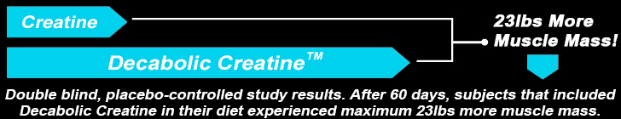

***10 Powerful Creatine Ingredients***

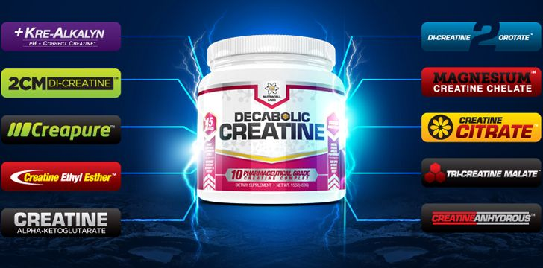

**Kre-Alkalyn Creatine** Kre-Alkalyn Creatine

One of the most advanced forms of creatine available. With a high pH value and in a purified buffered form, it is delivered to the muscle at a higher strength allowing for advanced results and enhanced levels of ATP production. Studies show that Kr-Alkalyn is easier on the stomach and avoids any uncomfortable bloating side effects. Due to its advanced nature a significantly lower dose is required to achieve great results, and in head to head trials with regular creatine has been shown to be up to 28.25% more effective.

**2CM Di-Creatine Malate** 2cm Di-Creatine Malate

A highly soluble creatine salt that has been shown in clinical studies to provide a much greater increase in creatine bioavailability when compared to regular creatine monohydrate. Structurally it is creatine bound to malic acid, which plays a crucial role in our bodys natural energy cycle. This creatine and malic acid combination provides much greater ATP production, and has been patented for its ability to increase muscle mass, cell volumization, increase overall strength and endurance, while decreasing fatty tissue mass.

**CreaPure Creatine Monohydrate** CreaPure Creatine Monohydrate

CreaPure is a patented German form of creatine with a guaranteed 99.99% purity, higher than the industry standard and one of the purest forms of creatine available. It is highly popular amongst athletes or even regular individuals looking to bulk up and promote additional muscular growth along with strength and power. CreaPure has been rigorously researched and repeatedly shown to be safe and highly effective.

**Creatine Ethyl Ester** Creatine Ethyl Ester

A derivative of regular creatine, also known as creatine ester or CEE, used as an effective aid for athletic performance and for muscular development in bodybuilding. CEE is said to have a much better absorption rate and a longer half-life in the body than regular creatine monohydrate because it is slightly more lipophilic. This form of creatine avoids the bloating effect of regular creatine and the esterification allows users to ingest smaller amounts while boosting muscle building results.

**Creatine Alpha-Ketoglutarate** Creatine Alpha-Ketoglutarate

Creatine-AKG is creatine attached to an alpha-ketoglutarate molecule for a very potent molecular combination (a mechanism initially found to boost absorption in nitric oxide boosters). Creatine-AKG has been shown in studies to deliver powerful muscle building effects along with enhanced strength levels even in the most stubborn traditional creatine "non-responders". Natural uptake is increased efficiently and more creatine is delivered expressly into the muscles than basic creatine for greater overall effects.

**Di-Creatine Orotate** Di-Creatine Orotate

A 3:1 molar ratio of normal creatine to orotic acid, with significant efficacy in the field of performance enhancement and muscle building. It is more effective than regular creatine because orotic acid is a precursor to Carnosine which helps make creatine more available to boost cell levels of creatine phosphate and intracellular glycogen stores. Clinical trials show excellent potential in enhancing workouts with additional energy, performance, strength and mass.

**Magnesium Creatine Chelate** Magnesium Creatine Chelate

Formed by creatine chemically bonded to magnesium, as oppose to a water molecule as with regular creatine. Giving MCC a completely different pathway of absorption to get the creatine to the muscle cells with less being lost in transportation. Magnesium is also an alkali compound which counteracts the acidic environment of the stomach meaning less degradation into the waste product creatinine, greater absorption and muscular utilization. Magnesium also plays a vital role in a variety of physiological functions during anaerobic exercise.

**Creatine Citrate** Creatine Citrate

Formed by a creatine molecule attached to a citric acid molecule; citric acid is also a vital part of the Krebs cycle. This is the metabolic pathway in which aerobic energy is produced within a muscle cell. When you add citric acid studies show an increase in muscular energy and better muscule power when compared to creatine alone. The citrate also increases solubility considerably.

**Tri-Creatine Malate** Tri-Creatine Malate

A formation of creatine monohydrate bound to malic acid. Tri-Creatine Malate (CTM) is three creatine molecules bonded each to a malic acid molecule, unlike creatine monohydrate where the creatine molecules are in free form. Malic acid is a crucial biological substance which plays an important role in energy release and presents numerous advantages when combined with creatine. Firstly is helps the efficiency of energy release by supporting the Krebs cycle, secondly it increases bodily absorption, presenting a powerful anabolic mix with less bloating, water retention and other side effects.

**Creatine Anhydrous** Creatine Anhydrous

Essentially creatine monohydrate without the water molecule for improved potency and hence effectiveness. This form provides at least 6% more pure creatine per serving compared with regular creatine, promoting increased muscle building and workout results, as shown to be the case in multiple clinical studies. It is not bound to other molecules giving it a slower absorption time, ideal for sustained release.

Quite simply you have not experienced the FULL potential of what Creatine products can truly achieve until you have tried Decabolic Creatine. Decabolic Creatine is without question one of the strongest Creatine formulations in the world, and a product that pulls no punches when it comes to giving you the results that you are looking for. Welcome to the real evolution in sports supplementation for the modern athlete!



*I've been training now for a few years and have noticed its not as easy to gain extra muscle size or definition like when I was starting out. I've been using a range of different products with my training, but nothing really impressed me or made me come back for more.* ***Decabolic Creatine*** *is different! Since taking this product every exercise I have done my weight has gone up at least 20% increase! Straight barbell bench has never been one of my strong points and 225lbs used to feel like a tonne of bricks, but now I'm doing it for reps. Stacking with* ***Testo Extreme Anabolic*** *also from Nutracell Labs the results have been staggering. These are real alternatives to anabolic steroids without all the negatives and I've put on 33lbs of muscle mass to prove it!*

*Within a single week it was obvious that the* ***Decabolic Creatine*** *was working great. Size and firmness, no bloat, stronger, improved muscle endurance. I was working a 5 day split, my usual workout for years, so I can easily spot changes in my workout performance. My strength is seriously through the roof and my weight has jumped from 174lbs to 198lbs in this time with only quality lean muscle size added! I worked out chest yesterday and pushed 305lbs 10 reps with no struggling or help and then even put on an extra 20lbs and proceeded to do 3 more reps with no help. This a dramatic change for me and my physique has dramatically changed to boot! I've told my buddys at the gym for years that steroids aren't worth it and that some day the time will come when cutting edge supplements will rival the effectiveness of steroids minus the harsh side effects. I'm glad that day is finally here thanks to* ***Decabolic Creatine****.*

*I used to be a firm believer that the only way to a monster physique was to take high doses of anabolic steroids - now I realise just how silly I was. After years of taking steroids it was starting to take its toll on me and I needed to come out of that destructive lifestyle permenantly. Needless to say I lost nearly 40lbs of size, as is usually the case when coming off steroids. Looking around for the latest developments on the supplement market I decided to give* ***Decabolic Creatine*** *and* ***Testo Extreme Anabolic*** *a try from* ***Nutracell Labs****. Wow. I can't believe that there is finally a couple of products that are truly as effective as being fully geared up! Let me tell you that these are the products you need if you want if you want to look jacked! I'm bigger than ever before, I'm leaner with more vascularity and my strength has even broken through my old plateaus. Recommended? HELL YEAH, nothing comes close!*

* **"The first thing you notice with Decabolic Creatine is how your pump can last so much longer! We're talking CONSTANTLY pumped. Just amazing." - Frasier, Exeter**
* **"After my first dose of Decabolic Creatine I experienced my best workout ever. Never felt such instant results before!" - Sunny, Preston**

***Frequently Asked Questions***

**How many servings per bottle?** Each tub contains 45 ultra high potency servings, with a massive 5000mg per serving. All Nutracell Labs products contain the highest industry standard ingredients and the absolute highest precision potencies. In many cases the highest potency concentrations allowed under UK law.

**How long does each bottle last?** For a first tub taking into account a loading (muscle saturation) and maintenance phase, this will last just over 30 days - subsequent tubs requiring only a single maintenance dose daily last a massive 45 days. Long term cycles are recommended (3 month). This is an extremely potent product and should always be used responsibly.

**Who can take this product?** This product is suitable for anyone over the age of 18 years. It is designed for both males and females looking to develop lean mass and strength, amplify focus and physical performance, and energize workouts to the maximum.



**Caution:** This product is not intended for use by persons under the age of 18. Not recommended for use by pregnant or nursing women. If you are taking any medications, please consult a doctor before use. Keep out of reach of children. Store in a cool dry place.



**Loading Phase (Days 1-4 for complete Muscle saturation):**

Take 1 Full dose of Decabolic Creatine with morning, afternoon and evening meals.

Additionally take 1 rounded scoop of Decabolic Creatine before going to bed.

**Maintenance Phase (Days 5+):**

Take 1 Full dose of Decabolic Creatine with a meal, or your post workout shake.