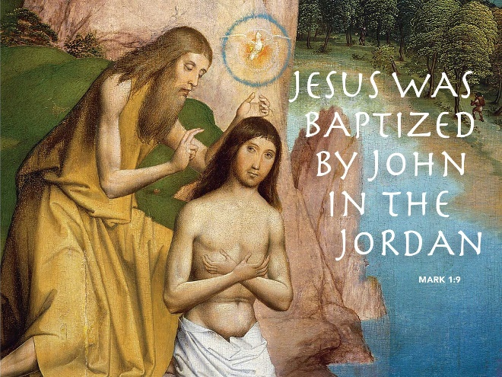

The Church-What Would We Do Without It
January 7, 2018
Mark 1:4-11
Baptism of Our Lord

Grace and peace to you from God, Our Father and from our Savior, Jesus Christ, amen.
Today is Baptism of the Lord Sunday. It’s a day when we are called to “Remember our baptisms and be thankful.” Of course, if you were baptized as a baby, you probably don’t remember your baptism… …so what is there to be thankful for? For one thing, baptism is our initiation into Christ’s Church. And what would our lives be like without the Church? I did a funeral once for a woman who had passed away several years ago. Although her obituary claimed she was a lifelong Lutheran, nobody in the only Lutheran Church in Xenia had ever heard of her. I know we Lutherans like to fly under the radar, but this woman was truly stealth. Anyway, we offered to have the family back to the Church after the funeral for the traditional luncheon, but the family declined our invite. After the funeral they all just went their separate ways, including the woman’s husband. Imagine, going home to an empty house where you spent the past decades with your loved one immediately after burying her. It was one of the saddest things I’ve ever seen. When I think what life would be like without the Church I see a life that’s formless, empty, and filled with loneliness and despair and it lacks purpose.
How would your life be different today if you did not have a loving community of brothers and sisters in Christ to support you and cheer you on? Too many people don’t have that—not even close!!! We live in a painfully isolated and fear-filled culture. Even in this age of social media we sit in front of one type on LCD screen or another—TV, computer, tablet, or smart phone. We have high tech, but I wonder if the price was the loss of human touch.
Loneliness and aloneness is the new thing. Despair is epidemic. Suicide rates have never been higher. People have never been more unhappy. What would you do, especially when the dark clouds begin to form and the difficult times of life arise, if you didn’t know a Savior who loves you unconditionally, walks with you along life’s way, is with you, not just on the mountaintop, but also in the valley of the shadow of death; a Savior who knows your sorrow and your grief, and will carry you all the way to the Promised Land?
We become members of Jesus Christ’s Church when we are baptized. Some of you may be thinking, “If I became a member of the church when I was baptized as a baby, then why did I have to take that membership class, or go through 2 years of confirmation and answer all those questions, one on one, in front of the pastor?” That’s because there is a difference between a “baptized member” of the Church and a “confirmed member.” A baptized member, often experiences Christian baptism long before he or she can understand what it means… …not that anyone ever really, truly understands it! But, we are called to live into our baptism. I mean baptism isn’t an end; it’s the beginning of a lifelong journey. Did you ever notice at Jesus’ Baptism God announces he’s well pleased with Jesus even before he started his ministry?
We might not think about it much, but for many of us, one thing that brings us to church on Sunday is the fact that we were baptized. At our baptism, our parents or guardians make a promise to bring us up in the Christian faith, and the congregation also makes a promise to nurture and love and be Christ to us. When we’re baptized as children, it’s kind of like our parents and the Church saying, “Before you could walk, we carried you… Before you could feed yourself, we fed you… Before you could cloth yourself, we clothed you...” In the same way, before you could believe, we believed for you… Before you could make a commitment to Christ, the we made a commitment for you. Before you could accept what Jesus had done for you on the Cross, we accepted it for you!!!” Then, when you got to a certain age, you were asked to investigate and determine whether you were going to accept that faith and salvation for yourself—to own it for yourself—to wear it—to PROFESS IT—to live it.
In a sense, that’s how it was for Jesus too. The story of Jesus skips from Him as an infant to a thirty-year-old, and we don’t have a clue as to what happened in between…except for one snippet when He was 12 and got left behind at the Temple in Jerusalem. One-day, only 9 verses into Mark’s story, Jesus puts down His hammer, takes off His tool belt, and heads South where He finds His cousin John, standing in the muddy Jordan River. In the Gospel of Mark we don’t even have a birth story. Chapter 1 simply starts with, “The beginning of the good news about Jesus Christ…” And 9 verses later bam, Jesus is getting baptized!!!
We’re told “Everyone in Judea and all the people of Jerusalem went out to the Jordan River and were being baptized by John as they confessed their sins.” So, Jesus gets in line and waits His turn. He wades out into the water, right next to real live sinners like you and me. Only one thing is different. When Jesus stands up, with the waters of the Jordan dripping down His face, He sees “heaven splitting open and the Spirit, like a dove, coming down on him and there’s a voice from heaven: ‘You are my Son, whom I dearly love; in you I find happiness.”
Then, Jesus goes into the desert for forty days to think about what it means to be God’s child. Jesus spends all the days and years that follow that afternoon at the Jordan, discovering the meaning of His baptism. Jesus gives everything—His dreams and actions, His hard work and life itself. Jesus gives Himself completely and lives among broken, hurting and lost people. Baptism was Jesus’ commissioning to ministry. It was God’s saying, “This is my Son; He is Mine. I accept and love Him. I claim Him and I send Him.”
In a very real sense, that’s exactly what God does for us as well when we are baptized. Today Ruby received her adoption into God’s family. She began her lifelong journey of faith discovering what it means for her to be a new person in Christ Jesus. Ruby didn’t decide to follow Jesus. She didn’t make up her mind to accept His love. Baptism is something God does for us. We can’t do anything to deserve it. It is all about grace and acceptance. Since it’s God’s work, God gets it right the first time—we don’t re-baptize persons.
During the week before His death, the leaders of the temple challenge Jesus: “By what authority are you doing these things?” Jesus answers with a reference to His baptism: “Was the baptism of John from heaven or not?”… In his question, Jesus was acknowledging the fact that He was baptized and that’s his authority.
In the waters of baptism, Jesus heard the Spirit calling Him. Therefore, Jesus doesn’t die of old age. He died because He took His baptism seriously! When Jesus cries out on the Cross, “It is finished,” it is His baptism that’s finally complete!!! Baptisms, like most beginnings, find meaning long after the initial event. Ruby’s Baptism this morning changed the trajectory of her life. As she lives and walks into her new life she will see everything in a new way. Her values won’t be the same values as her non-baptized friends. The decisions she makes will now be guided by God’s Holy Spirit and she will have a traveling companion that will never leave her side. That’s what God has done for Ruby and for each one of you in your Baptism.
May you always remember and be thankful for all God has done and continues to do for you. May your life be guided by the gifts of the Holy Spirit. May your Baptism always remind you that your life is no longer formless, or empty. You no longer need be filled with loneliness and despair because you are accompanied by surrounded by, and upheld by the community of believers which is called the Body of Christ. Thanks be to God for giving us meaning and purpose and calling us to live our lives among God’s people, the Church. Amen.

