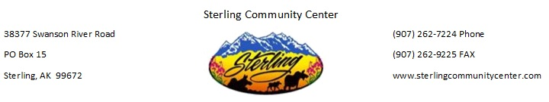

Credit Card Authorization Form

Please complete all fields. You may cancel this authorization at any time by contacting us. This authorization will remain in effect until cancelled.

Credit Card Information
Card Type: ☐ MasterCard ☐ VISA ☐ Discover ☐ AMEX
□ Other
Cardholder Name (as shown on card):
Card Number:
Expiration Date (mm/yy): CVV Code:
Cardholder ZIP Code (from credit card billing address):

I, , authorize Sterling Community Center to charge my credit card above for agreed upon purchases. I understand that my information will be saved to file for future transactions on my account.

Customer Signature Date .

Amount to be charged: __________________________________________

For What? ____________________________________________________

