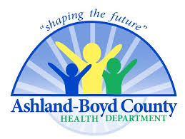
Ashland – Boyd Co. Health Department
Syringe Services Program Weekly Update
May 31st- June 3rd

- Return Client Visits – 41
- New Client Visits - 8
- Syringes Returned – 1303
- Syringes Dispensed (repeat clients) – 1223
- Return Rate – 93.8%
- Narcan Kits Dispensed – 30
- HIV tests performed – 7
- HEP C tests performed - 0

