Trinity Times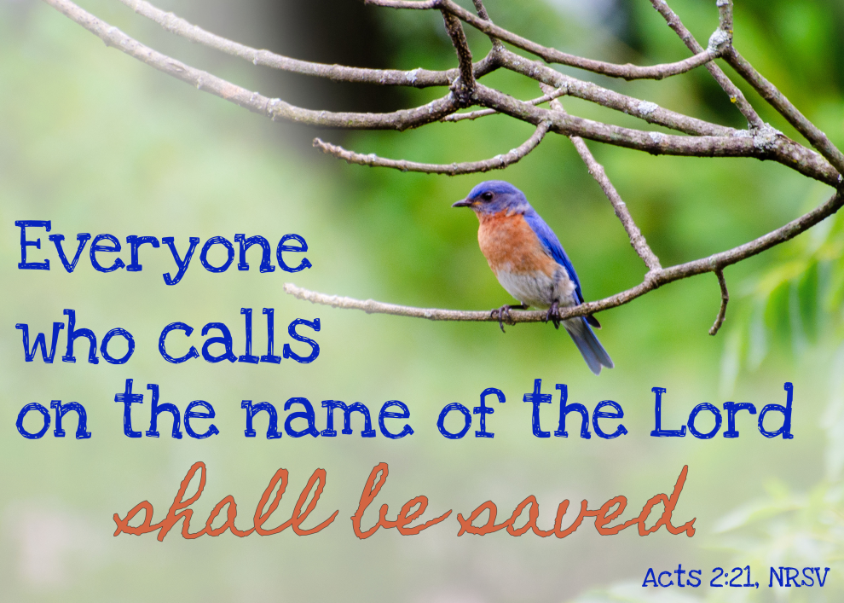es

Volume 9, Issue 5-6
May & June 2022

Trinity United Methodist Church
1160 Trinity Church Road
Newberry, SC 29108
803-276-1245 Office

dobenton@umcsc.org
trinityumcnewberry@gmail.com
www.trinityumcnewberry.net
PLEASE VISIT OUR WEBSITE
AS OFTEN AS YOU CAN!

Peggy Bogart, Church Secretary
Head Usher: Harry Longshore
Choir Director:
Organist: Eddie Welborn
Alternate Organist: Phyllis Sanders
Video Board: Josh Pitts, Bryan Waldrop
Caroline Senn, Foster Senn
Acolytes/Cross Bearers Coordinator:
Newsletter Editor: Harriet Stevenson

We are a caring church and want to share your concerns. Let us know if you or someone you know would like to share a prayer request with us. We will be happy to pray for you. To add or remove names, contact Peggy Bogart, Church Secretary or Harriet Stevenson, Comm. Chm.
Nursing Home: Gloria Brehmer (Springfield Place).

Trinity Church Members: Shirley Berry, Boyd Hendrix, Robert Pollard, Jeannette Poag, Pastor Doug and Carrie, Faye Senn, Rebecca Bundrick, Gerry Johnson
Family and friends of Trinity: Family of Janna Longshore, Freddie Bundrick, Woody and Connie Kreuzinger (Carrie’s parents), Family of Keith Bouknight.
UPDATE ON PASTOR DOUG
Update on Pastor Doug: He finished his treatments at MUSC and is now home but is still very weak. He and Carrie still need our prayers very much. He is making progress each week and taking small steps so let’s continue to pray for them both. His big day will be JULY 11 when he will go back to the doctor for a report. PRAYER WARRIORS -PRAY FOR HEALING! He and Carrie want to thank everyone for the cards and encouragement they both have received. Pastor Doug especially loved the video messages he received from the congregation. She said they meant the world to both of them.
For March and April

May 1 – Jane Woodward
May 8 – Betty Way
May 15 - Joan Morris
May 22- Harriet Stevenson
May 29- Watkins Martin

June 5 - Clarissa Hendrix
June 12 – Linda Lominack
June 1– John Pollard
June 26 - Myrtle Longshore

Greeters be in Narthex by 10:40 a.m.

May 1 – Sharon Baughman
May 8 – Harry Longshore
May 15 – Sylvia Holmes
May 22 – Foster Senn
May 29 - Crystal Waldrop

June 5 – Dixie Waldrop
June 12 – Lynn Mohler
June 19 – Frieda Kesler
June 26 – Betty Way

Happy Mother’s Day to all of our Trinity Mothers
on May 8.

Acolyte Schedule
May 1 – Wyatt Pitts
May 8 – Betty Way
May 15 – Taylor Bouknight
May 22 – Noah Mohler
May 29 – C.J.Griffen

June 5 - Kelly Morris
June 12 – Sylvia Holmes
June 19 – Kruz Bouknight
June 26 – Wyatt Pitts
ACOLYTES: Be robed and in narthex by 10:50 a.m.

Contact Kelly Morris (803) 924-5715 or
Peggy Bogart, Church Secretary (803) 944-1769
if you are unable to serve or if you need to switch
with someone, so they can make changes in bulletin.
Readers, you will receive a bulletin in the mail with scripture included for your assigned Sunday.

LAY SERVANT CLASS
Harriet Stevenson recently completed a 10-hour lay servant advanced class on Opening Ourselves to Grace: The Means of Grace and Discipleship taught by Don Hopper. These classes are held in the spring and fall. Won’t you consider becoming a lay servant? For more information, see Grady Senn or Harriet Stevenson.

HAPPLY FATHER’S DAY
TO ALL OF OUR TRINITY
FATHERS ON JUNE 19TH!

- Trinity Women’s Club - May 2 – 5:00 pm
- Trinity Men’s Club – May 4 - 7:30 pm
- Mother's Day — May 8
- Epworth Offering – May 8
- Administrative Council – May 9– 6:30
- Silver and Gold – May 11 – 11:30 am
- Church Workday – May 14 – 8:30-11:30
- Graduation Sunday – May 15
- May 21 – 1st day of summer
- Luncheon after church – May 22
- Memorial Day — May 31
- Men’s Club – June 1 -7:30 p.m.
- Trinity Women’s Club – June 6- 5:00 pm
- Silver and Gold – June 8 - TBA
- Administrative Council – June 13 – 6:30
- Father’s Day – June 19
- 1st Day of Summer – June 21
May 1 – Anna Grace Waldrop
May 5 – Sheryl Burgess
May 9 – Beverly Brehmer
May 15 -Charles Senn
May 16 – Josh Pitts
May 16 -Erin Pitts
May 19 – Shirley Berry
May 21 – Sharon Baughman
May 22 – McCallum Senn
May 28 – Frances Pitts
May 28 -Carol Johnson
May 29 – Della Senn
May 30 – Ashley Wilson
May 30 – Tyler Poag
June 4 – Dena Pollard
June 3 – Heather Armstrong
June 6 - Eddie Welborn
June 6 - Peggy Marlowe
June 6 - Lavone Coats
June 17 - Dale Bundrick
June 25 – Lynn Mohler
June 29 – Leah Caldwell
EPWORTH’S MOTHER’S DAY OFFERING

EPWORTH IS OUR MINISTRY! Did you know that in the last year Epworth Children’s Home gave over 200 children a safe and loving place to call home? Each of these children had this opportunity because of United Methodist churches in South Carolina who embrace and provide for this ministry in support of the children and families in our state. We will
participate in the annual Mother’s Day Offering on Sunday, May 8, 2022, to benefit the children who call Epworth home. Please be in prayerful consideration of what God is calling you to give to this valuable and life changing ministry.

A heartfelt thank you to my church family for your many acts of kindness show during Philip's long illness and at his passing. The cards, calls, visits, flowers and food offerings have been overwhelming! Your love, prayers and thoughtfulness will always be remembered!
Phyllis

Congratulations to all of our graduates!

GRADUATES HIGH SCHOOL PROUD PARENTS

Joe Brehmer Newberry High School Steve & Beverly Brehmer
Coye Cutshall Newberry High School Mark & Ashley Cutshall
Cameron Hawkins Newberry Academy Mike & Allison Hawkins
Laura Mohler Newberry High School Burt & Lynn Mohler
Caroline Senn Newberry Academy Foster & Sharon Senn
Emily Spicer Online Home-Schooling Ray & Melissa Spicer
Laura Spicer Online Home-Schooling Ray & Melissa Spicer
Noah Waldrop Newberry High School Bryan & Crystal Waldrop

Sarah Mohler Wofford College Burt and Lynn Mohler
McCallum Senn Clemson University Foster & Sharon Senn

Thank you to Kelly Morris and Josh Pitts for all of their hard work on the Graduate Sunday presentation to be included in the service on May 15.

“Twenty years from now you will be more disappointed by the things you didn’t do than by the ones you did do. So throw off the bowlines. Sail away from the safe harbor. Catch the trade winds in your sails. Explore. Dream. Discover.”
—Mark Twain

Silver and Gold
Wed* May 11* 2022
11:30 a.m. Fellowship Hall
Women wear your hats and men bow ties!
Enjoy authentic Derby food cooked
Did you know??
Mia Kate Brehmer and her cheer team have won many 1st place awards! Congratulations Mia Kate! Mia Kate is the daughter of Lance and Kaitlyn Brehmer.

by Silver and Gold members to include mock mint juleps, Benedictine sandwiches, tea sandwiches, strawberry salad, and Derby pie.

Jackson Livingston, grandson of Phyllis Sanders, will be attending Western Carolina
University this fall. He was awarded a football and an academic scholarship and will also be active in track and field in the javelin. Jackson holds the 3-A State Title in javelin.

Play Kentucky Derby games for prizes. Over 55? Join us for food, fellowship and devotions.

Hebrews 12:1 “So let us run the race that is before us and never give up.”

Please RSVP to Harriet in person or by phone.

Silver and Gold in April at the Joanna Grill
17 people in attendance, our largest crowd to date. A good time was had by all and we were
treated like royalty. Good food and good fellowship.

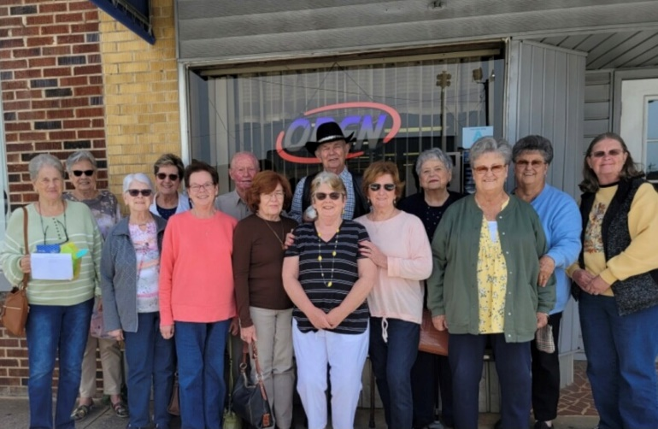
Missing from photo: Wilson, Wade and Frances

Photos from Easter Breakfast
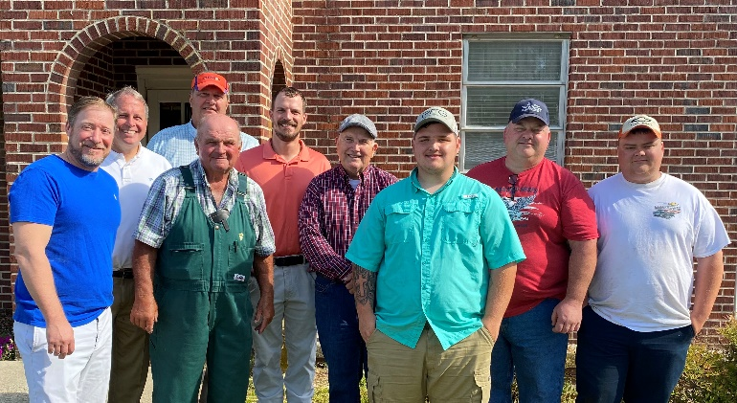
The Cooks
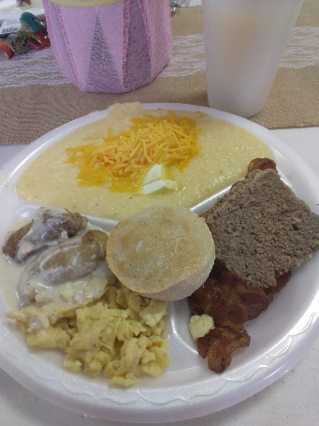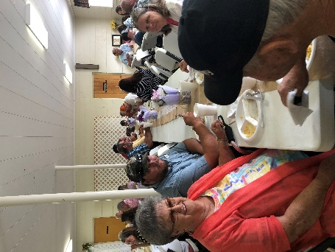
The Food The People

Since Memorial Day falls on the 5th Sunday of May, we are having our usual 5th Sunday festivities on the 4th Sunday, May 22, instead.

LETS’S HAVE A SUMMERTIME
LUNCHEON AFTER CHURCH ON

May 22, 2022

- Bring a covered dish
- Bring a dessert
- Enter the “WINNING DESSERT” contest
- Games and prizes
- Fun and fellowship
- Signup in the narthex

Trinity lost two of its former pastors recently. Sympathy is extended to the families of Rev. Allen Senn, 90, who passed away in Spartanburg in January and Rev. Phil Jones, 92, who passed away in Columbia in April.

May 26
For 40 days after his resurrection on Easter Sunday, the Bible says that Jesus travelled and preached with his apostles, preparing them for his departure from Earth. Ascension Day marks the moment Jesus literally ascended into heaven before his disciples, at the village of Bethany, near Jerusalem

June 5
The Christian holiday of Pentecost is celebrated on the 50th day from Easter Sunday. It commemorates the descent of the Holy Spirit upon the Apostles and other followers of Jesus Christ while they were in Jerusalem celebrating the Feast of Weeks, as described in the Acts of the Apostles.

Our prayers and sympathy are extended to Phyllis Sanders and family on the recent passing of her husband, Philip Sanders, who had battled poor health for a number of years. Phyllis was his faithful caretaker.

VACATION BIBLE SCHOOL 2022
June 12 – 15, 2022
Sunday – Tuesday evening Bible School
5:30 – 7:30 p.m.
With program on Wednesday evening
6:30 p.m.

LYNN MOHLER, VBS DIRECTOR

North Castle is hidden in a frozen land. The King’s valiant Knights are on a quest in search of the King’s Armor. But the armor isn’t what they think it is.
Cokesbury’s VBS, Knights of North Castle: Quest for the King’s Armor, invites children to be strong in the Lord and in the strength of God’s power by exploring how we put on the armor of God. Kids will take on the role of brave Knights and begin their quest each session by opening the King’s Book. They’ll explore Old and New Testament stories and discover different pieces of protective armor—the Belt of Truth, the Breastplate of Justice, the Shoes of Peace, the Shield of Faith, and the Helmet of Salvation—at work in the lives of familiar Bible characters and explore how that armor works in their own lives as they follow and serve God.

Help kids take up the gauntlet this summer and accept the challenge to “armor up” and be strong by remaining with God and sharing God’s love in a world that needs it more than ever.

“Be strong in the Lord and in the strength of his power” Ephesians 6:10

See Lynn if you would like to help in any way.

VBS - Sunday – Tuesday
5:30 – 7:30 pm
Program – Wednesday
6:30 pm

Trinity UMC
1160 Trinity Church Road
Silverstreet, SC 29145

