Strong 24 hour fat burning support from Biogen Health Science.

Kick start an even more aggressive fat burning course!

## Important information

#### Safety Information:

* This formula is made from the highest grade pharmaceutical quality dietary ingredients and is highly concentrated. This product should always be used as directed - never exceed recommended serving dose for a 24 hour period. This product is not recommended for those under the age of 18 or nursing and pregnant mothers. Those who take prescription medication regularly or have a diagnosed medical condition should consult with their medical professional prior to use. Side effects are exceptional rare but please discontinue use immediately if adverse effects are experienced. Keep out of reach of children.

#### Indications:

This product contains a highly concentrated maximum strength formulation with every herbal extract standardized and certified for the highest precision potencies. Please follow the instructions carefully and never exceed the recommended serving dose as highlighted. * This product is not intended to treat or cure disease. * Not to be taken as a substitute for a healthy and balanced diet.

#### Ingredients:

Elaterin; Honeysuckle; Aloe; Fiveleaf; Gynostemma Herb; Semen Cassiae; Torae; Follum Nelumbinis; Ginseng; Barbary Wolfberry Extract;

#### Directions:

Care should be taken when following the instructions on the packaging. (1) Clean the skin around the area of administration. (2) Open the package and remove the clinical backing of the Fat Burner Patch. (3) Apply the patch to the skin. (4) Wear the patch for 12 hours. (5) Remove the patch after use and dispose of.

## Product Description

### Achieve Your Goals With Products Based On Science!

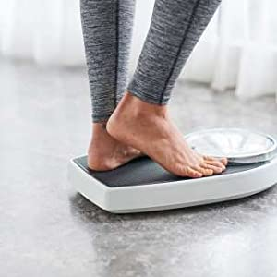

Biogen’s T5 Fat Burner weight loss patches contain proven fat burning and detoxification ingredients. By utilizing nano-magnetic and transdermal technology (the same as nicotine patches) these ingredients bypass the digestive system and are delivered through the skin for a direct undiluted fat burning and detox effect.

The nano-magnetic technology removes oxidatives that your body would take a week of normal liver function to remove - research proves those who have high levels of toxins have difficulty losing weight. Expect to see a host of consistent fat burning benefits being supported; including elevated fat loss, enhancement of the endocrine system and heightened metabolic rates.

Ideal for: Use alongside any of Biogen’s fat burner range for significantly enhanced and extended 24 hour fat burning capabilities. Containing no caffeine, each patch should be worn for a maximum of 12 hours through the night. This will enable you to give your fat burning and detox course the ultimate boost - even while you sleep!

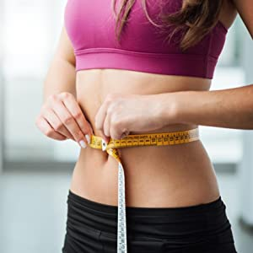

How to apply the T5 Fat Burner patch?

1. Clean the skin around the naval area, do not use moisturizing soap or lotion before applying.
2. Open the package and remove the backing of the fat burner patch.
3. Place the fat burner patch on a clean and dry naval.
4. Press the fat burner patch firmly on your skin for at least 10 seconds, ensuring it sticks well especially around the edges.
5. Wear the fat burner patch for a total of 12 hours.
6. Remove the fat burner patch (used patches should be folded in half and safely thrown away).

**When to apply T5 Fat Burner patch?**  
  
Most recommended: Containing no caffeine - only proven fat burning and detox ingredients, the T5 Fat Burner patch is ideal for use throughout the night when you are at your least active. Each patch when worn for 12 hours will enable you to give your fat burning course the ultimate boost - even while you sleep.

**Ideal for:** Use alongside any of Biogen’s fat burner range for significantly enhanced and extended 24 hour fat burning capabilities - throughout the day and night. The T5 Fat Burner patch combined with any Biogen fat burning product is all you need to burn more excess fat, maintain energy and encourage detox.

**Most effective when:** One patch is applied before your workout to increase cellular respiration. The T5 Fat Burner patch when used in this way will encourage metabolic reactions and processes that convert energy within cells for increased calorie expenditure. Highly beneficial and ideal for those needing an extra boost to sustain optimum energy levels to fuel exercise.

**Tip:** In order to get the best results, Biogen Health Science recommend to use the T5 Fat Burning patch for at least 28 days for optimal results.

|  |  |  |
| --- | --- | --- |
| **fat burners** | **fat burners** | **fat burner** |
| Maximum Strength Biogen's premium quality formulation contains 100% PURE and quality graded ingredients far exceeding the dosage proven effective in clinical studies.  Each patch has the absolute maximum potency conecentration allowed for consumption under dietary supplement laws. | Who should use? Biogen pledge an innovative solution for both men and women who want to achieve reliable results.  Each pack comes with 28 patches – a full month’s course where 1 patch is applied daily. | Side Effect Free We take every precaution necessary to ensure that these products are 100% safe & herbal in nature.  Rest assured that we would never consider manufacturing an item that did not fully meet these requirements. |

**Note(s):**• Not intended for persons under the age of 18.  
• Keep new and used T5 patches out of reach of children.  
• People with sensitive skin and/or are prone to skin rashes and/or eczema may find that a different T5 fat burning product may be more suitable.  
• If you develop a skin rash from using the fat burner patch, stop using immediately.   
• Using the patch while exercising may result in excess sweat weakening the adhesive.  
• Manufactured in a MHRA, FDA and GMP approved laboratory for your highest safety.

# Strongest Keto Diet Pills : Advanced Fast Weight Loss Formula for Men and Women (60 Capsules / 2 Month Supply)

# About this item

* Keto Plus+ is a scientifically backed and potent fat burning supplement
* Ideal for both men and women who are seeking rapid weight loss
* Unique formulation simultaneously speeds up the metabolism, suppress appetite and burns fat
* Proven To Work: Average Fat Loss Of 4-6lbs A Week!
* Manufactured within an FDA and MHRA approved facility for your highest level of safety.

**Important information**

**Ingredients:**

Advanced Keto Formulation: Caffeine Anhydrous (110mg per serving); Guarana (20mg per serving); Green tea 40% extract (20mg per serving); N-Acetyl-L-Carnitine (10mg per serving).

**Product Description**

**Achieve Your Goals With Products Based On Science!**

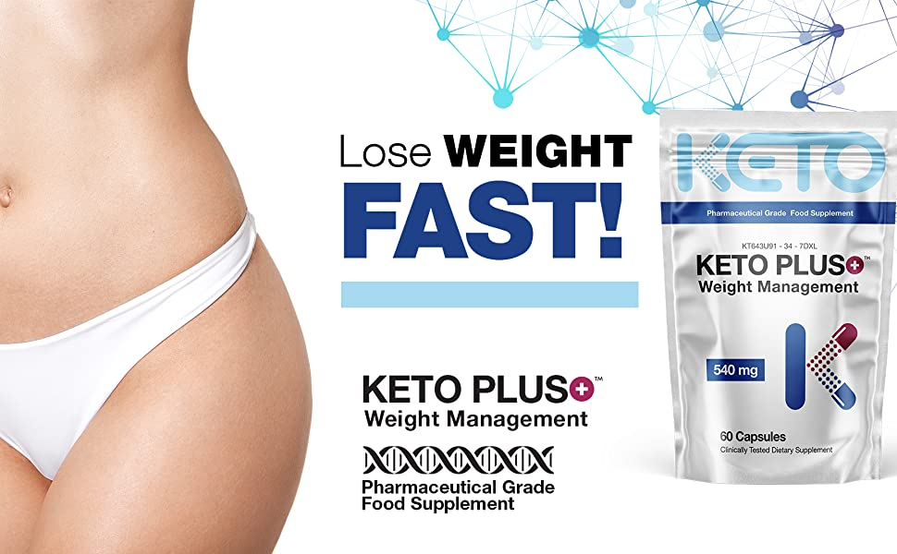

All ingredients are clinically proven to stimulate the mechanisms of ketosis and induce the complex systemic and powerful metabolic changes that speed up the metabolism, suppress appetite and burn fat! Combined the result is a dietary supplement essential for fast weight loss!

Keto Plus+ is formulated to facilitate optimal fat loss during ketosis. Under normal conditions, insulin enables glucose from the bloodstream to enter cells to generate energy. Keto Plus+ shifts the body's metabolism away from carbs and towards fat stores as a primary source of energy. Your body is able to burn through your fat rapidly by enhancing these fat burning pathways!

* Keto Friendly
* No Prescription required
* Formulated for Rapid Weight Loss *

* While this product has been specifically formulated to facilitate rapid weight loss. If you find yourself losing more than 7 pound per week, health care professionals recommend decreasing the dose.

**Benefits**

|  |  |  |  |
| --- | --- | --- | --- |
| **keto diet pills** | **keto diet pills** | **keto diet pills** | **keto diet pills** |
| **Reduced Hunger**  Another advantage of Keto Plus+ is the ability to suppress appetite and hunger. It can effectively decrease levels of ghrelin - one of the body's main hunger hormones. By reducing ghrelin levels your body is tricked into believing that it's not hungry! Keto Plus+ is ideal on its own or can facilitate fasting! | **Faster Metabolism**  Keto Plus+ shifts the body's metabolism away from carbs and towards fat stores as a primary source of energy. By super charging the metabolism, Keto Plus+ enables the body to burn through your fat stores rapidly but most importantly, this enhanced formulation decreases the body's ability to store fat. | **Enhanced Mental Performance**  When in ketosis, the brain doesn't require dietary carbs. It is fueled around the clock by ketones alone with a smaller quantity of glucose synthesized in the liver. Using fat stores as an energy source, the flow is steady and you are able to avoid spikes and crashes with blood sugar swings. | **Increase Physical Endurance**  By accessing vast amounts of energy in fat stores, physical endurance will be increased. The body can only store carbs (glycogen) to facilitate a couple of hours of intense exercise, but fat stores can provide unlimited energy as long as there is fat to be burnt! |

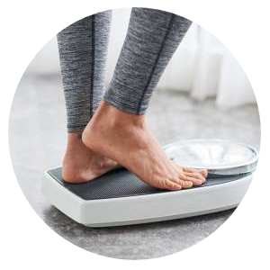

**Results for Everyone - Every Time**

One of the biggest benefits of to Keto Plus+ is the ability to inhibit an enzyme called amylase - a digestive enzyme that helps the body break down carbs to be easily absorbed. By inhibiting the breakdown of bonds in carbs and starch - when consumed they pass into the large intestine without being broken down and absorbed!

Keto Plus+ can drastically reduces carbohydrate absorption and launches the body into a ketosis metabolic state. When the body is in ketosis, ketones sever as an alternative, primary and more efficient energy source that are produced from the breakdown of fats. This happens because there is not enough carbs and glucose to meet the body's energy requirements.

The enhanced formulation then stimulates the complex systemic and powerful metabolic changes that speed up the metabolism, suppress appetite and burn fat! For anyone looking to lose weight fast, the improvement and stimulation of these natural processes is highly crucial and incredibly beneficial for weight loss.

**Superior Standards**

|  |  |  |
| --- | --- | --- |
| **keto diet pills** | **keto diet pills** | **keto diet pills** |
| **Directions For Use**  This is an extremely potent product and should always be used responsibly.  Take one (1) capsule once per day. Ideally the dose should be taken in the morning on an empty stomach or at least 1 hour after eating, to increase absorption.  For an additional energy boost one (1) additional capsule can be taken 30 - 45 minutes before physical activity or exercise.  Do not exceed the stated dose. | **Premium Quality Supplement**  Every bottle is manufactured in a fully licensed facility, using only premium graded ingredients.  Rest assured that we would never consider manufacturing an item that did not fully meet these requirements. | **Advanced Multi-Complex Formula**  Keto Plus+ weight management capsules contain pharmaceutical grade ingredients that are recommended by leading health professionals for enhanced weight loss.  Each capsule has the absolute maximum potency concentration allowed for consumption under dietary supplement laws. |

**Green Tea Tablets 9000mg (60 Tablets) Strongest Legal Green Tea Extract 100% Pure Certified**

* Maximum strength 450mg Green Tea Extract 20:1 (9000mg green tea leaf equivalent) standardised to provide 95% Polyphenols, 45% Catechins (EGCG) & 7% Caffeine.
* Powerful natural antioxidant compounds that has an abundance of health benefits.
* Maximizes weight loss by stimulating and enhancing metabolic function.
* Each component of BioPharmX advanced formulation has been highly refined and exceeds the HIGHEST pharmaceutics purity standards.
* Manufactured in an FDA and MHRA approved facility for your highest level of safety.

## Product Description

### Green Tea Extract Tablets - 60 Tablets (2 Month Supply)

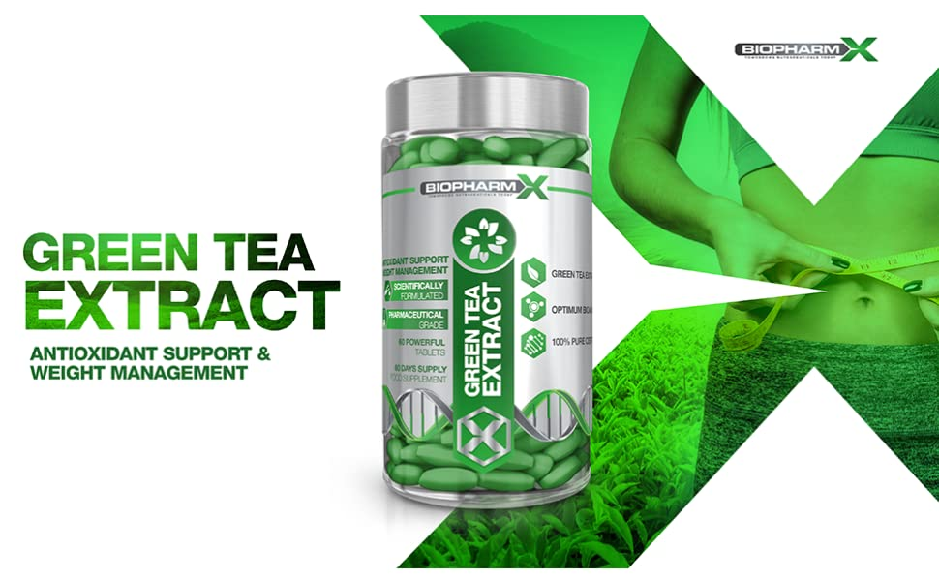

The chemical composition of Green Tea extract is diverse, unique and complex and with many compounds being unique to green tea itself. This duel action fat burner is not just remarkable for weight loss aid but also delivers a wide range of benefits for general health.

Why not just drink Green Tea? Each tablet contains 450mg of ultra-potent, pharmaceutical grade Green Tea Extract 20:1 (9000mg green tea leaf equivalent) standardised to provide 95% Polyphenols, 45% Catechins (EGCG) & 7% Caffeine. In order to achieve the same benefits as 1 BioPharmX Green Tea Extract tablet, one would have to drink an insurmountable of green tea per day.

Essential for:

* Increased Fat Burning for Energy
* Whole Body Antioxidant Support
* Cell Protection from Oxidative Stress
* Powerful Anti-Inflammatory
* Healthy Lipid Profile
* Essential Minerals for Overall Health

### The following benefits have been identified in published studies and clinical reports surrounding Green Tea and its numerous bioactive compounds.

|  |  |  |  |
| --- | --- | --- | --- |
| **green tea extract** | **green tea extract** | **green tea extract** | **green tea extract** |
| Weight Management Green Tea extract contains bioactive compounds polyphenols, EGCG and caffeine - all have been shown to induce thermogenesis, stimulate fat oxidation and significantly boost metabolic rate.  By super charging the metabolism, Green Tea enables the body to break down and burn through fat stores rapidly as well as using consumed calories for energy rather than storing them as fat and other lipids! | Whole Body Antioxidant Support Biochemical analysis has clearly demonstrated Green Tea’s ability to provide whole body antioxidant support as a potent antioxidant to neutralize free radicals.  As you age your naturally defense against free radicals becomes less effective, as cells accumulate free radical damage over time - so that’s why research shows that high levels of antioxidants can prevent many age related diseases by preventing free radicals from oxidizing biological molecules. | Powerful Anti-Inflammatory EGCG has successfully demonstrated its anti-inflammatory effects. The natural anti-inflammatory compound works by targeting multiple diverse steps within the inflammatory pathway and effectively reduces inflammation at a molecular level.  Boosts levels of GABA, serotonin and dopamine: All are important neurotransmitters in the brain that work to regulate mood, emotions, alertness, concentration and sleep. | Mental Health & Well-being L-theanine is an exclusive amino acid found in tea plants which is responsible for the taste of green tea. It acts as a neurotransmitter in the brain which works to promote feelings of relaxation and facilitates a better night’s sleep by stimulating numerous mechanisms within the brain.  Consuming Green Tea during times of stress has been shown to induce relaxation by reducing markers of psychological stress by up to 50%! |

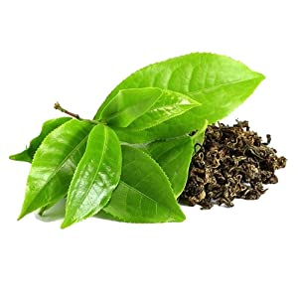

### In order to achieve the same benefits as 1 BioPharmX Green Tea Extract tablet, one would have to drink an insurmountable of green tea per day.

BioPharm-X manufacturing department is an MHRA licensed, GMP certified and ISO accredited, operating within compliance of all relevant laws and regulations.

* Maximum Strength Green Tea Extract
* Pharmaceutical Grade Ingredients
* GMO Free
* Suitable for Vegetarians

### BioPharmX: Superior Standards in Nutritional Supplements

|  |  |  |
| --- | --- | --- |
| **green tea extract** | **green tea extract** | **green tea extract** |
| Leaders in Nutritional Supplements BioPharmX has the goal of enhancing the well-being of their customers around the world by delivering premium quality, best value nutritional supplements.  Each tablet has been formulated to safely provide significantly more then other Green Tea Extract supplements on the market. | Premium Quality Every bottle is manufactured in a fully licensed facility, using only premium graded ingredients.  Rest assured that we would never consider manufacturing an item that did not fully meet these requirements. | Directions for Use Adults: As a supplement begin by taking 1 tablet in the morning on an empty stomach with at least 8fl oz of water.  Do not exceed stated dose in a 24-hour period.  Use only as directed. |

### Ingredients

Green Tea Extract 20:1 (450mg) 95% Polyphenols; 45% EGCG