## Meanwhile in the bleak mid-winter – outside work continues on the Tower and moving towards the east end of the building (the scaffolding now in place) work on removing the old roofing, and replacing it with a new temporary structure, has now begun. This ancient part of the building is an important historic feature and proper repairs will (subject to funding being available) start in the Spring/Summer of 2013. We can expect to see more work in this area next week and hope that at lest for now the weather remains relatively dry.

## IMG_2359.JPGIMG_2360.JPG

It must be the time of year – but some-  
one has attempted to break-in the con-  
tractors compound by bending back   
the sheeting - only to find more sheeting behind – they didn’t get too far, the alarm wasn’t activated, so we guess they give up and went elsewhere. Thieves beware – we do have CCTV and an alarm system operational!

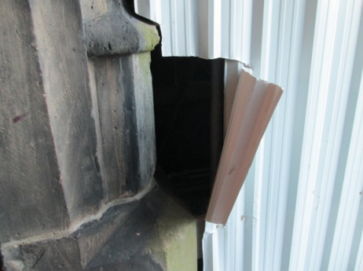The second set of unwanted visitors have paws and claws, can’t read the signs and seem to come out at night – feral cats - which we are of course arranging to evict via the appropriate authorities and regrettably (or maybe not) have no photos of.

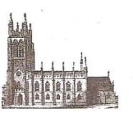

 St Mary’s in the Marketplace.



Issue No 20 (2nd December 2012)

**“Securing the future for the next 100 years”**

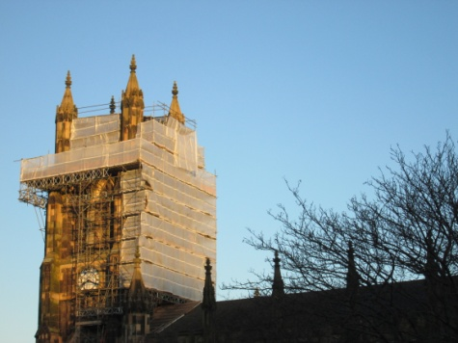We are into our Christmas Programme this coming week and very much hope that you will support as many of our concerts and carol services as you can and encourage your family and friends to do the same. Work will continue throughout the next month, both inside and out, with our Contractors/Sub-contractors all being aware of the busy schedule of services, concerts and other activities that will be taking place, and the hundreds of people we expect to be visiting St Mary’s. They will, as best they can, ensure that disruption within Church is kept to a minimum. We appreciate that the facilities aren’t ideal - with no operational indoor toilets as yet - but will do our best to ensure that everyone visiting us is made welcome and their needs accommodated for in the temporary facilities we have been able to provide.

Copies of the Christmas   
Programme are available   
in Church and all details  
listed on our web site at  
www.stmarysinthemarketplace.com

**Take a seat! We do have a non-operational indoor loo…**

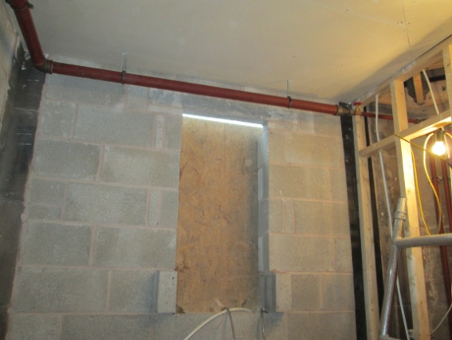Our contractors have certainly been busy this week and the first of our three new toilets has arrived on site – seen here located inside Church as part of a row of chairs - but don’t worry it has been moved!

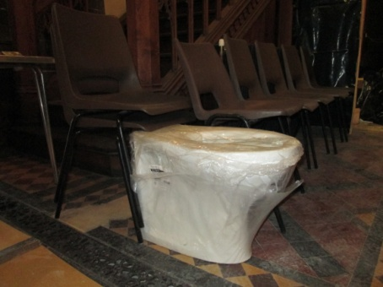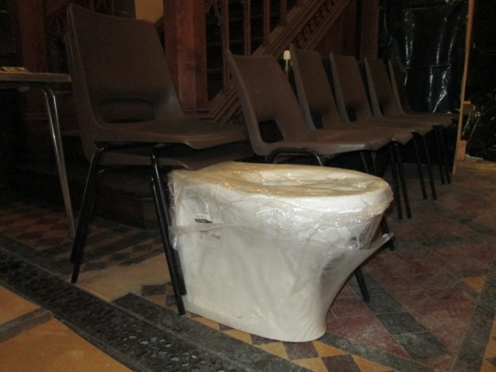

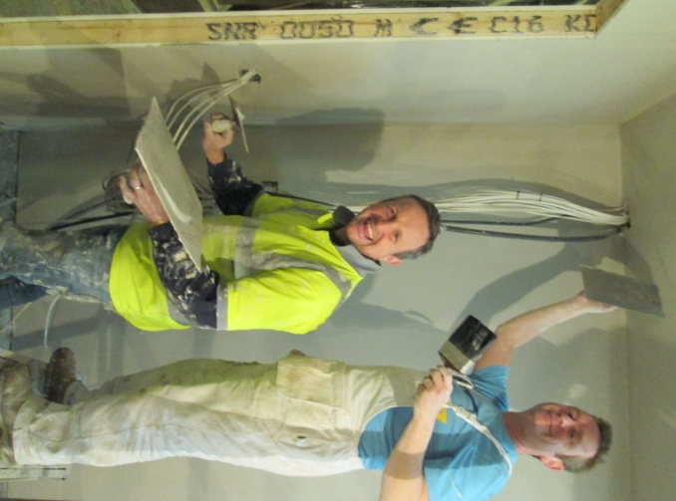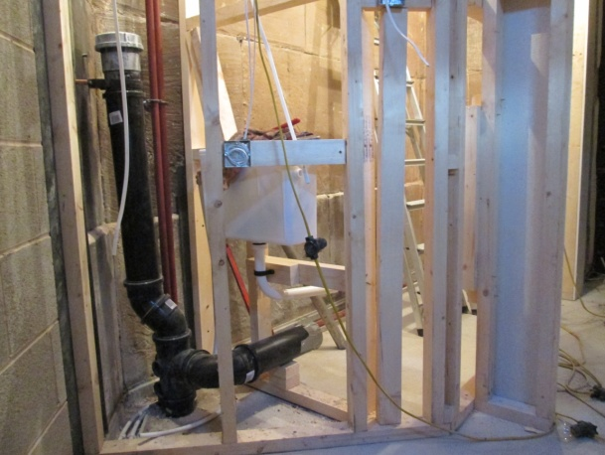Behind the screens and the new   
facilities are taking shape, with walls being put in place and the plumbing fitted within the toilet area, whilst the kitchen was being plastered. More  
 work in this area next week and along  
 the north aisle.

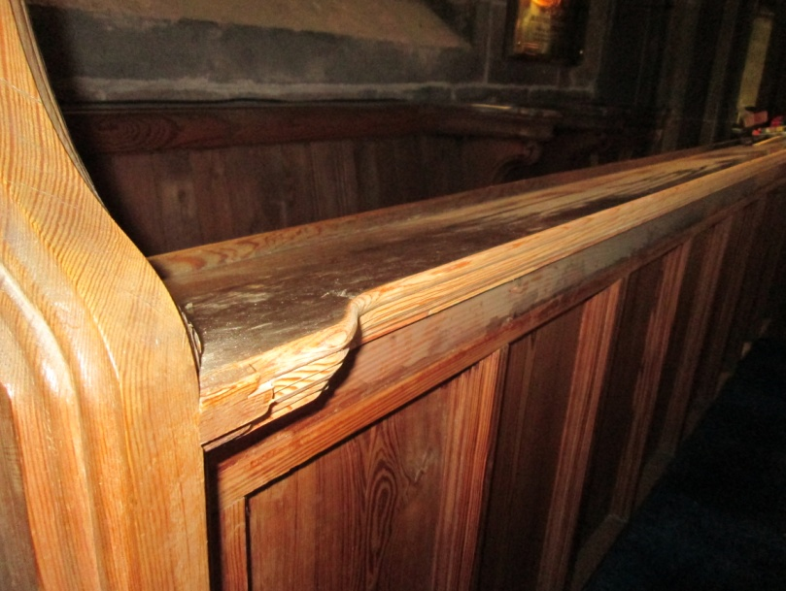For those of us who have sat in the Chancel during the last week it has been wonderful to note that the modifications have been made to the pews. Our decorators just need to do a little cosmetic work and then we will be ready to add those very important cushions - at the appropriate time.

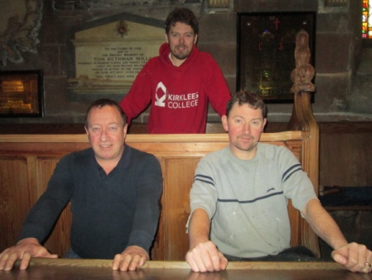Thanks guys – no more banging the back of our heads when we sit down – what a relief! A job well done and much appreciated.

Not a stones throw away from  
where our carpenters are sitting  
we have a virtually un-usable  
Rector’s Vestry. A room with a  
view to the sky this week!  
   
This area of the church was always expected to be a problem and in urgent attention of emergency work, so our weekly report next takes us back outside, where a lot of activity has taken place over the last few days up on the vestry roof - and where there is lots of work still to be done.