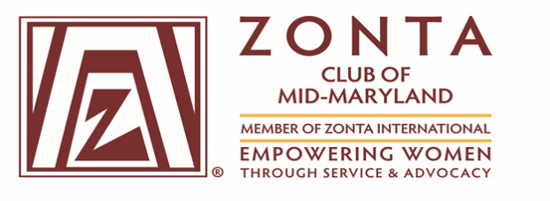

**(Chartered May 5, 2016)**

**General Membership Meeting Minutes**

**Virtual Zoom Meeting**

**Thursday, September 10, 2020**

**Attendance:**

**President** Virginia Moore, **1st Vice President,** Tammie Edwards, **2nd Vice President**, Nicole Barnes, **Treasurer** Tanya Duckett-Brennan, **Assistant Treasure** Erma Barron, Doris Winston**, Correspondence** Secretary; **Directors:** Alice Ross and Cleopatra White; Gloria Smith-Hill, Linda White-Andrews, Diane Williams, Amanda Welch, Tanya Shanklin, Gwen Terry, Stanita Scott, and Britney Jones. **Total - 15 Members**

**Call to Order:** President Virginia H. Moore called the meeting to order at 7:05 pm

**Zonta Vision and Code:** Read by President, Virginia M. Moore

**Agenda Review/Approval:** The agenda was reviewed and approved by members. No comments or changes were noted.

**President’s Remarks:**

Virginia Moore commented on District Conference, scheduled for October 3rd Virtual Seminar, and asked members of Mid-Maryland to attend conference.

**Correspondence:** Family Justice Center provided thank you letter. Received District Conference letter.

**Minutes of the general membership meeting were approved.**

**Treasurer’s Report:**

**Service Budget for 2021-**Presented by Tanya Duckett-Brennan for June thru August 2020, was provided to members and the board.

**FY 2021 – General Operations Budget** –was approved in May 2020. Revised budget for 8/7/20 was reviewed and explained. Members voted and approved the revised budget and general operations budget.

1

**Discussion:**

**Operations Financial Report – June 2020; Service Financial Report – June 2020; Operations Account Financial Report – 8/16/20; Operations Account Financial Report – 9/1/20; Service Account Financial Report for 8/31/20**

**1st Vice President Membership Report:**

Tammie Edwards provided an overview of the membership committee report.

Promoting membership/Recruitment and Retention Efforts

**2nd Vice President- Programs Report:**

Nicole Barnes working on calendar of activities, events, and guest speakers.

**Committee Reports:**

**Fundraiser Committee Report:** Presented by Gloria Smith-Hill, provided an overview on programs and focus on domestic violence for FY 2020/2021. Partnership with Yellow Rose Foundation and Healthy Babies. Plan to implement projects in October 2020. Financial Goal - $5K.

**Service Committee Report:** Alice Ross and Cleopatra White reached out to Ashley Greer regarding the food pantry. Sought Justice Center for their needs. Cleopatra requests members to join committees. Members should collect non-perishable foods and reach out to food pantries.

Alice commented on the Family Justice Center upcoming holiday children’s party. Alice said that the organization has a donation list for items. Justice Center needs donated items. Alice and Cleopatra need volunteers for service committee. If interested please email Alice or Cleo.

**Public Relations and Social Media Committee:** Presented by Tanya Shanklin

The Zonta Club of Mid-Maryland Website and Facebook will be updated to include:

Scholarships and Fellowships announcement; Amelia Earhart Fellowship; Young Women in Technology; Jane M. Klausman Young Women in Business (Scholarship, no announcement of the award, expect an announcement soon, selection sometime in November 2020); and Press Releases of Zonta Club Events. Next scholarship, April 1, 2021, Young Women in Public Affairs. Discussion concerning the budget for the website and the need for a new Visa Card. Virginia advised to review the budget and may have some contingencies for the budget.

**Advocacy Committee Report: “Call to Vote Initiative”**

Amanda Welch, Co-Chair; Nicole Barnes gave an over review of the event. Proposed goal 250 safety kits, two sites selected, Bladensburg High School and Northwester High School, these areas have a high rate of domestic violence, sexual assaults and human trafficking. Zonta brochures will be included in the kits. During the Presidential Election on November 3rd, sites identified will be covered from 8am-4pm, volunteers will cover 2 to 4-hour shifts.

2

Email Nicole or Amanda if anyone is interested in volunteering.

Emma Barron – Announcement, District 3 Conference on Saturday, October 3, cost $15.

**Maryland Early Voting: October 26, 2020 – November 2, 2020**

**Election Day: November 3, 2020**

**New Business: None**

**Unfinished Business: None**

Meeting was adjourned at 8:39 pm

Minutes respectfully submitted by Doris Y. Winston, Secretary

3