 | ISKF PAYMENT
 | Date: ____________
 | Check #: _________
ALASKA SHOTOKAN KARATE | Amount: $________
International Shotokan Karate Federation - Alaska Region, Inc. | Initials: __________
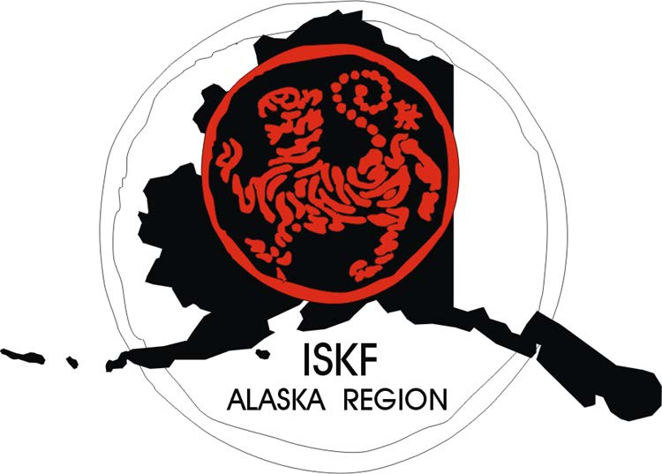
Sep 2022 - Aug 2023 APPLICATION FOR MEMBERSHIP
$50 annual membership fee payable to ISKF-Alaska (all ranks)

Make checks payable to ISKF-Alaska. Return form with payment to your instructor.
Instructors please mail to ISKF-AK, % Susan Jones, Box 240264, Anchorage, AK 99524
Name _____________________________ Rank_____ Gender (M/F) ____ Age ____ Birth date ___/___/____

Address _________________________________ City __________________ AK ZIP _____________

Home Phone______________ Cell Phone ______________ Email: ________________________________

Do you have any physical handicaps or limitations that your instructor should know? ◻ No ◻ Yes (If yes, please describe on the bottom of this page or explain to your instructor.)

In case of emergency, call (name) _________________________ cell phone _______________________

In case of emergency, call (name) _________________________ cell phone _______________________

At which Alaska Shotokan Karate Club are you currently training? __________________________________

Your instructor’s name _____________________________________

______ Initial here to grant permission for your or your child’s picture to be taken for the purpose of general media or press releases for ISKF-Alaska. Place an “X” if you do not grant permission.

RELEASE INDEMNITY

I, intending to be legally bound hereby and as a condition of membership in Alaska Shotokan Karate Club (herein referred to as ASKC, and also refers to the Alaska Region of the International Shotokan Karate Federation and ISKF) do hereby release said ASKC, the members, instructors, and representatives thereof, from any and all claims, liabilities, obligations, causes of action or demands that I or my administrators, executors, heirs or assigns may at any and all times hereafter have or obtain, due to or as a result of, any personal injury or bodily harm, sustained or suffered by me during, arising out of or as a result of any karate activity, physical or athletic activity, or physical instruction or sport conducted or carried on by or for said ASKC, either by itself or with others, or occurring while I am on any premises of property occupied or used by said ASKC.

I further, intending to be legally bound hereby and as a condition of my membership do agree to indemnity and save harmless ASKC, its members, instructors, and representatives, from any act committed or omitted by me during or arising out of or as a result of any activity or exercise or sport carried or participated in by said ASKC, by itself or with others, or occurring on any premises of property or used by said ASKC.

I further release said ASKC, its members, instructors and representatives from all claims of liability for any property or valuables lost, mislaid or stolen.
I sign this fully realizing that karate is a martial art and my participation or engagement in the activities of said ASKC may subject me to personal injury or bodily harm. I further have read the foregoing and fully understand the contents of this release indemnity.

Signature ________________________________________________ Date _______________

For students under 18 years of age, a parent or legal guardian must sign the approval statement below.

Approval and Acceptance by Parents or Guardian

The undersigned, the parents or legal guardian of ______________________________ have read the foregoing, understand the same and do hereby accept and agree to the terms, conditions and provisions of the foregoing Release Indemnity on behalf of ourselves and the said minor, intending to be legally bound hereby.

Signature _____________________________________ Date __________________

Printed Name: ________________________________________

Please describe below any physical limitations or handicaps that you would like your instructor to know about:

