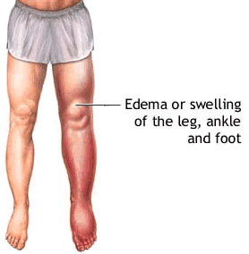
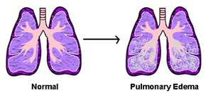


Edema
... is an abnormal accumulation of fluid beneath the skin or in one or more cavities of the body that produces swelling. Generally, the amount of interstitial fluid is determined by the balance of fluid. Electrolytes (minerals) are very involved in this fluid balance.

Supplements of Benefit:
- Shaklee Alfalfa ... used generously (1 for every 10 pounds of body weight daily)

- Drink Shaklee Performance (an electrolyte drink), to help correct the fluid imbalance

- Shaklee VitalMag is frequently of benefit. If the potassium and magnesium levels in the blood test are slightly low, supplementation is of benefit. Potassium and magnesium should always be at the upper end of the reference range provided in the blood tests from the lab.

