Scleroderma –
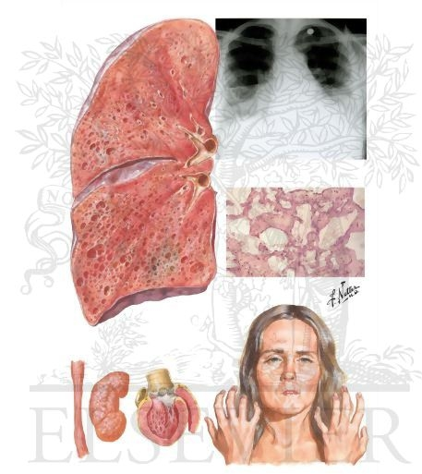
Scleroderma with Lung Involvement

An Auto-Immune Disease

Description:
The tissues becomes thickened and tough, often
with pigmented patches. There is a persistent hardening
and contraction of the body’s connective tissue which
causes a restriction of muscular activity in the affected
area. It can affect any part, including the skin, heart,
kidneys, lungs, or esophagus. Scleroderma may be
localized or it can spread slowly throughout the body, and
will eventually causing death if it is not treated. Due to the
thickening of the skin, the body does not detoxify well,
which can lead to a variety of cancers.

Areas to address when dealing with Scleroderma:

Since Scleroderma is an auto-immune disease, this means

that the immune system is overreacting and will not turn off.

Therefore, every system of the body needs to be checked to

determine if there is an imbalance. The total body must be

brought back into homeostasis as quickly as possible.

The following areas should be checked thoroughly:

- Allergies – if there are allergies to food, they must be eliminated in order for the immune system to down regulate. Call 905-871-4281 for test kit

- Hormones – thorough hormone testing is essential. An imbalance here can be the reason why the immune system will not down regulate. Have a blood test to check Estradiol, Progesterone, Testosterone, and DHEA. Call 905-871-4281 if you need more details.

- Detoxification is essential – in order to get rid of as many toxins as possible that irritate and interfere with the cellular function

- Eliminate toxins in your personal environment - such as toxic household cleaners, personal care products and cosmetics. These can aggravate an already imbalanced system.

- Check for Heavy Metals: A Hair Analysis is the most accurate way to do this. Call 905-871-4281 for test kits

Recommendations:
- Eat according to the Healthy Body Diet

- Detoxify using Shaklee DTX, Herb Lax … Water flushing each morning and Celery Flushes done every two months are very beneficial.

- Start supplementation with the “Rx for a Healthier Life” from Shaklee

- Additional supplements: Lecithin, GLA, OmegaGuard, Alfalfa

- Chelation Therapy (Chelation Suppositories … call Martha Willmore @ 905-871-4281) & Therapeutic amounts of Vitamin C given intervenously may be very helpful

- Other supplements and herbal remedies may be required based on each individual’s need

