Celebrate the Life
of
Amy Alison Otstot
May 16, 1961 - October 11, 2010
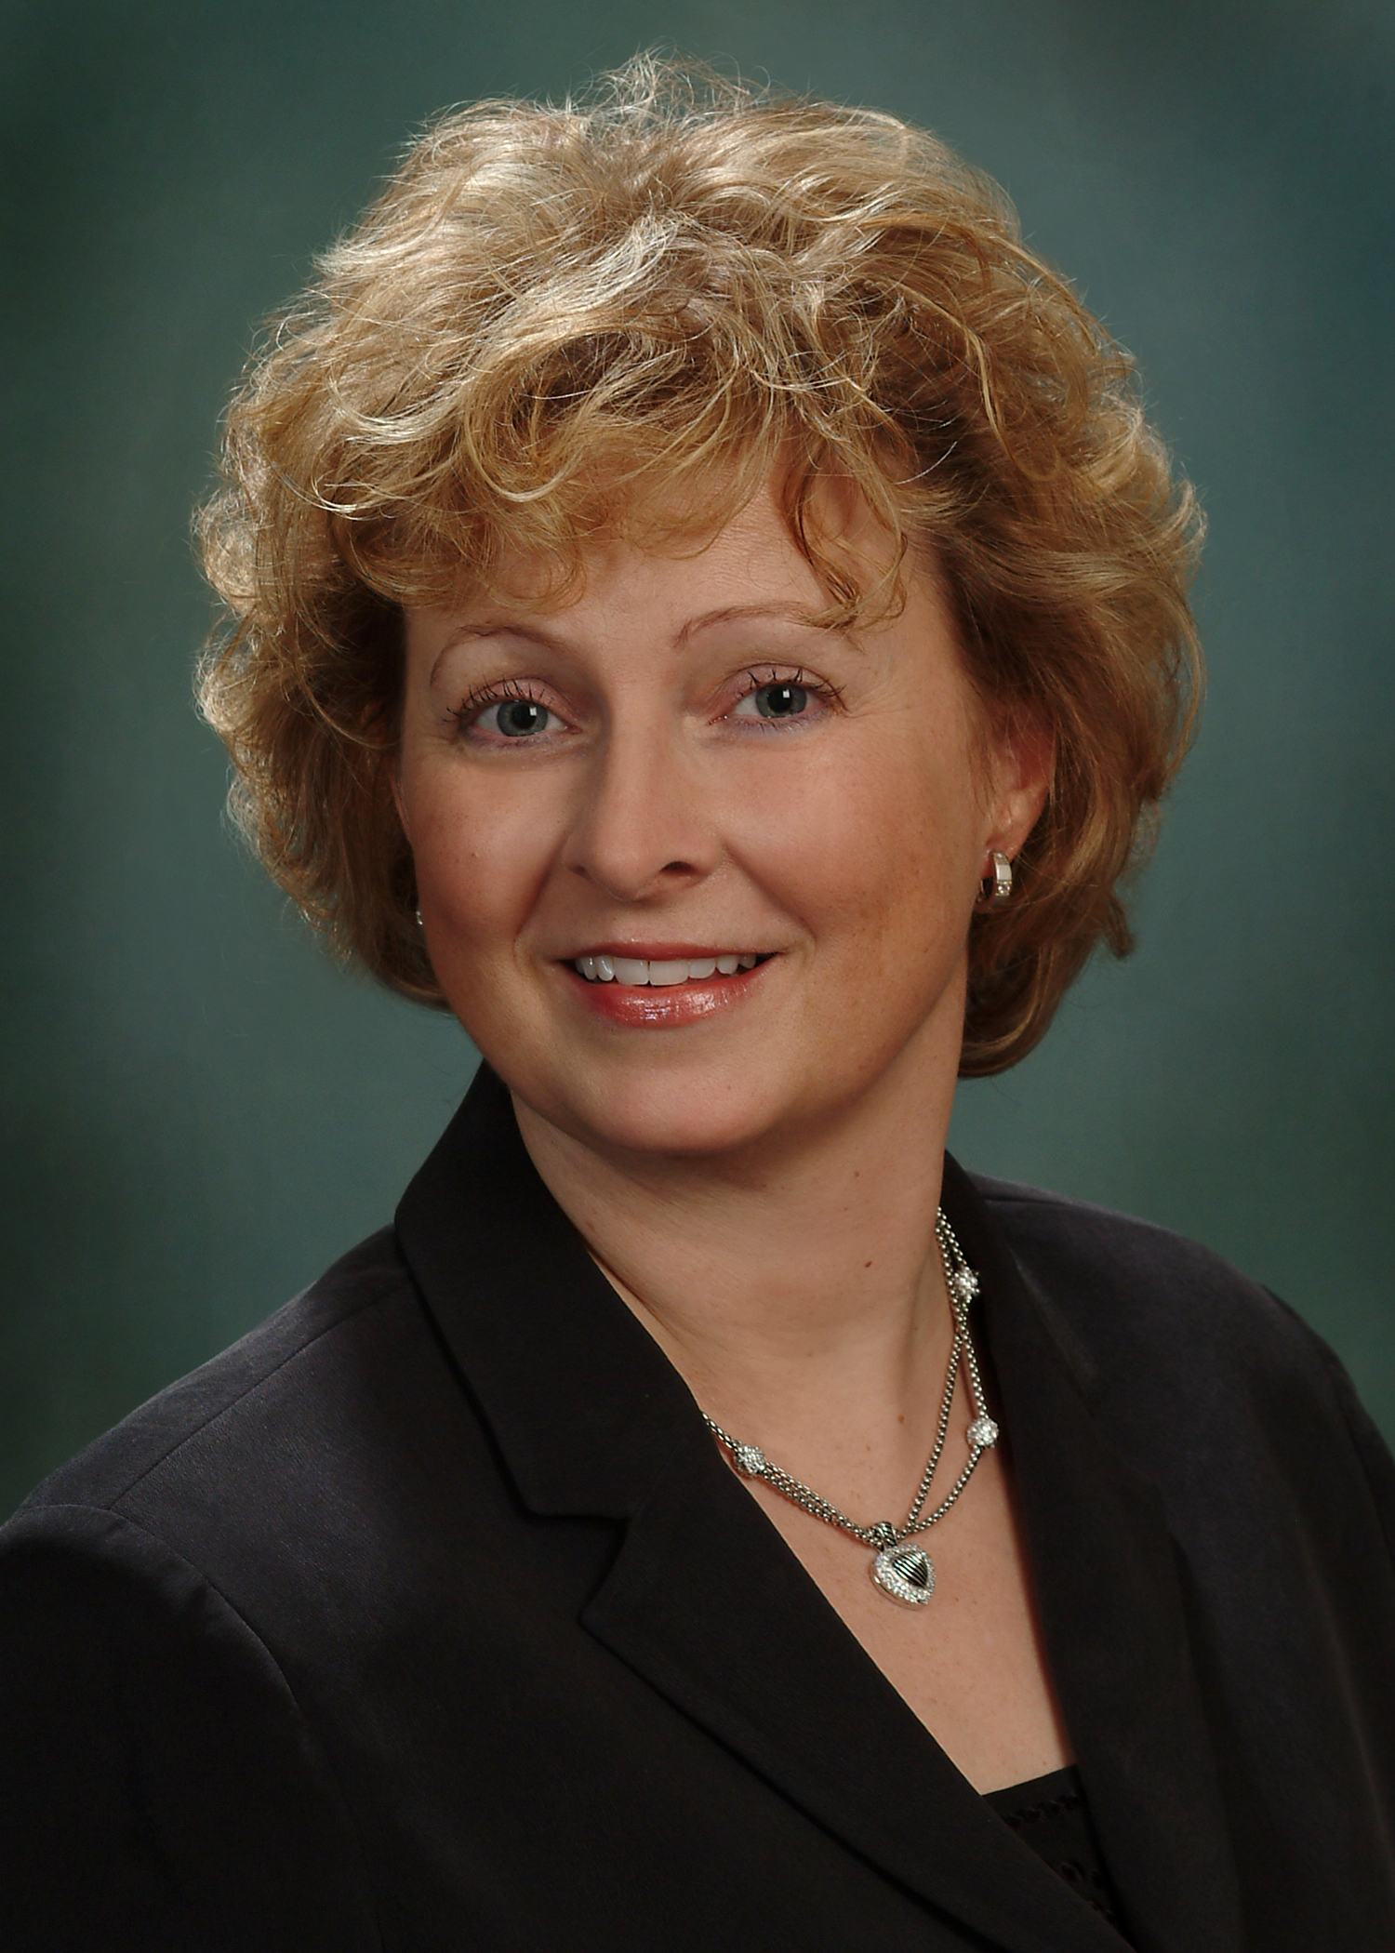
Fo rever In Our Hearts
Alison had a short life on this earth, but her accomplishments were great. She grew up in Madison , WI and at an early age showed just how smart she was. She was in the theater, she played the flute, she was fluent in French, and was on the debate team. She has many friends in Wisconsin to this day as well as from every segment of her life….both professionally and personally. She was truly loved by many…..
Alison was extremely smart and her academic achievements showed her intelligence. She received her doctorate in Health Informatics from Queensland University in Australia and earned her masters from Johns Hopkins.
Alison married Scott Newman in 1993 and, together, they created her greatest achievement – her daughter Sara. Being the best mother was her most important goal…..and she was the best mother!
In 2004, Alison fell in love with Bill Otstot and they married in 2006. Their love was the second most important thing to her in this world.
Alison will be sorely missed, but we hope that today fills your heart with memories of Alison to take with you so that she is never forgotten.
Thank you for your love and support!
Bill and Sara

