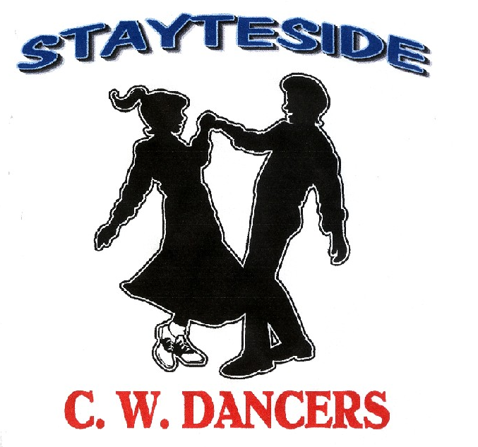

But I Do
Description: Partner Dance. (64 Counts)
Start Position: Right Side by Side (Sweetheart) Gent’s and Lady’s footwork the same throughout unless otherwise stated.
Choreographers: Carol* & George Stayte, (UK). *Qualified D & G Instructor. 02392 423925 carol.stayte@ntlworld.com
Music: “But I Do” by Vince Gill & Paul Franklin. CD: Bakerfield. (108 bpm. 32 Count Intro)
Alternative: “Angel at the Station Inn” by Lawrence John Project. CD: Country and Greengrass. (104 bpm. 20 count intro)
Tracks available at: iTunes and Amazon.

1 STEP LOCK. SHUFFLE FORWARD. STEP FORWARD. TAP BEHIND. STEP BACK.TAP ACROSS.
1 – 2 Step fwd on right, lock left behind right.
3 & 4 Right Shuffle fwd RLR.
5 – 8 Step fwd on left, tap right behind left. Step back on right, tap left across right.

2 STEP LOCK. SHUFFLE FORWARD. ROCK STEP. SHUFFLE 1/2 TURN.
1 – 2 Step fwd on left, lock right behind left
3 & 4 Left Shuffle fwd LRL.
5 – 6 Rock fwd on right, recover on left.
7 & 8 Shuffle ½ turn right RLR. RLOD

3 PIVOT 1/2 TURN. SHUFFLE FORWARD.ROCKING CHAIR.
1 – 2 Step fwd on left pivot ½ turn right. LOD (Release left, right over Gent’s head)
3 & 4 Left shuffle fwd LRL. (Rejoin into side by side/sweetheart position)
5 – 8 Rock fwd on right, recover on left, rock back on right, recover on left.

4 SHUFFLE 1/2 TURN. 1/4 TURN X2. SHUFFLE FORWARD X2.
1 & 2 Shuffle ½ turn left on a RLR. RLOD (Release left, right behind Gent’s back. Rejoin left in front of Gent, hammerlock.)
3 – 4 ¼ turn left on left, ¼ turn left stepping fwd on right, LOD (Release right hand, left over Ladies head, rejoin into
Side by Side/sweetheart position)
5 & 6 Left shuffle fwd LRL.
7 & 8 Right shuffle fwd RLR.

5 TURN 1/4. WEAVE. ROCK STEP, SAILOR ¼ TURN.
1 – 4 ¼ turn right stepping to side on left, step right behind left, side on left, cross right over left. OLOD (Indian position)
5 – 6 Rock to side on left, recover on right.
7 & 8 ¼ turn left sweeping left behind right, stepping down on left, together on right, step fwd on left. LOD (Side by side/Sweetheart)

6 WALK, WALK, SHUFFLE FORWARD X2
1 – 2 Walk fwd on right, left.
3 & 4 Right shuffle fwd RLR.
5 – 6 Walk fwd on left, right.
7 & 8 Left shuffle fwd LRL.

7 SIDE TOGETHER. SHUFFLE BACK. 1/4 TURN, STEP TOGETHER, 1/4 TURN SHUFFLE FORWARD.
1 – 2 Step to side on right, step together on left,
3 & 4 Right shuffle back RLR.
5 – 6 ¼ turn left on left, slide right next to left
(Release right, left over Gent’s head. Rejoin right in front of Gent, hammerlock)
7 & 8 Shuffle ¼ turn left to RLOD LRL.

8 SIDE TOGETHER. SHUFFLE BACK. 1/4 TURN, STEP TOGETHER, 1/4 TURN SHUFFLE FORWARD.
1 – 2 Step to side on right, together on left.
3 & 4 Right shuffle back RLR.
5 – 6 ¼ turn left, slide right next to left.
(Release right, raise left over Ladies head. Rejoin into Side by Side/Sweetheart)
5 & 8 Shuffle ¼ turn left to LOD LRL.
START AGAIN

